Table of Contents

Table of figures 3

Table of Tables 5

Acknowledgement 6

Summary 6

Chapter 1: Introduction 7

1.1 Introduction of the system 7

1.2 Background of the system 7

1.2.1 Features 7

1.2.2 Scope and aim 7

1.2.3 Objectives 7

Chapter 2: Analysis 8

2.1 Introduction 8

2.2 Analysis Methodologies 8

2.3 Information Gathering 8

Interview 9

Questionnaire 9

2.4 Feasibility Study 10

Technical Feasibility 10

Economic Feasibility 10

Legal Feasibility 10

Operational Feasibility 11

Scheduling Feasibility 11

2.5 System Requirement Specification 11

2.5.1 Functional Requirement 11

2.5.2 Non-Functional Requirement 13

2.5.3 MoSCoW Prioritization 13

2.5.4 Requirement Specification 15

2.6 Use Case Diagram 16

2.7 System Architecture 19

2.7.1 National Language Architecture [NLA] 19

2.7.2 Initial Class Diagram 20

2.7.3 System Architecture 21

Chapter 3: Design 22

Introduction 22

3.1 Structural Modelling 22

3.1.1 Class Diagram 22

3.1.2 Data Flow Diagram [DFD] 25

3.2 Behavioral Modelling 27

3.2.1 Activity Diagram 27

3.2.2 Sequence Diagram 31

3.3 Database Modelling 34

3.3.1 ER Diagram 34

3.3.2 Data Dictionary 35

3.4 UI Modelling 36

3.4.1 Prototyping 36

Chapter 4: Implementation 50

Introduction 50

Tools used for project 50

Development Environment 50

Conclusion 51

Chapter 5: Testing 52

Testing 52

Conclusion 69

Appendix 70

References 117

# Table of figures

Figure 1: Use Case Diagram 16

Figure 2: Initial Class Diagram 20

Figure 3: System Architecture 21

Figure 4: Class Diagram 24

Figure 5: Admin DFD 26

Figure 6: Registration Form 37

Figure 7: Login Form 38

Figure 8: User's Profile 39

Figure 9: User’s Homepage 40

Figure 10: About Us 41

Figure 11: Contact Page 42

Figure 12: Cart Details 43

Figure 13: Admin Login Page 44

Figure 14:Admin Profile 45

Figure 15: Admin Password Change 45

Figure 16: Admin Dashboard 46

Figure 17: Manage Category 47

Figure 18: Manage Products 48

Figure 19: Manage Orders 48

Figure 20: Manage Testimonials 49

Figure 21: Manage Messages 49

Figure 22: Manage Access 50

Figure 23: Validation 54

Figure 24: Valid Details 55

Figure 25: Account Created Successfully 56

Figure 26: Successful Login 57

Figure 27: Invalid Login 58

Figure 28: Admin Login Validation 59

Figure 29: Valid Info of Admin 60

Figure 30: Admin Login Successful 61

Figure 31: Add to Cart 61

Figure 32: Add to Cart Successful 62

Figure 33: Checkout 62

Figure 34: Checkout Order Successful 63

Figure 35: Message to Admin 63

Figure 36: Message from Users 64

Figure 37: Before Updating Products 64

Figure 38: Adding Product by Admin 65

Figure 39: Product Added On Product Details 66

Figure 40: Updated Products 66

Figure 41: Home Page 70

Figure 42: Products Page 71

Figure 43: Index.php 72

Figure 44: Home.php 75

Figure 45: Header.php 76

Figure 46: Footer.php 76

Figure 47: About Page 78

Figure 48: About.php 80

Figure 49: Contact Page 81

Figure 50: Contact.php 83

Figure 51: Login Form 84

Figure 52: SignUp Form 84

Figure 53: Login and Signup.php 87

Figure 54: Add to Cart Page 88

Figure 55: Cart.php 90

Figure 56: Profile Page 91

Figure 57: Profile.php 93

Figure 58: Category Page 93

Figure 59: Add Category.php 95

Figure 60: New Category Form Page 96

Figure 61: Add New Category.php 96

Figure 62: Edit Category 97

Figure 63: Edit Category.php 98

Figure 64: Product Page 98

Figure 65: Product.php 100

Figure 66: New Product Form 101

Figure 67: New Product.php 102

Figure 68: Edit Product Form 103

Figure 69: Edit Product.php 104

Figure 70: Orders Page 104

Figure 71: Orders.php 106

Figure 72: Testimonials Page 107

Figure 73: Testimonials.php 109

Figure 74: Add Testimonial Form 109

Figure 75: Add Testimonial.php 110

Figure 76: Messages Page 111

Figure 77: Messages.php 113

Figure 78: Admin Profile Edit Form 113

Figure 79: Edit Profile.php 115

Figure 80: Admin Password Edit Form 115

Figure 81: Edit Password.php 116

# Table of Tables

Table 1: Functional Requirement 12

Table 2: Non-Functional Requirement 13

Table 3: MoSCoW Prioritization 14

Table 4: Use Case 18

Table 5: Class Diagram Notation 23

Table 6: Notation Diagram of Data Flow Diagram 25

Table 7: Notation of activity diagram 29

Table 8: Notation of Sequence Diagram 32

Table 9: ER Diagram 34

Table 10: Table Names 35

Table 11: Table Names 35

Table 12: Data Dictionary 36

# Acknowledgement

I would like to express my humble gratitude to my teachers for guiding me all the way from understanding the basics of web development to develop a complete project. I am very much grateful for their guidance, effort and mentorship that they put to make me understand the stuffs required to develop a functional website. I would also like to acknowledge all my friends who have assisted and supported me during this project.

And last but not least, I would like to express my sincere regards to other people who have helped me directly or indirectly to clear my doubts, confusion and helping me to complete the project in limited period of time.

# Summary

Our country is an agricultural country. Most of the people in our country are engaged in agriculture as their daily livelihood and occupation. People produce a large amount of vegetables, fruits, etc. They sell these items at their local market. Most of these agricultural products go waste since they are produced in large quantity and the number of consumption at local level is small compared to the number of the production. If these highly produced agricultural items are to be sold where the consumption of these products are high then these products will not go waste and people engaged in these sectors will benefit much more.

Therefore, Online Vegetable and Fruits is a solution to overcome the problem people engaged in agricultural fields. This project will help people to sell their products online which will reduce the quantity of agricultural products going on waste. Since the Online Vegetable and Fruits helps people to sell and buy fresh products online, not only the seller will benefits from it buyers will also benefit as it helps people to buy as per their wish. Online Vegetable and Fruits will be user friendly and will be easy to use for those people who have a basic knowledge of online activity. Since the world is advancing to online transactions, Online Vegetable and Fruits will help people to purchase fresh, cost efficient and online delivered products.

# Chapter 1: Introduction

## Introduction of the system

Online Vegetable and Fruits is a functional website which is made for selling and buying of the fresh vegetables and fruits online. It will help sellers by providing a platform to sell their products online and buyers to buy fresh vegetables and fruits at the tip of their fingers. The website provides a full detail on the products, and provides an online delivery. It is also working on the return policy in case the unexpected product is mistakenly delivered. It is aiming to expand its store to facilitate more customers.

## Background of the system

Online Vegetable and Fruits is a web application which contains useful information on fresh, healthy vegetables and fruits. It is like a platform to serve users with details on the vegetables and fruits that are available at market on a reasonable price. Traditionally, the selling and buying of the vegetables and fruits were done in person. It consumes most of the time since we used to visit different stores to get the product we need. And as for sellers, they need to rent stores to contain the vegetables and fruits which was a little costly.

But with this online platform, customers can access their preferred choices. Sellers can maintain profit by selling a large amount of products.

## Features

Online Vegetable and Fruits is a project which consists of valuable features including CRUD operations. One of the important feature is to buy the products online. Other features include online delivery, administrative features, etc.

## Scope and aim

The main purpose of the organization is to provide a platform for the people who can’t find a proper platform to sell their products due to which the products go waste and to provide people fresh vegetables and fruits by simply browsing Internet.

* Enhance the overall production, perfection and furnish recommended services.
* To firm the individual details, statistics and subscription of the customer.

## Objectives

To refine the drawbacks the farmers are facing with the features of this project are the main objectives of creating this system. Some of those objectives are:

* To provide accurate, efficient and updated details.
* To reduce the manual effort.
* To provide secure, effective transactions.

# Chapter 2: Analysis

## 2.1 Introduction

Analysis means a systematic examination and evaluation of data and facts to uncover and understand cause-effect relationships, thus providing basis for problem solving and decision-making. (Analysis, 2020) We should do a proper analysis before starting any project. Proper analysis of the project will help to make the project much effective, and also facilitates us in different ways.

## 2.2 Analysis Methodologies

Analysis is one the most important part of developing a system which will help us to point out the features and functionality that an application needs to have. It helps us to point out all of the examination that are needed in an application to make the application much more applicable.

For analysis of this project, object-oriented analysis [OOA] methodology has been chosen. It analyzes and designs an application based on the system’s logical components that interact with one another. It also combines all characteristics, states, and behaviors together into a single analysis process, instead of splitting them into different stages, as many other analysis methodologies would do.

Following interaction diagrams have been used in my project;

* Class Diagram

Class Diagram in the Unified Modeling Language (UML) is a type of static structures diagram that shows the collection of classes, attributes, interfaces, their association and relationships among objects.

* Activity Diagram

Activity Diagram is a behavioral diagram in Unified Modeling Language (UML) which describes the dynamic aspects of the system. It is an advanced version of flow chart that models the flow of one activity to another activity.

* Sequence Diagram

Sequence Diagram are interaction diagrams that detail how operations are carried out. They are time focus and show the order of the interaction visually by using the vertical axis of the diagram to represent time what messages are sent and when. (Sequence Diagram, 2020)

Detailed insight of above mentioned interaction diagrams will be given in the design phase.

## 2.3 Information Gathering

The simplest way to define information gathering would be the process of collecting information about something you are interested in. Information are gathered in order to understand the requirements of the system. The more the information gathered about the system, the more the probability to obtain relevant results. I have used the following two information gathering techniques which involves direct communication with the clients; interview and Questionnaire.

### Interview

An information converging interview is an administered discussion with a particular motive that utilizes a question-and-answer scheme. In the interview you are eager to conceive the opinions of the interviewee and his/her sentiments about the contemporary state of the system, personal and organizational goals, and informal procedures for interacting with information technologies. While interviewing, seek the opinions of the person you are interviewing. Opinions may be more important and more revealing than facts. (Interviewing in Information Gathering, 2020) Some of the questions that I prefer to ask to the interviewee are;

* What are the general and specific features that you want in the system?
* How can we make the system much more user friendly?
* Are you having any issue while using the system?

### Questionnaire

Questionnaire in an information gathering technique helps system analysts to study attitudes, beliefs, behavior, and characteristics of several people in the system/organization who may be affected by the current and proposed systems. Responses gained through questionnaire using closed questions can be quantified and can be used to survey a large sample of system users to sense problems or raise important issues before interviews are scheduled. It helps to distinguish the behavior and preferences of people in a specific field. (System Analysis, 2020) Some of the questionnaire that I prefer to ask are;

* What is your budget estimation for the project?
* Do you need further maintenance services?
* Have you registered domain for the company?
* Does your company have branding inclusions like logo/banners/established images?
* Do you have technicians to run the website?
* How often do you update the contents in website?
* Do you have any hosting company preference?
* Do you want us to train your staff to operate the website?
* What is your deadline for the project?
* Who are going to use the website?
* Would you like us to handle your other web aspects like digital marketing, search engine optimization (SEO) or you already have other dedicated member?
* Who are your targeted audience?
* Who will provide the contents for the website?
* Do you want to include any 3rd party application in your website?
* What are the features you want in your website?

## 2.4 Feasibility Study

A feasibility study is an analysis that takes all of a project’s relevant factors into account-including economic, technical, legal, and scheduling considerations- to ascertain the likelihood of completing the project successfully. Feasibility studies are used to discern the pros and cons of undertaking a project before they invest a lot of time and money into it. It also provides a company’s management with crucial information which could prevent the company from entering blindly into risky businesses. It is always good to have a contingency plan that you test to make sure it’s a viable alternative in case the first plan fails while doing a feasibility study. (feasibility study, 2020)

For the project I have done the following types of feasibility study;

### Technical Feasibility

Technical feasibility study focuses on the technical resources available to the organization. The project is a total website which is made on Laravel (a php web framework). To study technical feasibility of the project, we need to confirm if the existing computer system are compatible with the technologies that we will use. The project will work perfectly across all the devices, browsers since it will be optimized properly. The requirements needed for project to run successfully are freely available and manageable. Therefore, the project is technically feasible.

### Economic Feasibility

Economic feasibility typically involves a cost/benefits analysis of the project which helps organizations to determine the viability, cost, and benefits associated with a project before the financial resources are allocated. Since the project is made up of freely available technologies, basic operating computer system, no cost will be charged. Some cost will be charged during the hosting of the website, for the development team. The project will be small, efficient so there will be training for short period of time which minimizes the cost of training. And while the records of clients and other credentials will be off the paper it will also minimize the cost. Therefore, the project is economically feasible.

### Legal Feasibility

Legal feasibility determines whether any aspect of the proposed project conflicts with legal requirements like data protection acts or social media laws. (Feasibility Study, 2020) For the project, I have used open source tools that have free license which will not permit the violation of the legal conflicts. And as for the website, we have a privacy policy which will clear the data related to the users. Thus, it will help the website to be fully secure which depicts no legal crimes. Therefore, the project is legally feasible.

### Operational Feasibility

Operational feasibility involves undertaking a study to analyze and determine whether and how well the organization’s needs can be met by completing the project. It also examines how a project plan satisfies the requirements identified in the requirements analysis phase of system development. (Feasibility Study, 2020) A proper orientation and basic trainings will be provided to the users so the introduction of new system will not affect anyone. In this way, the project will be operationally feasible.

### Scheduling Feasibility

Scheduling feasibility is the most important for project success because a project will fail if not completed on time. An organization estimates how much time the project will take to complete. My project will have enforced several time estimates on which several chunks of works related to the project will be done which will balance the work load and help the project to be completed on time. In this way, my project will be on time.

## 2.5 System Requirement Specification

A System Requirements Specification (SRS) is a documents or set of documentation that describes the features and behavior of a system or software application. It includes a variety of elements that attempts to define the intended functionality required by the customer to satisfy their different users. (System Requirements Specifications, 2020)

## 2.5.1 Functional Requirement

The functional requirement specification documents the operations and activities that a system must be able to perform. It is designed to be read by a general audience. Readers should be able to understand the system, but no particular technical knowledge should be required to understand the document. (Functional Requirements, 2020)

List of functional requirements are shown below;

|  |  |  |  |  |
| --- | --- | --- | --- | --- |
| ID | Title | Description | Dependency | Rational |
| FR_101 | Registration | Add new user | N/A | To access secure system |
| FR_102 | Login | Registered user can login to the system | FR_101 | To provide access to a valid user |
| FR_103 | Verify password | To check the password entered with the database | FR_101,  FR_102 | To authenticate the user |
| FR_104 | Display Dashboard | To provide a functional front page | FR_101,  FR_102 | To navigate entire system easily |
| FR_105 | Edit Profile | Change personal information | FR_101,  FR_102 | To update user’s information in case of emergency |
| FR_106 | Add Category | Add new category of fruits and vegetables | FR_102 | Add new type of category of the product |
| FR_107 | Update Category | Add new details on the existing category details | FR_102,  FR_106 | For any additional information is needed to be add |
| FR_108 | Delete Category | Remove the category | FR_102,  FR_106 | To remove the unnecessary category |
| FR_109 | Add Product | Add new product | FR_102,  FR_106 | To add new product under different category |
| FR_110 | Update Product | Add new details on the existing product details | FR_102,  FR_109 | To add extra information about the product or remove the unwanted details |
| FR_111 | Delete Product | Remove the product | FR_102,  FR_109 | To remove the product that is unavailable |
| FR_112 | Add to cart | Add product to the cart | FR_102,  FR_109 | To buy the product |
| FR_113 | Delete from cart | Delete the added product | FR_102,  FR_112 | To not to buy the product incase of change of mind |
| FR_114 | View Order Details | Lists out all the order | FR_102,  FR_112 | Details the list of all the order placed by the user |
| FR_115 | Approve Order | Approve the order for delivery | FR_102,  FR_112 | To approve the order placed by the user. |
| FR_116 | Delete Order | Deletes the order | FR_102,  FR_114 | To delete the order incase of lack of the product |
| FR_117 | Add Message | Sends message to the admin | FR_102 | To send any information that a user possesses to the admin |
| FR_118 | View Message | Lists out all the message | FR_102,  FR_117 | To view the message the users have send to the admin |
| FR_119 | Delete Message | Deletes the message | FR_102,  FR_117 | To delete the message the admin has already seen |
| FR_120 | Manage Access | Maintains the level of access | FR_101,  FR_102 | To provide certain level of authority |
| FR_121 | Logout | Logout at desired time | FR_102 | To secure users’ data to be misused |

Table 1: Functional Requirement

## 2.5.2 Non-Functional Requirement

Non functional requirements define system attributes such as security, reliability, performance, maintainability, scalability, and usability. They serve as constraints or restrictions on the design of the system across the different backlogs.

List of non-functional requirements are shown below;

|  |  |  |  |
| --- | --- | --- | --- |
| ID | Title | Description | Dependency |
| NFR_101 | Scalability | The system should be able to manage the users’ information. | N/A |
| NFR_102 | Verification | The system should verify the password and the point of access to verify who the user claim to be. | NFR_104 |
| NFR_103 | Reliable | The system should be strongly reliable so that the users’ information is strongly preserved and protected. | NFR_109 |
| NFR_104 | Security | The system should be secure since it contains all the valuable information about the users. | NFR_102 |
| NFR_105 | Efficiency | The system should be efficient so that the users can access it without any errors. | NFR_105 |
| NFR_106 | Acceptance | The system should accept all the users new or old registered to the system. | NFR_102 |
| NFR_107 | Intuitiveness | The system should be easily understandable so that the users find it more way friendly to use. | NFR_106 |
| NFR_108 | Usability | It defines that the services provided by the system should be easily useable with no problems. | NFR_103,  NFR_105 |
| NFR_109 | Availability | The system should be accessible form anywhere so that the user can do what ever they can with the help of the site. | NFR_103,  NFR_106 |
| NFR_110 | Quality | The system should be qualified for performing all the functional and non-functional requirement of the system. | NFR_105,  NFR_107,  NFR_108 |

Table 2: Non-Functional Requirement

## 2.5.3 MoSCoW Prioritization

MoSCoW Prioritization, also known as the MoSCoW method or MoSCoW analysis, is a popular prioritization technique for managing requirements. The method is commonly used to help key stakeholders understand the significance of initiatives in a specific release.

The acronym, MoSCoW stands for 4 different categories of initiatives: must-haves, should-haves, could-haves, and will not have. (MoSCoW Prioritization, 2020) The MoSCoW prioritization for my project is as follows:

|  |  |  |
| --- | --- | --- |
| ID | Functional and Non-Functional Requirements | MoSCoW |
| MP_01 | Registration | Must have |
| MP_02 | Login | Must have |
| MP_03 | Verify Password | Must have |
| MP_04 | Display Dashboard | Should have |
| MP_05 | Edit Profile | Could have |
| MP_06 | Add Category | Must have |
| MP_07 | Update Category | Must have |
| MP_08 | Delete Category | Should have |
| MP_09 | Add Product | Must have |
| MP_10 | Update Product | Must have |
| MP_11 | Delete Product | Should have |
| MP_12 | Add to cart | Must have |
| MP_13 | Delete from cart | Must have |
| MP_14 | View order details | Should have |
| MP_15 | Approve order | Must have |
| MP_16 | Delete order | Should have |
| MP_17 | Add Message | Must have |
| MP_18 | View Message | Must have |
| MP_19 | Delete Message | Should have |
| MP_20 | Manage access | Must have |
| MP_21 | Logout | Must have |
| MP_22 | Scalability | Could have |
| MP_23 | Verification | Must have |
| MP_24 | Reliable | Could have |
| MP_25 | Security | Must have |
| MP_26 | Efficiency | Must have |
| MP_27 | Acceptance | Should have |
| MP_28 | Intuitiveness | Must have |
| MP_29 | Usability | Should have |
| MP_30 | Availability | Should have |
| MP_31 | Quality | Must have |

Table 3: MoSCoW Prioritization

## 2.5.4 Requirement Specification

A requirement specification is a document that captures complete description about how the system is expected to perform. The requirement specification for the project is as follow:

Software Requirement

Programming Language: PHP

Framework Used: Laravel

User Interface Design: HTML, BOOTSTRAP, jQuery

Operating System: Windows 7 and above

Server: Apache

Database: MySQL

Web Server Solution Package: Xampp

Hardware Requirement

RAM: 2GB and above

Processor: Intel Processor Dual Core and above

## 2.6 Use Case Diagram

Figure 1: Use Case Diagram

A use case diagram is the primary form of system/software requirements for a new software program underdeveloped. Use cases specify the expected behavior (what), and not the exact method of making it happen (how). A key concept of use case modeling is that it helps us design a system from the end user’s perspective. It is an effective technique for communicating system behavior in the user’s terms by specifying all externally visible system behavior. (Use Case Diagram, 2020) The use case diagram shown above describes the relationship between the users and the system including the system’s functions. The relation is explained in the table below.

|  |  |  |  |  |
| --- | --- | --- | --- | --- |
| ID | Use Case Title | Summary | Alternative Sequence | Actor |
| UC_01 | Register | User need to register themselves to the system to access the system. | N/A | Unregistered  User |
| UC_02 | Login | Administrative and regular users’ login is done. | In case of incorrect password a message pop ups. | Admin,  User |
| UC_03 | Verify password | The system verifies the password entered with the password on the database | N/A | The System |
| UC_04 | Display dashboard | Both users land firstly here. | N/A | Admin,  User |
| UC_05 | Edit Profile | Both users can edit their profile. | Message is displayed after editing the profile. | Admin,  User |
| UC_06 | Add Category | Admin adds new category. | Message is displayed after a category is added. | Admin |
| UC_07 | Update Category | Admin updates the category. | Message is displayed when the category is updated. | Admin |
| UC_08 | Delete Category | Only admin can delete the category. | Message is displayed when the category is deleted. | Admin |
| UC_09 | Add Product | Admin can add new products. | N/A | Admin |
| UC_10 | Update Product | Admin can update the existing product. | N/A | Admin |
| UC_11 | Delete Product | Admin can delete the existing product. | N/A | Admin |
| UC_12 | Add to cart | Users can add the product to their cart | N/A | User |
| UC_13 | Delete form cart | Users can delete the product they added to their cart | Message will be displayed when a product form the cart is deleted. | User |
| UC_14 | View order details | Admin will view all of the orders made by the users. | N/A | Admin |
| UC_15 | Approve Order | Admin is capable of approving the orders. | N/A | Admin |
| UC_16 | Delete Order | Admin can delete the orders. | N/A | Admin |
| UC_17 | Add Message | Users can send message to the admin. | N/A | Users |
| UC_18 | View Message | Admin will see the message send by the users. | N/A | Admin |
| UC_19 | Delete Message | Admin can delete the message. | A message saying message deleted will be displayed | Admin |
| UC_20 | Manage Access | Only admin is capable of controlling the access provided to the users. | N/A | Admin |
| UC_21 | Logout | Both users and admin can logout of the system as per their choice. | Logged out successfully message will be displayed. | Users,  Admin |

Table 4: Use Case

## 2.7 System Architecture

The system architecture describes how a product is composed of components and how the components are related to each other via interfaces. (System Architecture, 2020)

## 2.7.1 National Language Architecture [NLA]

Salaka Vegetables and fruits is a farm where fresh, local fruits and vegetables are grown and are sold. It is located at Salleri, Solukhumbu and is at service since the early 2000. Here a large amount of fresh vegetables and fruits are grown and sold at the local market. All the works in this farm are done in a traditional method. They sell their products only at local markets. Since it produces vegetables and fruits at large number the consumption of these goods at local market is lower. Due to this these products are going to waste.

So, the owner of this farm intends to expand its service to other places. So, he has asked to make a web application that enables users from other areas to be able to buy their products.

Here are his requirements:

There are many farmers and people who wish to sell their fruits and vegetables online. These people who produce fresh vegetables and fruits sometimes have to let their fruits and vegetables go to waste because the fruits and vegetables they produce are in high quantity and the number of consumption is low. So the owner wants me to make a web application that will help these people. The web application should be able to help user register to the system. It should be user-friendly, easily accessible. It should also take users message so that they can elevate the level of application to another level. Customers should be able to order the product they want to purchase and admin can add as many product as they want to provide the information about products to the customers.

List of nouns (potential class) are:

Users, Customer, Order, Farmers, Fruits, Vegetables, Product, Admin.

Final candidate class has been finalized following the rules given below:

* Removed the matching, irrelevant, synonyms and outside the scope nouns.
* Removed the architectural level action noun. Also, the noun that could be design during development were skipped.

Final Candidate class

* Customer
* Order
* Product
* Admin

## 2.7.2 Initial Class Diagram

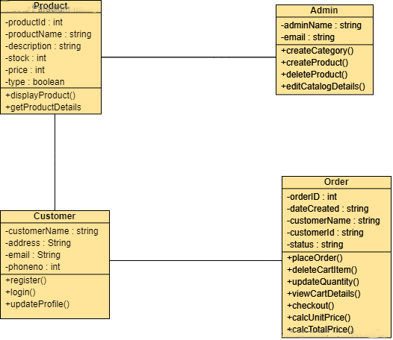

Figure 2: Initial Class Diagram

## 2.7.3 System Architecture

3-Tier system architecture has been used which holds the user interface, data storage, isolated platform and business logic. It includes client-server relation like client tier, application and database tier. It is used because all the tasks are separated which are handled by each layer in client-server application. Interface services are displayed to user in client tire whereas all the business logic is maintained in application tier. All the information are received and preserved in the data tier independently from other tiers. It also helps to keep the availability, scalability and performance of the overall system.

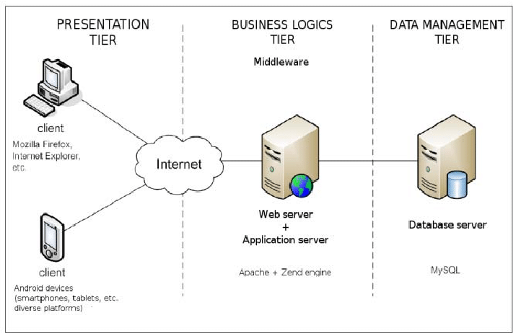

Figure 3: System Architecture

# Chapter 3: Design

## Introduction

The stage of development where all the decision regarding the final product are made to make the product much better and smooth is known as design in programming. User interface, logical function are planned before the coding of an application in the design phase. It is executed based on the requirements of the application.

## 3.1 Structural Modelling

Structural Modelling is an analysis technique which presents the logical organization of the objects without indicating how they are stored, created, or manipulated so that analysts can focus on the business, without being distracted by technical details. (STRUCTURAL MODELING, 2020)

## 3.1.1 Class Diagram

Class diagram is a static diagram which represents the static view of an application. It describes the attributes and operations of a class and also the constraints imposed on the system. It is a part of unified modelling language. (UML - Class Diagram, 2020)

The importance of class diagram are:

* To show the classes and how it interacts within the system.
* To show the relationship between class and object as it is an object oriented application.
* To outline all the object which the system contains and finalize relationship between them.
* To reduce maintenance time as it provides the structural diagram of the application.

Notation of Class Diagram:

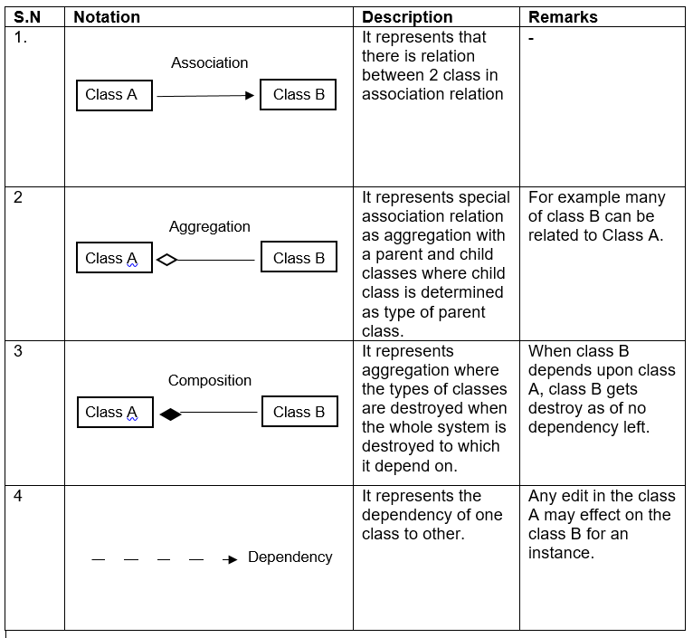

Table 5: Class Diagram Notation

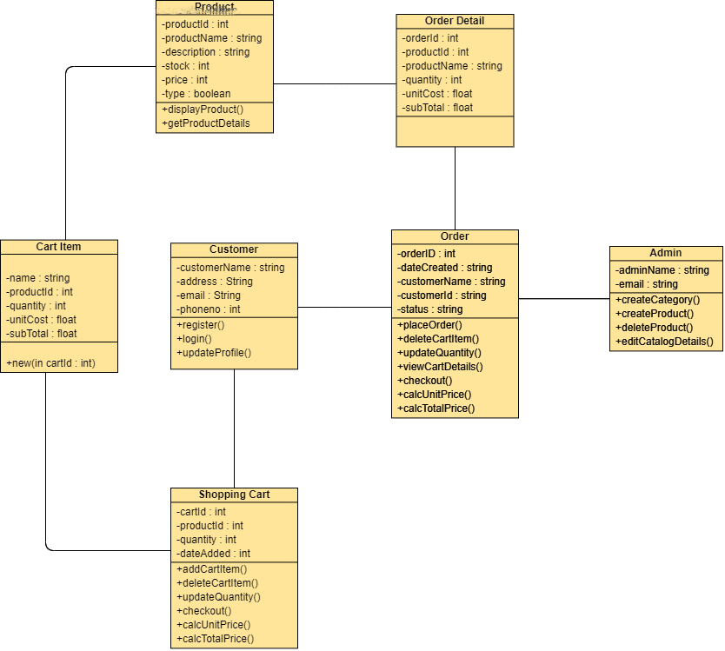

Figure 4: Class Diagram

## 3.1.2 Data Flow Diagram [DFD]

Data Flow Diagram (DFD) shows the flow of the system through a business procedure where it signifies all the inputs, output, data storage and other process which occurs in the website.

The importance of the data flow diagram are:

* Helps to narrate the end lines of the system.
* Can be included as a report in pre-implementing plans.
* Reduces data redundancy.
* Its structural diagram shows the execution of the website.

Notation of Data Flow Diagram (DFD):

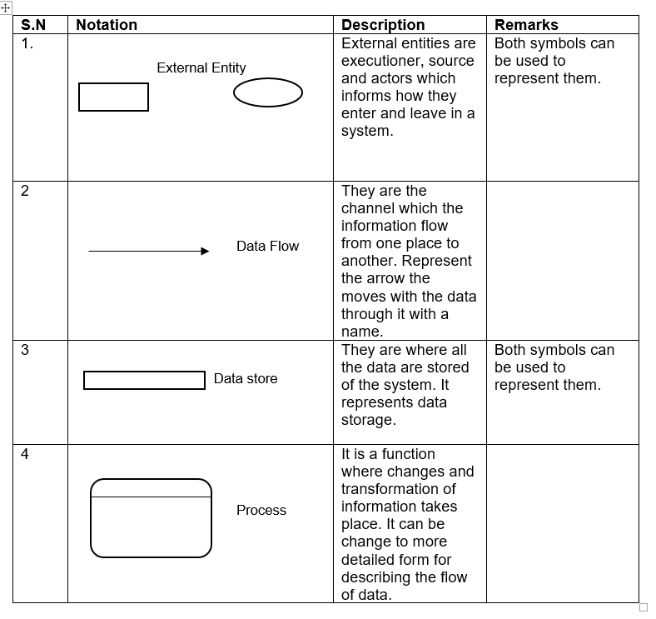

Table 6: Notation Diagram of Data Flow Diagram

Admin DFD:

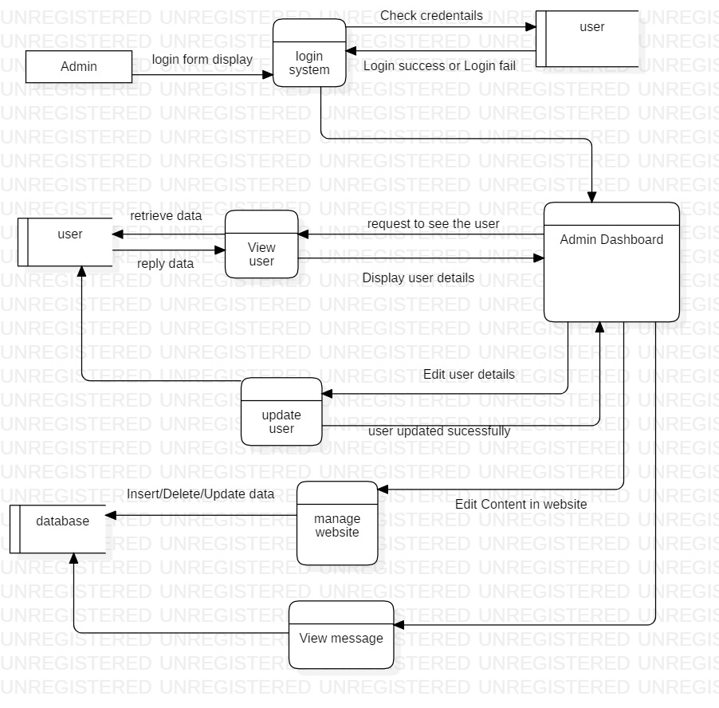

Figure 5: Admin DFD

## 3.2 Behavioral Modelling

Behavioral models describe the internal dynamic aspects of an information system that supports the business processes in an organization. During analysis, behavioral models describe what the internal logic of the processes is without specifying how the processes are to be implemented. Later, in the design and implementation phases, the detailed design of the operations contained in the object is fully specified. (BEHAVIORAL MODELING, 2020)

## 3.2.1 Activity Diagram

Activity Diagrams describe how activities are coordinated to provide a service which can be at different levels of abstraction. It describes the flow of methods to another method in a system.

Importance of activity diagram are:

* Helps to finalize the use case diagram.
* Views the flow of function in the system.
* It simplifies and improves complicated methods.
* It describes all logic of the system in particular diagrams.

Notations of activity diagram are: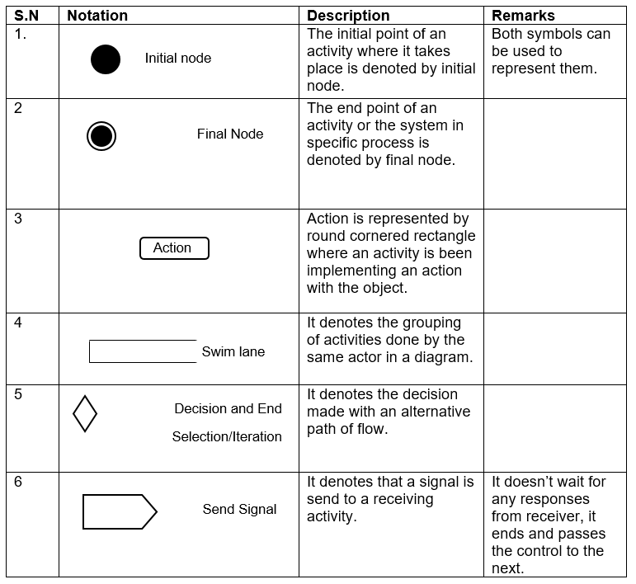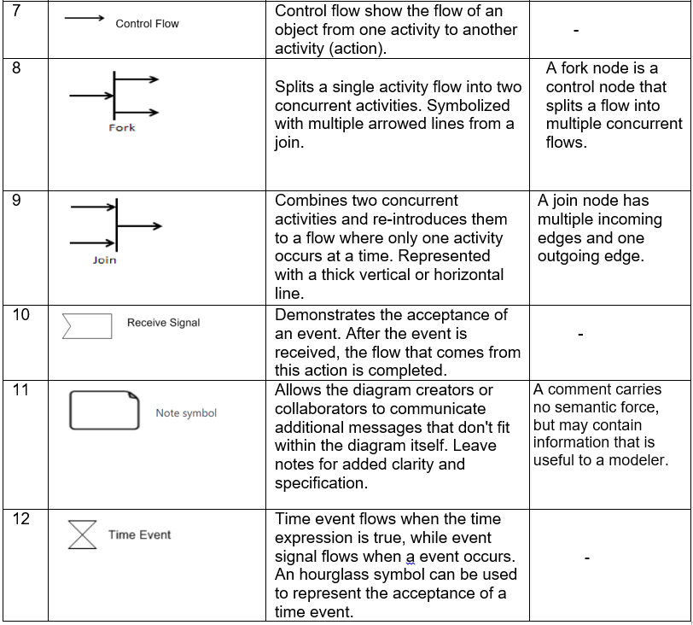

Table 7: Notation of activity diagram

Activity diagram of login and registration:

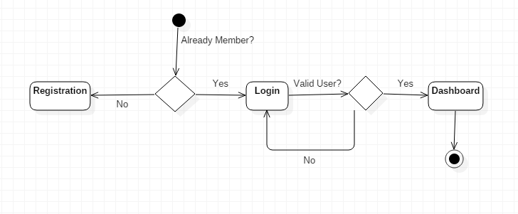

Figure 6: Activity Diagram of login and registration

## 3.2.2 Sequence Diagram

Sequence Diagrams are interaction diagrams that detail how operations are carried out. They capture the interaction between objects in the context of a collaboration. Sequence Diagrams are time focus and they show the order of the interaction visually by using the vertical axis of the diagram to represent time what messages are sent and when. (Sequence Diagram, 2020)

The importance of Sequence diagram are:

* It shows the reaction with object and its operations.
* It helps to plan and understand the function of object for future reference.
* It helps to adjust the operation of the system.
* It identifies problem, interface and architectural problems.

Notations of sequence diagram are:

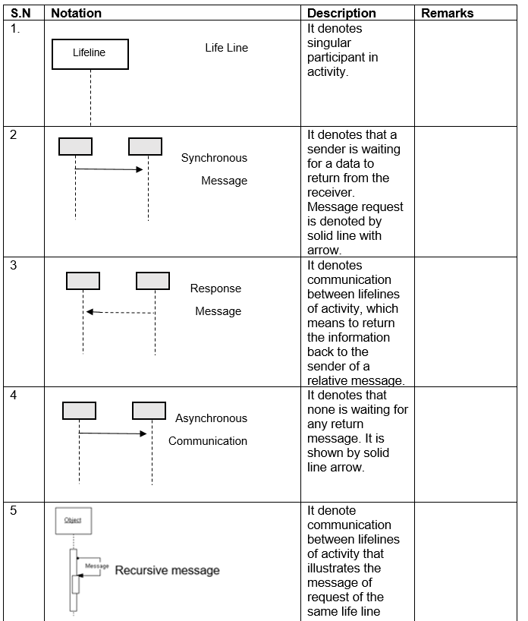

Table 8: Notation of Sequence Diagram

Sequence diagram of login system:

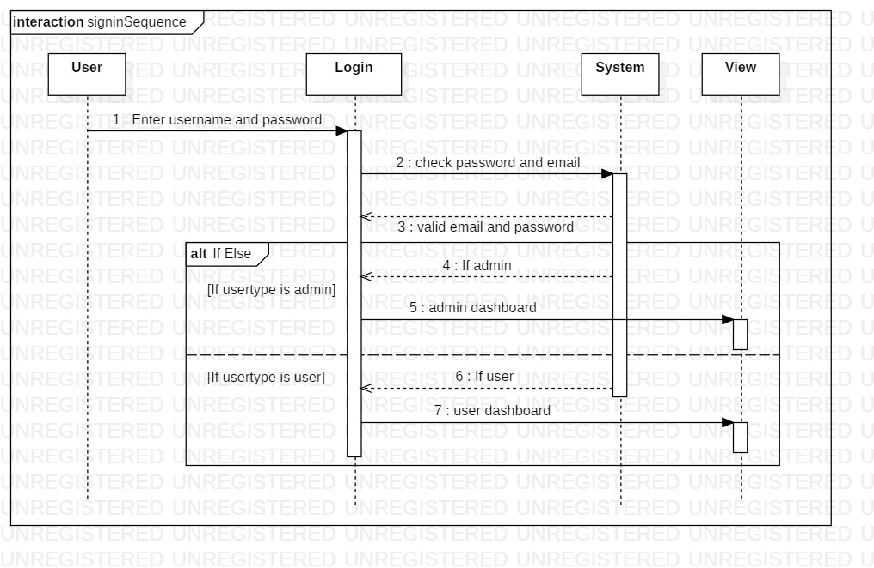

Figure 7: Sequence Diagram of login system

## 3.3 Database Modelling

**Database modelling (data modelling)** is the process of creating a data model for the data to be stored in a Database. This data model is a conceptual representation of Data objects, the associations between different data objects and the rules. Data modeling helps in the visual representation of data and enforces business rules, regulatory compliances, and government policies on the data. Data Models ensure consistency in naming conventions, default values, semantics, security while ensuring quality of the data. (Data Modelling, 2020)

## 3.3.1 ER Diagram

ER (Entity Relationship) diagram is a pictorial diagram illustrating the relationship between class, objects, function, etc. as per the requirement of the system and given by the client.

Importance of ER diagram:

* Object and attributes can be determined.
* Show the relation with one entity to another.
* It shows the number of relations implemented in the entity.

Table 9: ER Diagram

## 3.3.2 Data Dictionary

It is a set of data and information which contains metadata such as table name, column name, attributes, and related information.

|  |  |
| --- | --- |
| **S.N** | **Table Name** |
| 1 | Admin Table |
| 2 | Customer Table |
| 3 | Product Table |
| 4 | Order Table |
| 5 | Shopping Cart Table |
| 6 | Order Details Table |
| 7 | Cart Item Table |

Table 10: Table Names

Admin Table

|  |  |  |  |  |
| --- | --- | --- | --- | --- |
| Column Name | Type | Length | Nullable | Key |
| ID | Int | 10 | Not nullable | Primary Key |
| First_name | Varchar | 255 | Not nullable |  |
| Last_name | Varchar | 255 | Not nullable |  |
| Email | Varchar | 255 | Not nullable |  |
| Password | Varchar | 100 | Not nullable |  |

Table 11: Table Names

Table 12: Data Dictionary

## 3.4 UI Modelling

The process of developing front end layout of the website or an application before implementing in the back end of the system is called UI (User Interface) modeling. UI is very important nowadays as every people trust in a friendly user interface which help them to use it in an easy and smooth order. As my project is a website it is the key component of the project. Here, I have designed my layout in an external application called Balsamic.

## 3.4.1 Prototyping

Prototype is rough sketch of the layout of the front end design of any application or a website to sort out future problems. It helps to show the client how the system work in a user interface module.

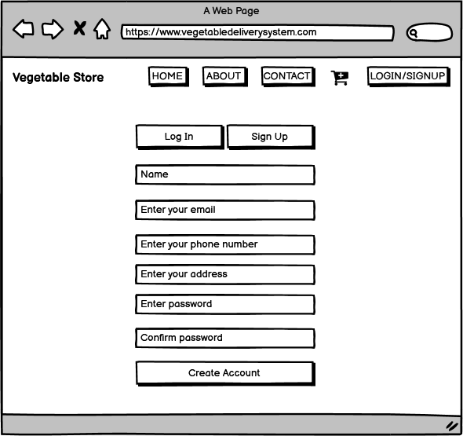

Figure 6: Registration Form

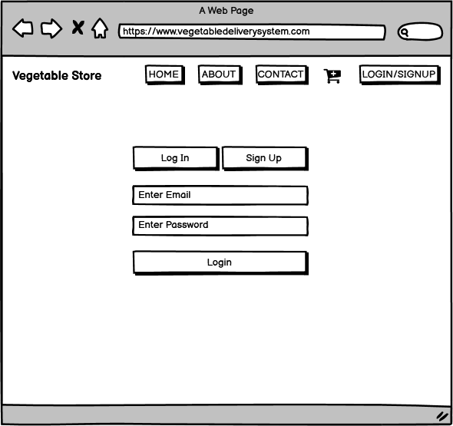

Figure 7: Login Form

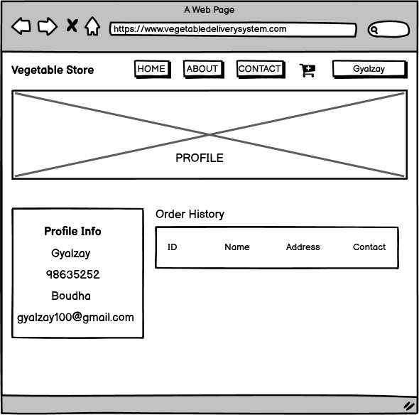

Figure 8: User's Profile

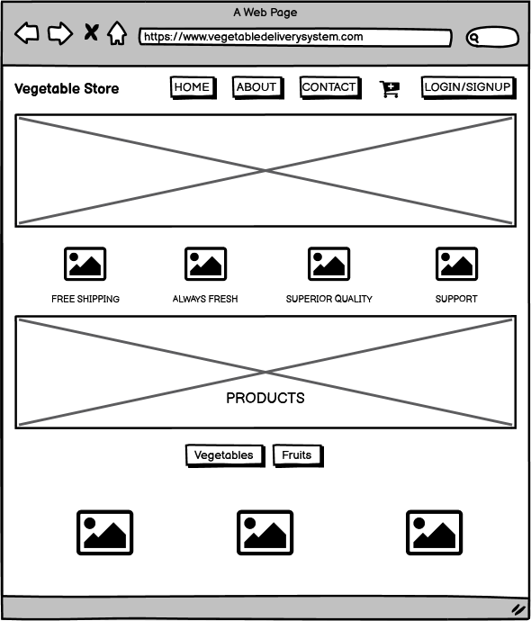

Figure 9: User’s Homepage

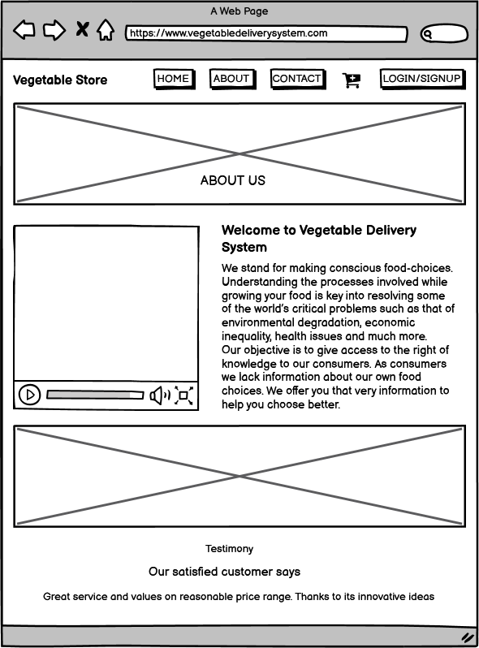

Figure 10: About Us

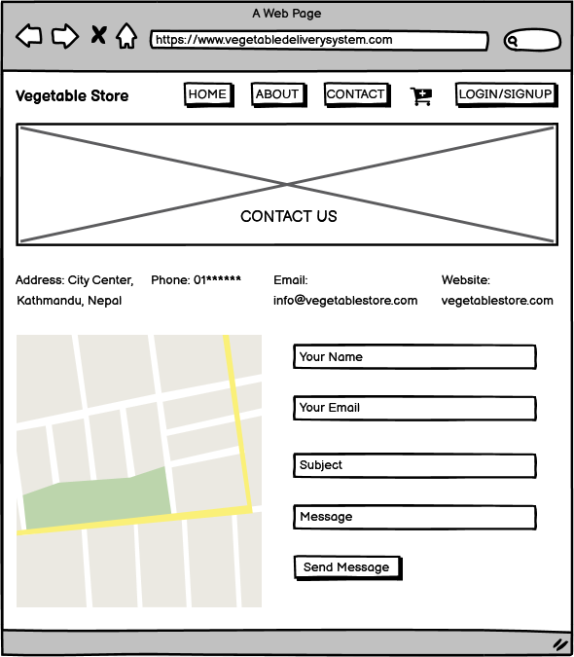

Figure 11: Contact Page

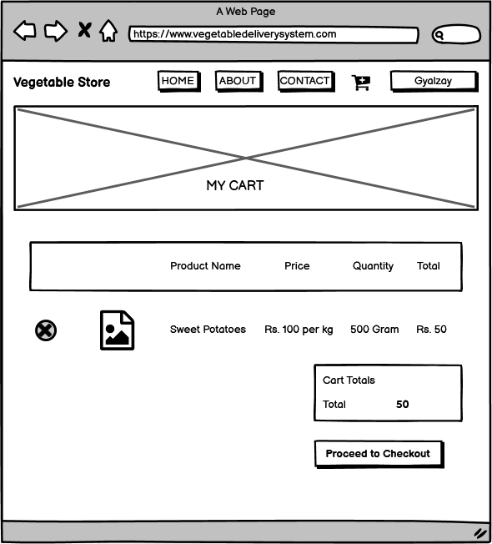

Figure 12: Cart Details

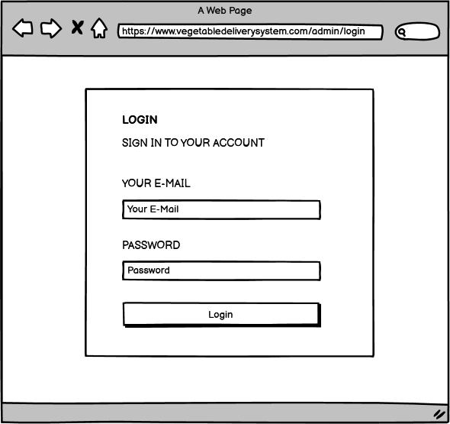

Figure 13: Admin Login Page

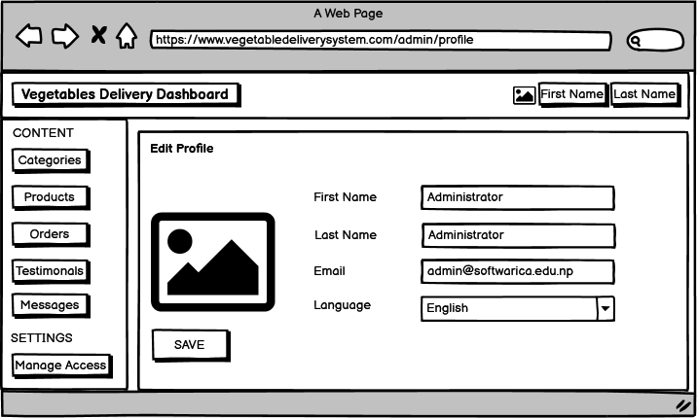

Figure 14:Admin Profile

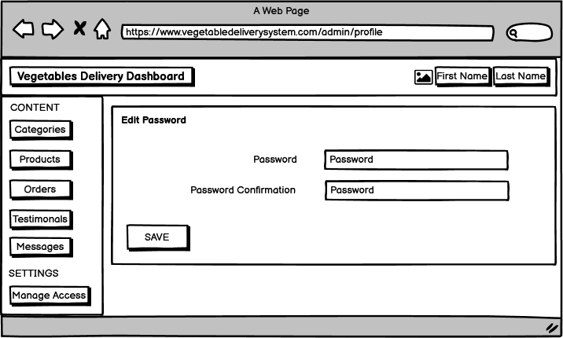

Figure 15: Admin Password Change

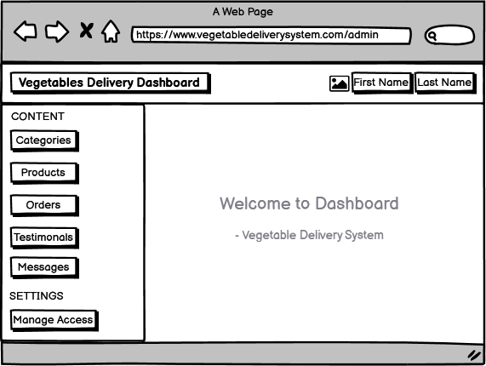

Figure 16: Admin Dashboard

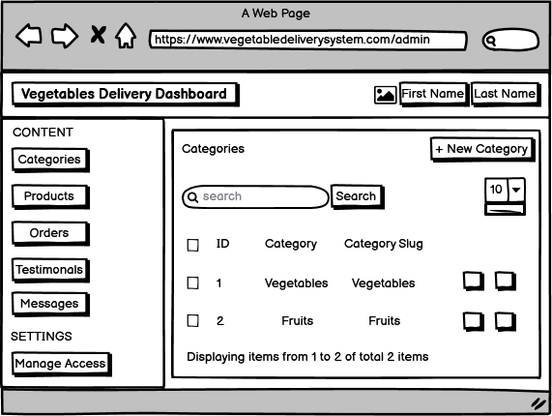

Figure 17: Manage Category

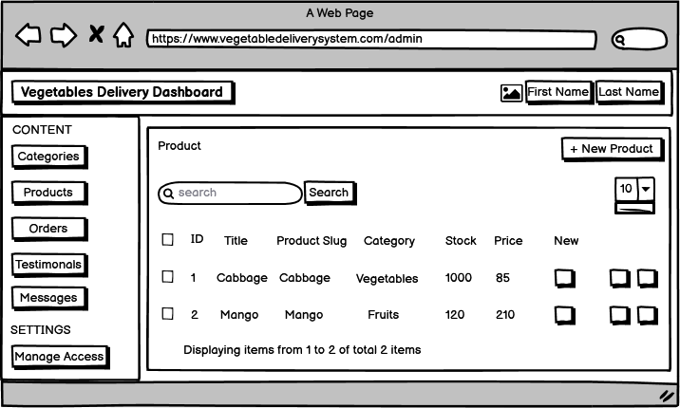

Figure 18: Manage Products

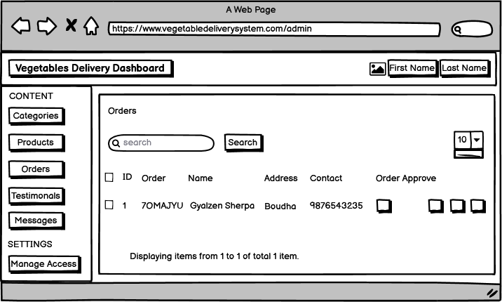

Figure 19: Manage Orders

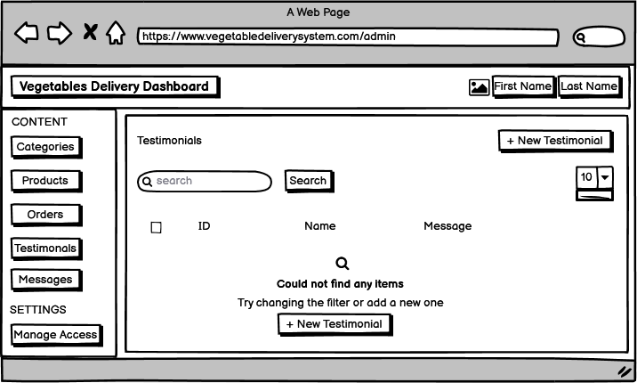

Figure 20: Manage Testimonials

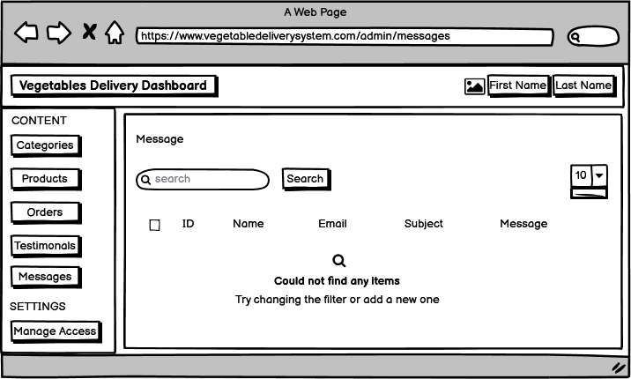

Figure 21: Manage Messages

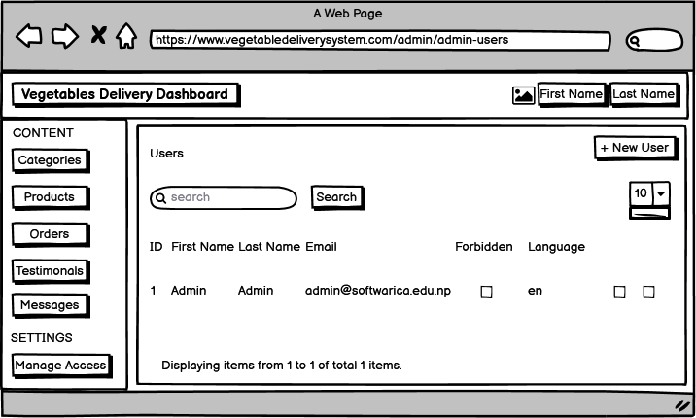

Figure 22: Manage Access

# Chapter 4: Implementation

## Introduction

In this stage, all the information gathered before in the previous stages are implemented. We implement all the function for the project to be developed. We start the implementation process by creating the site from the back end of the topic.

## Tools used for project

Online vegetables and fruits is a web based application where users can buy fresh vegetables and fruits which can be delivered at their home if preferred. To make this project, I have used PHP language, Javascript, HTML, CSS, jQuery. And the framework used to make the website is Laravel. For the database I have used MySQL and for the server I have used Xampp a cross platform application which enables Apache server and database functionality.

## Development Environment

Integrated Development Environment (IDE)

The code editor used to develop this website is Visual Studio Code. Visual Studio Code is refined and optimized for building and debugging modern web and cloud applications.

Development platforms

I have windows 10 on my computer system. It has 64-bit operating system, x64-based processor, 8GB RAM

## Conclusion

The proper implementation of the system is done with the help of the analysis and design methods in the earlier section. To avoid some problems in the future a proper testing of the application will be done in the next section.

# Chapter 5: Testing

## Testing

Software testing is a process to evaluate the functionality of a software application with an intent to find whether the developed software/application met the specified requirements or not and to identify the defects to ensure that the product is defect-free in order to produce the quality product. (Software testing, 2020) For my project, I have used black box and white box testing.

Unit Testing (White Box Testing)

Unit Testing or White Box Testing refers to a kind of testing where individual units or components of a software are tested. (Unit Testing Tutorial, 2020) Unit Testing is done to validate that every unit of the software code performs as expected.

Black Box Testing

Black Box Testing is a software testing method where all the functionalities of the software applications are tested. During the test there is no proper knowledge of the internal code structure, details of the implementations, and the internal parts of the software system. Black Box Testing mainly emphasizes on the input and the output of the system. (Black Box Testing, 2020)

|  |  |  |  |
| --- | --- | --- | --- |
| Case Name | Data Passed | Expected | Result |
| BBT1 | Invalid | Fail | Fail |

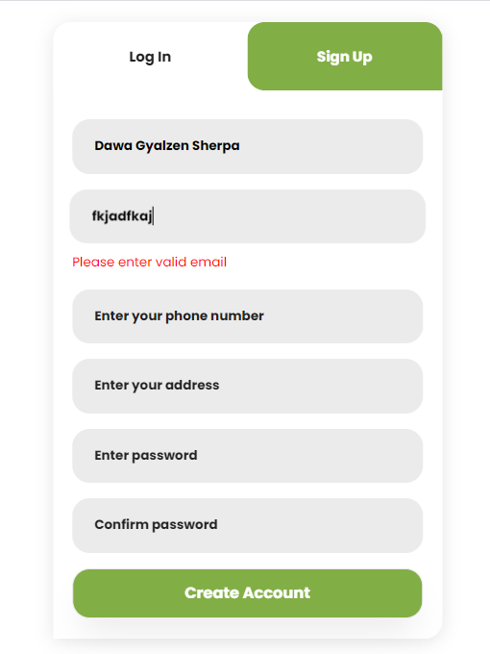

Figure 23: Validation

|  |  |  |  |
| --- | --- | --- | --- |
| Case Name | Data Passed | Expected | Result |
| BBT2 | Valid | Pass | Pass |

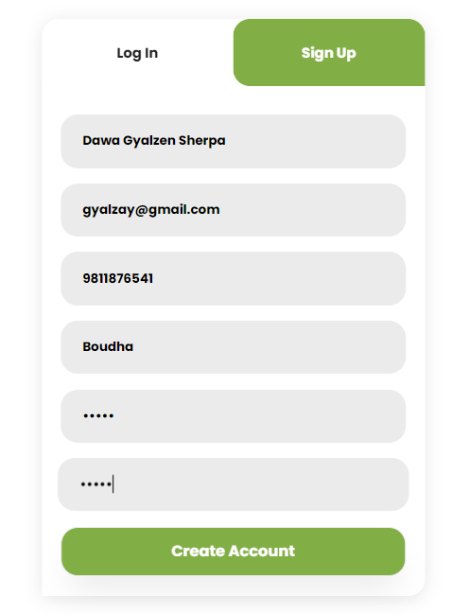

Figure 24: Valid Details

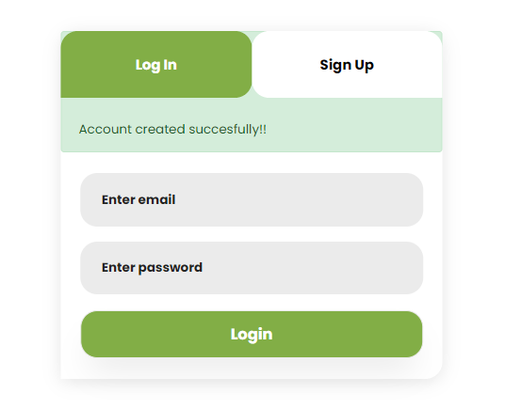

Figure 25: Account Created Successfully

|  |  |  |  |
| --- | --- | --- | --- |
| Case Name | Data Passed | Expected | Result |
| BBT3 | Valid Info | Successful Login | Pass |

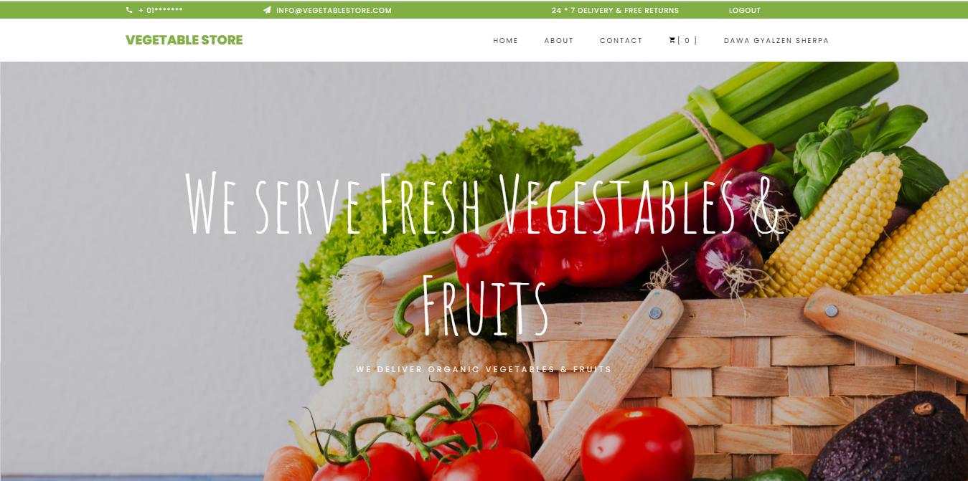

Figure 26: Successful Login

|  |  |  |  |
| --- | --- | --- | --- |
| Case Name | Data Passed | Expected | Result |
| BBT4 | Invalid Info | Successful Login | Fail |

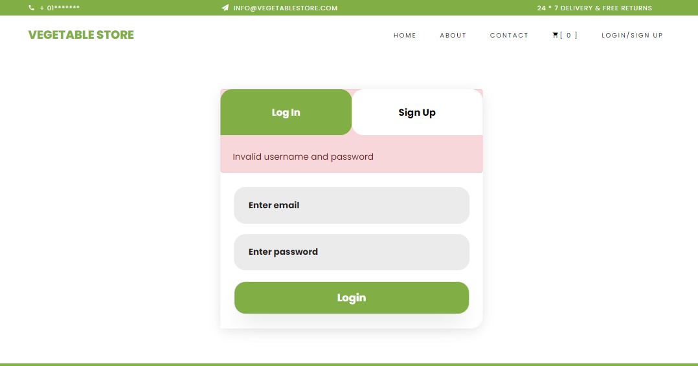

Figure 27: Invalid Login

|  |  |  |  |
| --- | --- | --- | --- |
| Case Name | Data Passed | Expected | Result |
| BBT5 | Invalid Info of Admin | Successful Login | Fail |

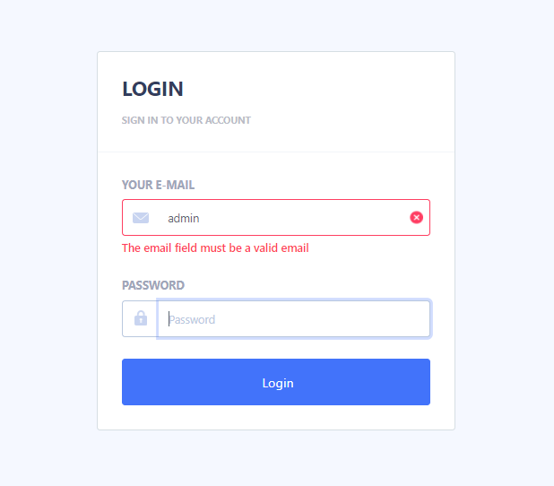

Figure 28: Admin Login Validation

|  |  |  |  |
| --- | --- | --- | --- |
| Case Name | Data Passed | Expected | Result |
| BBT6 | Valid Info of Admin | Successful Login | Pass |

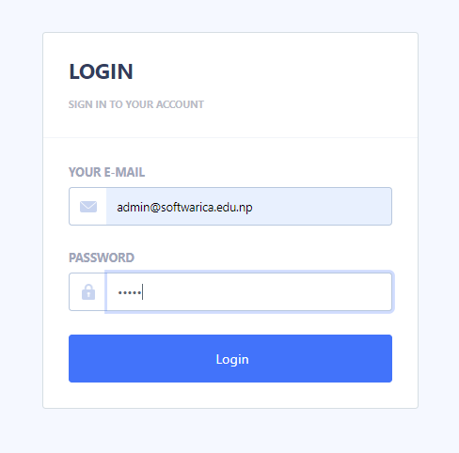

Figure 29: Valid Info of Admin

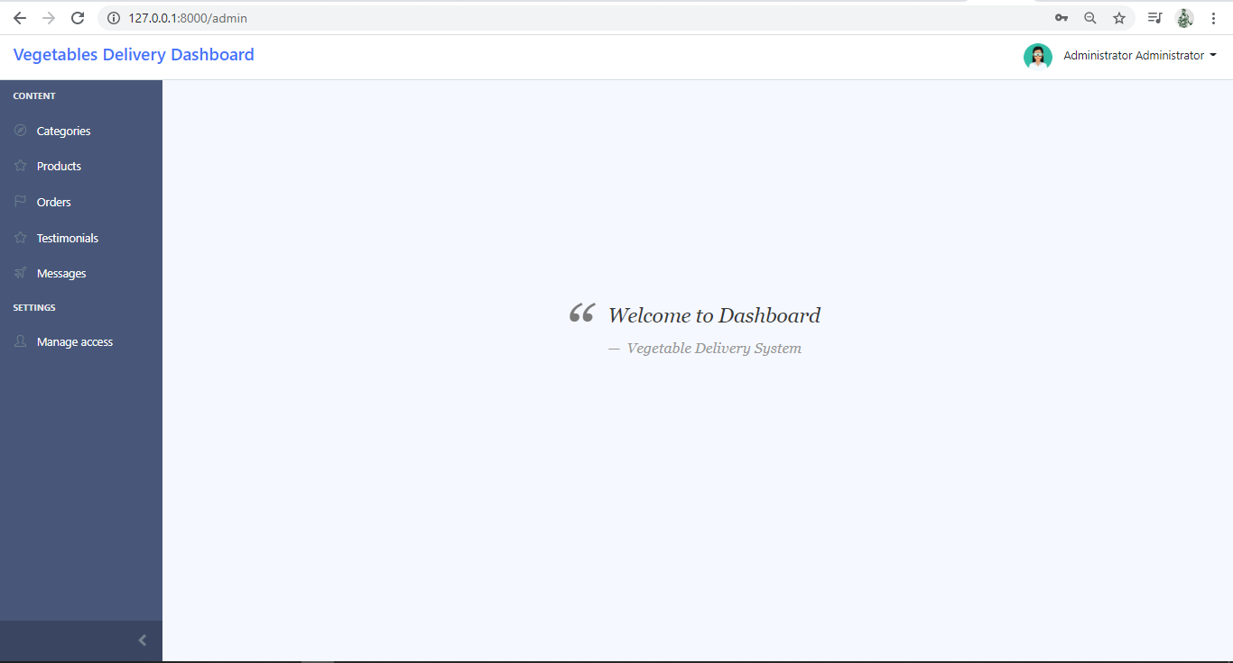

Figure 30: Admin Login Successful

|  |  |  |  |
| --- | --- | --- | --- |
| Case Name | Data Passed | Expected | Result |
| BBT7 | Add to Cart | Successful | Pass |

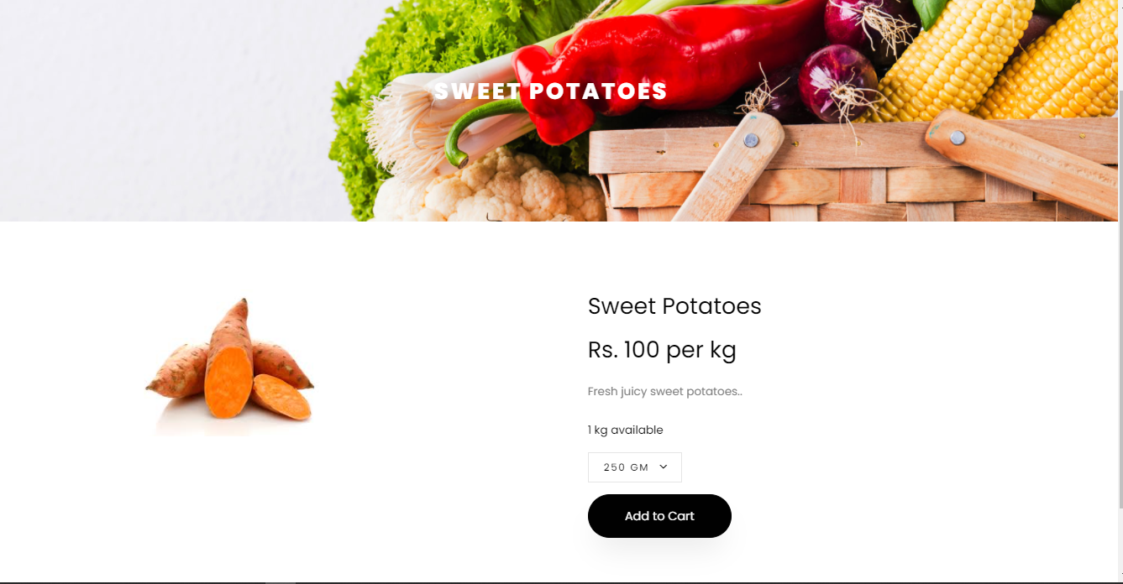

Figure 31: Add to Cart

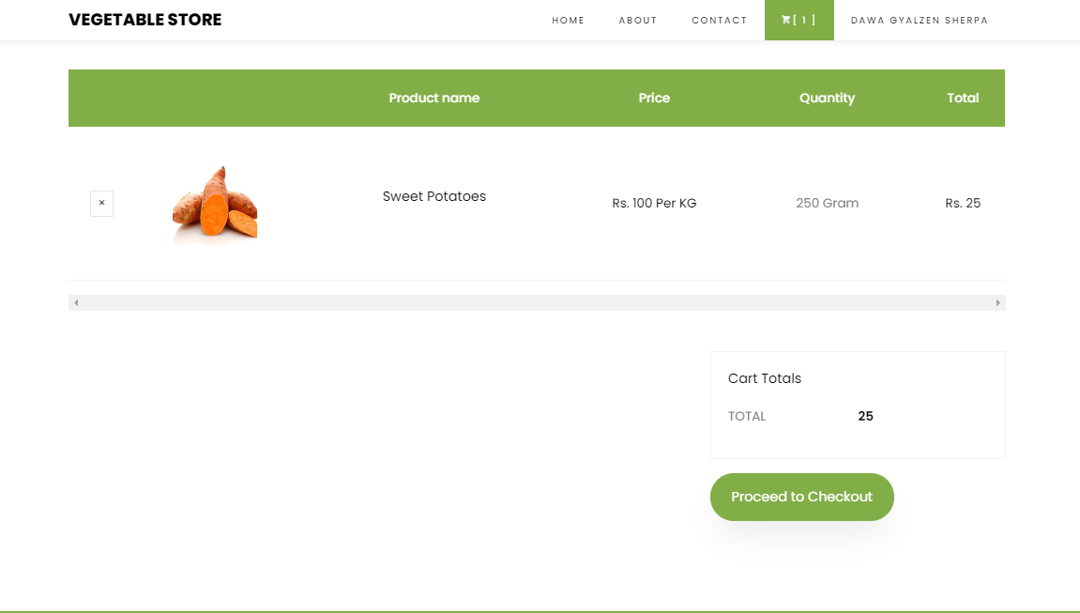

Figure 32: Add to Cart Successful

|  |  |  |  |
| --- | --- | --- | --- |
| Case Name | Data Passed | Expected | Result |
| BBT8 | Checkout | Successful | Pass |

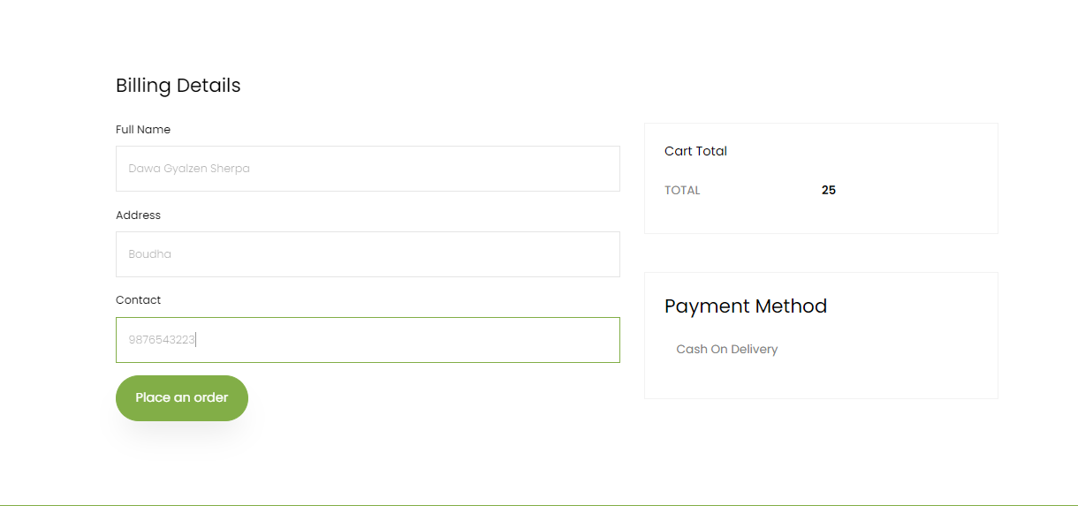

Figure 33: Checkout

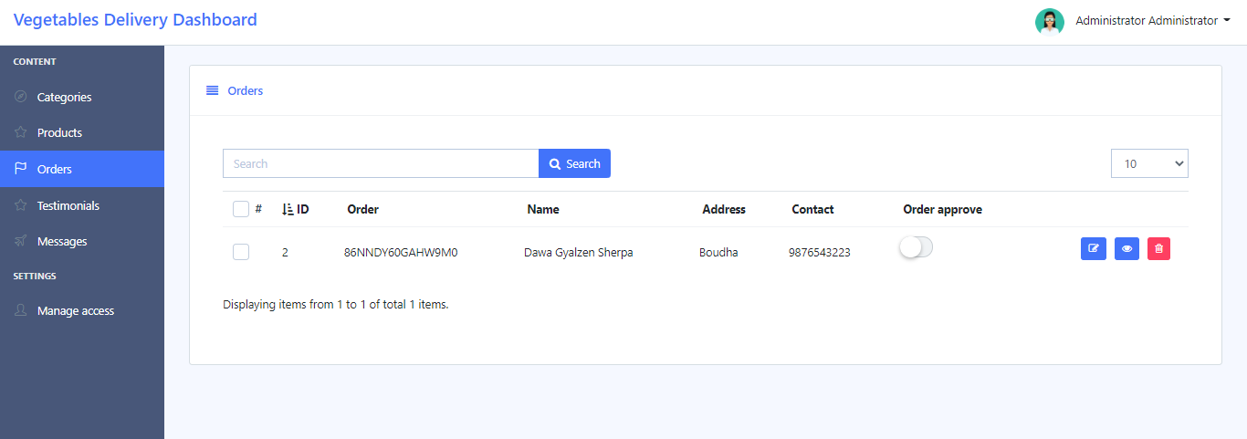

Figure 34: Checkout Order Successful

|  |  |  |  |
| --- | --- | --- | --- |
| Case Name | Data Passed | Expected | Result |
| BBT9 | Message to Admin | Successful | Pass |

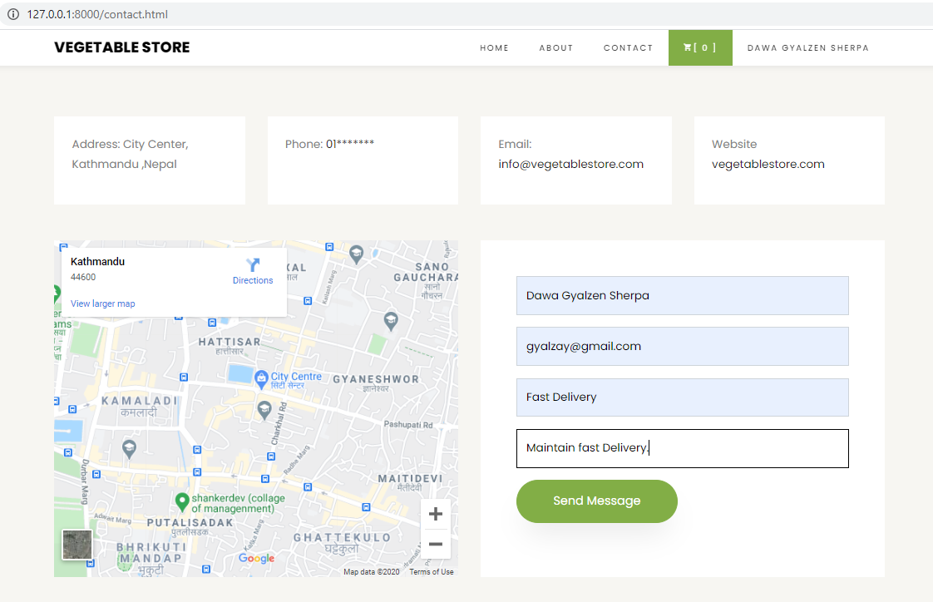

Figure 35: Message to Admin

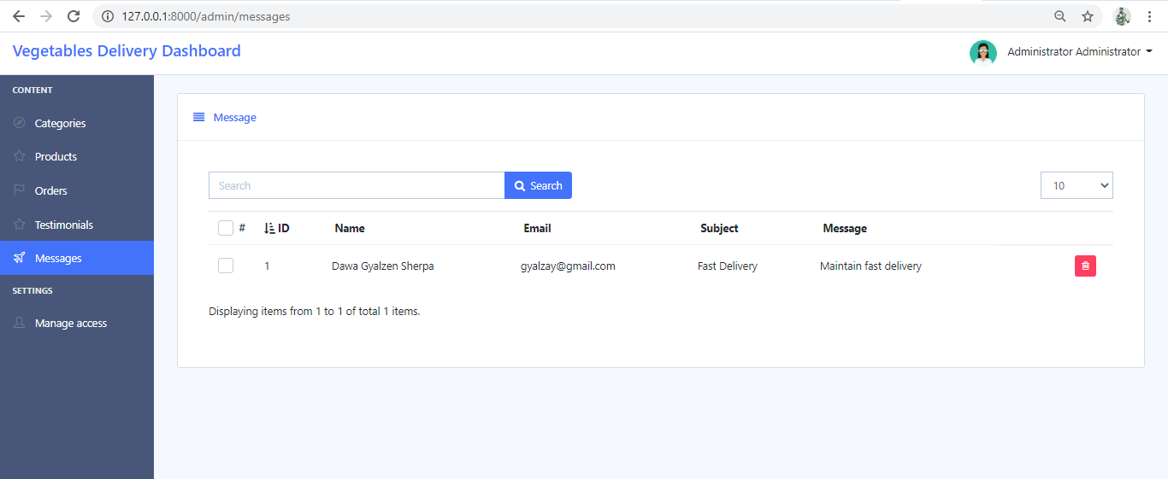

Figure 36: Message from Users

|  |  |  |  |
| --- | --- | --- | --- |
| Case Name | Data Passed | Expected | Result |
| BBT10 | Adding Product | Added successful | Pass |

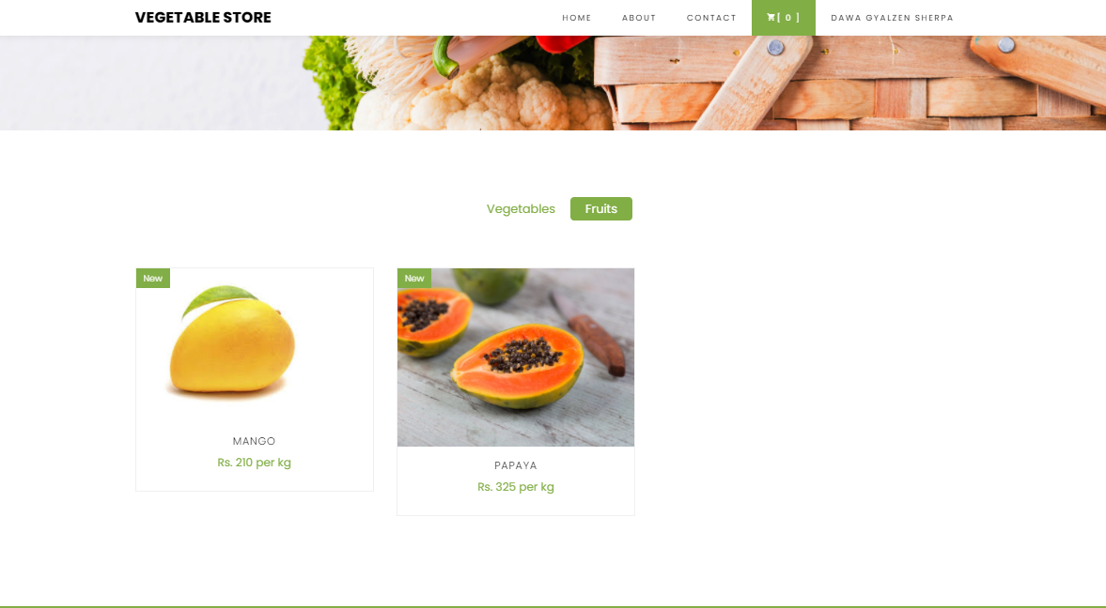

Figure 37: Before Updating Products

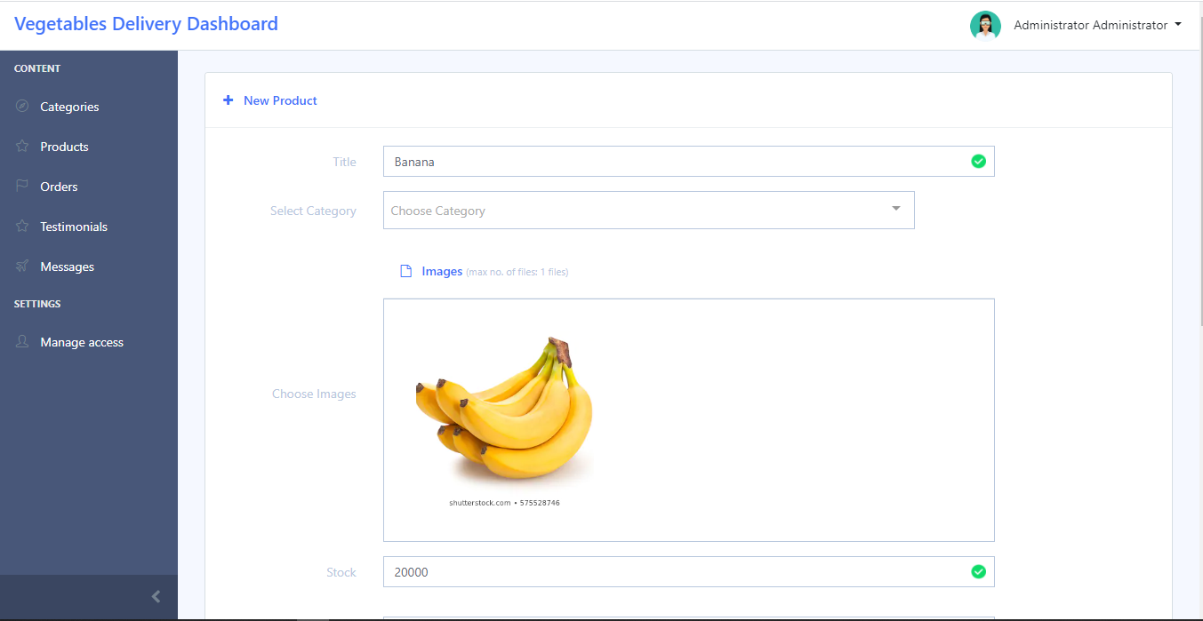

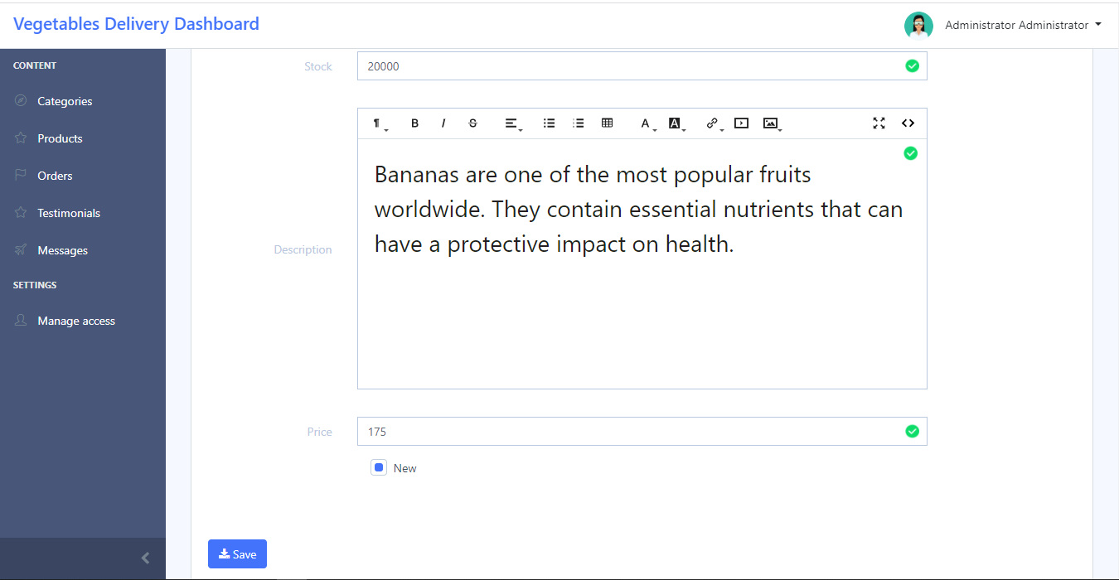

Figure 38: Adding Product by Admin

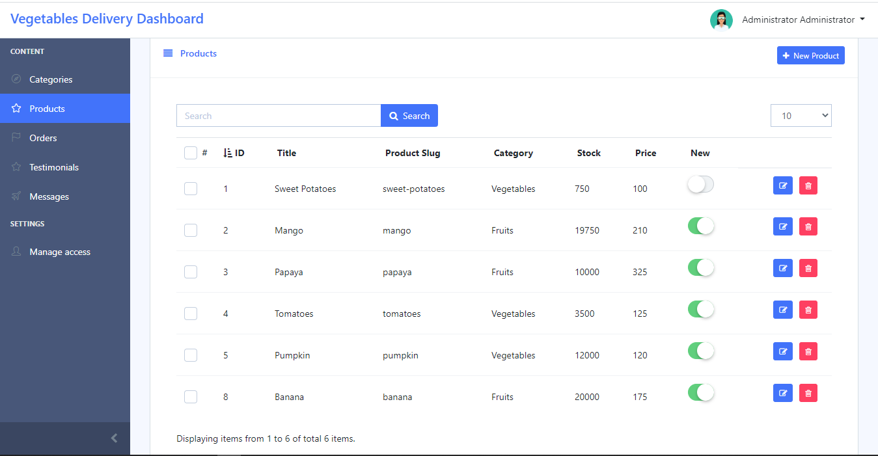

Figure 39: Product Added On Product Details

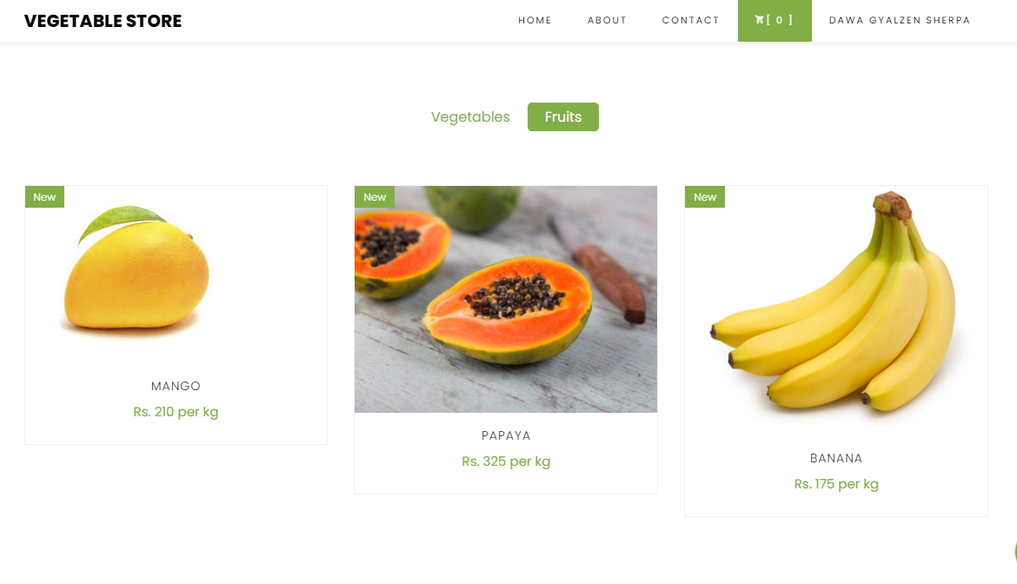

Figure 40: Updated Products

Identification of Risk

Risk management is the operation of controlling, identifying and evaluating risks to the application or program. These risks can damage the organization’s data, information, prestige, etc. Nowadays, people are more concerned about their personal data and billing details. Those risk impact on management, financial status and legal liabilities of the organization directly or indirectly. Risk management is usually evaluated in three areas like risk consequences, probability and affect due to risk.

Risk management table

This table evaluates the risk that may damage the program in the future days. This is to maintain the application for longer period of time with no attacks. Organization may lose their prestige, integrity, and etc. due to lack of maintenance.

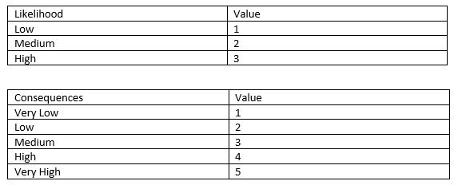

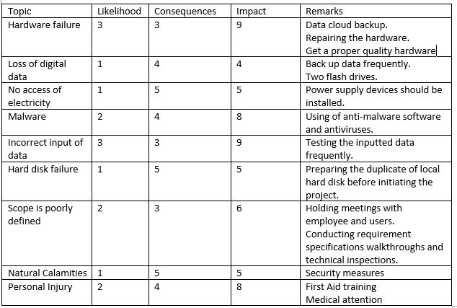

Other issues

Other issues are all the other unimplemented issues that may occur to the project due to lack of time, resources and technology. Different problems may occur even if it is not expected in the technical world.

Future Works

Many of the functions was not been able to add to the project due to lack of time and resources. Some of the features that may be added in the near future are as follows.

* Internet payment, E-banking could be implemented via various third party like PayPal in the coming days for simplicity of payment to the users.
* Various kind of time details of same course can be included.
* Search function by categorizing the classes was complicated may be useful while updating the system.

Configuration Management

It is a method for maintaining execution, cost, physical quality and plan similarly reliability in data for the life duration of the project. It also help to maintain complexity of the system.

File management of the project is effectively followed. For no threat to occur in any situation the file are manage in corporate order. It contains all the suitable document related with the organization of the system.

User training

User training is necessary to people who aren’t familiar to website an online booking. All the necessary interface are user friendly and easy to use. All the system of website are very simple made for student over 16 years so would not be a problem to book a course. If any of the user faces any difficulty they can concern to the institute itself and can help the needy. Like normal website, user can easily find booking if they are logged in. Even for the not user they can easily access register page and book a course.

Limitation

Vegetables and fruit delivery system consist of some limitation which includes online payment, inefficiency in delivering the services on proper time all 365 days, etc

# Conclusion

The project was developed to make an easy way for people to buy fresh vegetables and fruits online. And as for the farm it was developed to help sellers sell their products in a huge quantity which helps them to maximize their profit level as per their performance. The system is simple, user-friendly which requires user to register to the system and can have access to the system by simply login to the system.

The system will function efficiently since it has been developed under the Laravel framework. The main ambition of the project was to help sellers to sell their products online and buyers to buy products as per their needs.

# Appendix

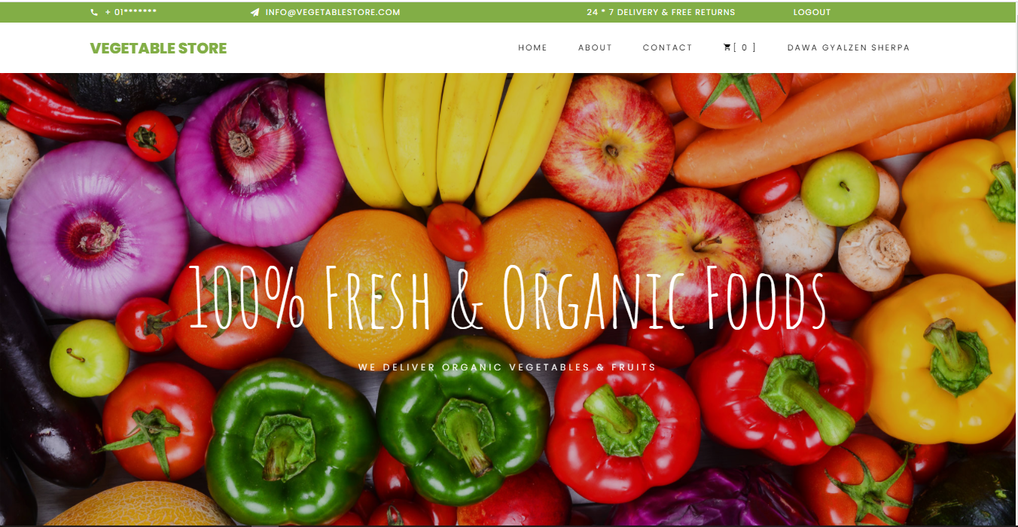

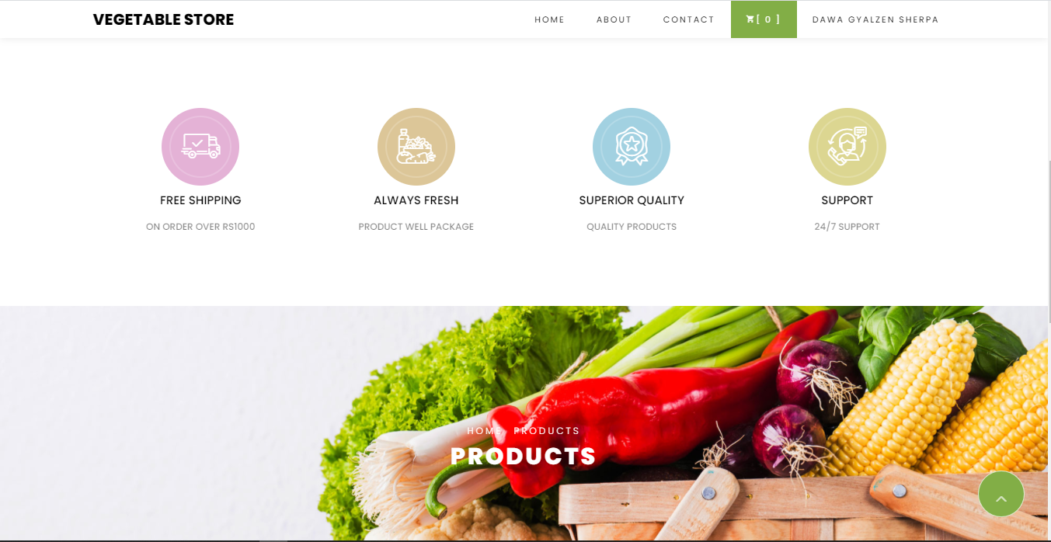

Figure 41: Home Page

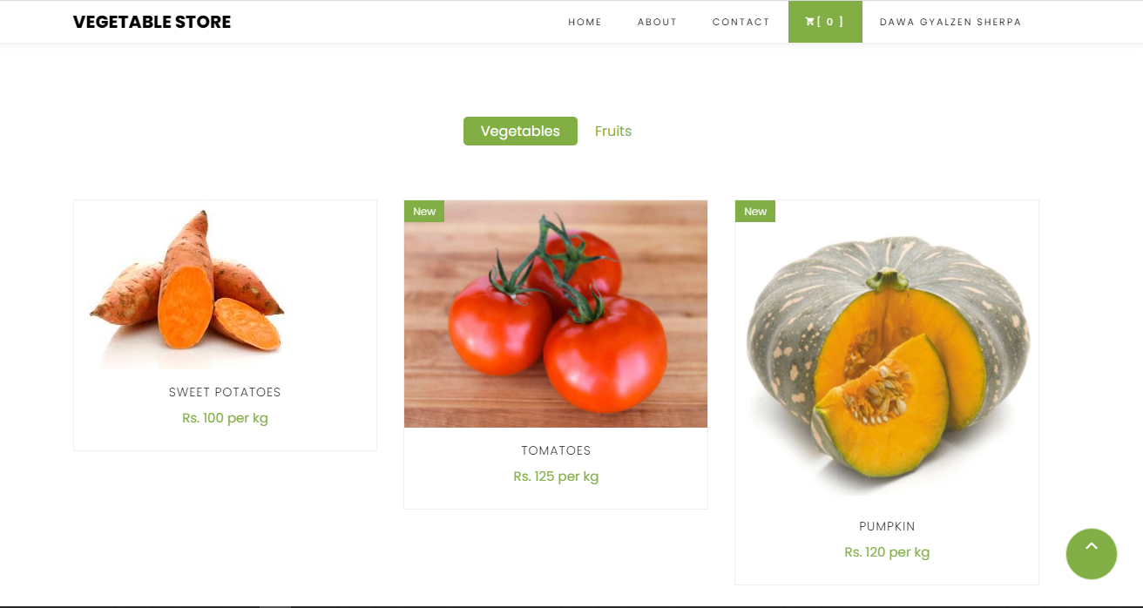

Figure 42: Products Page

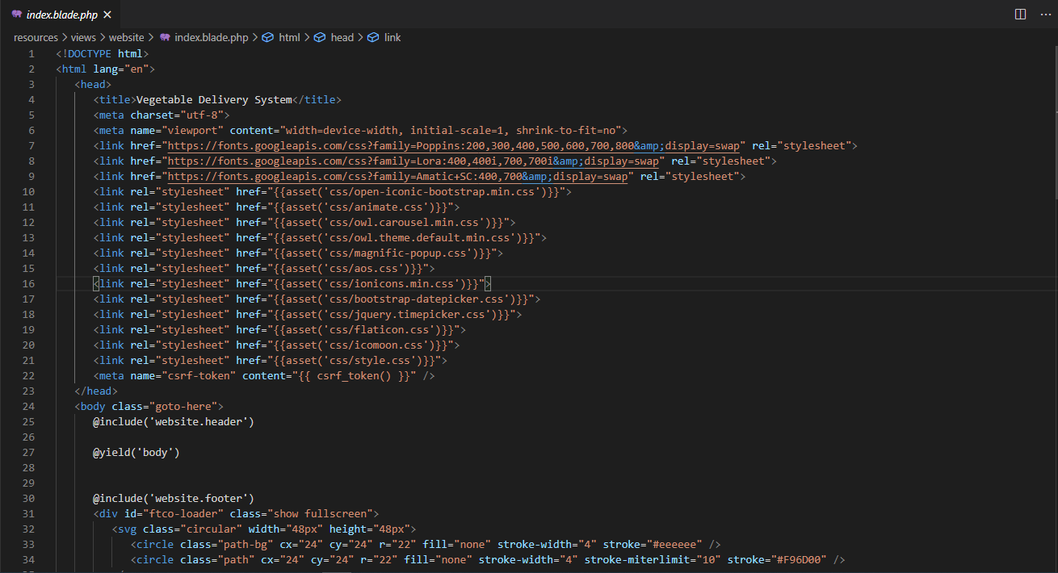

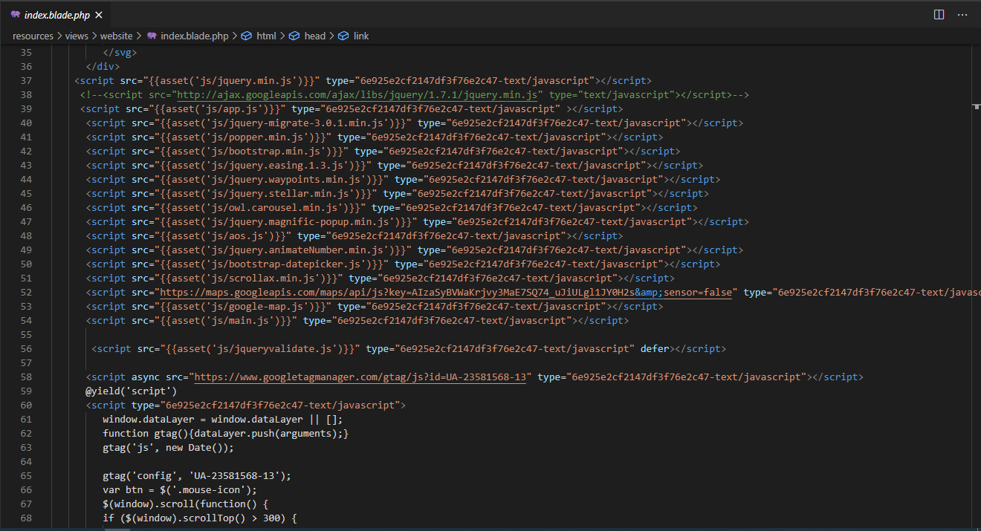

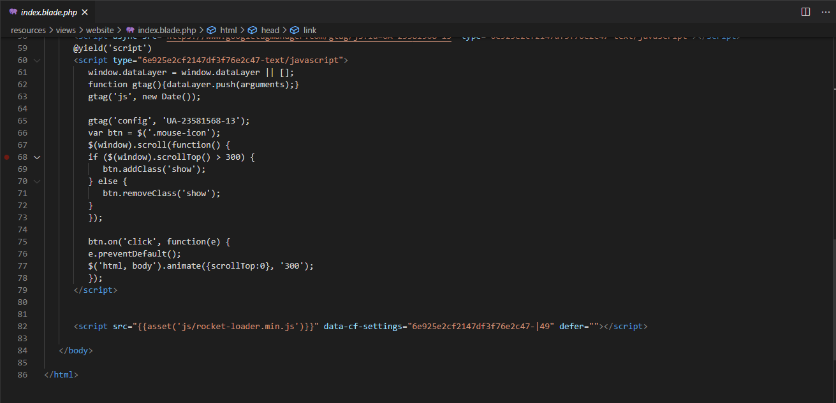

Figure 43: Index.php

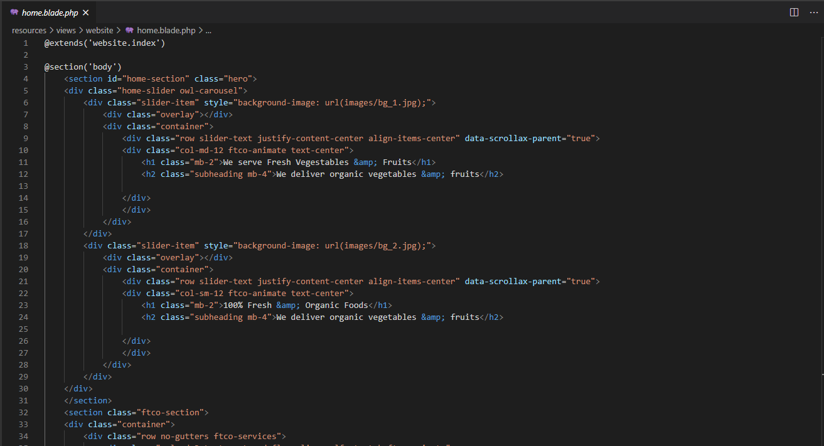

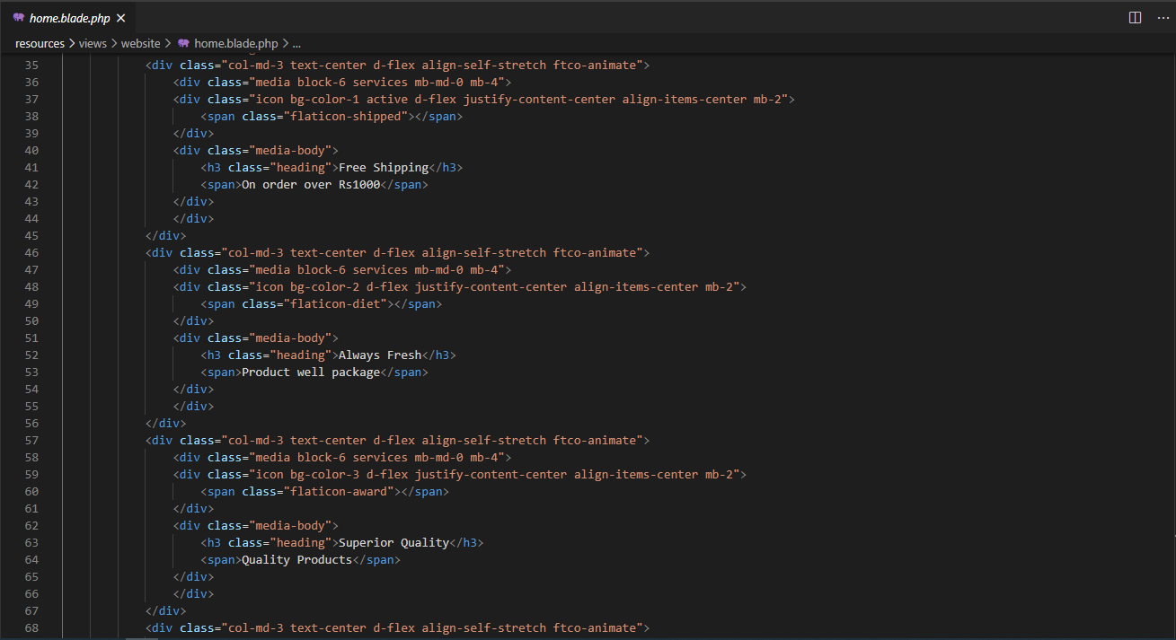

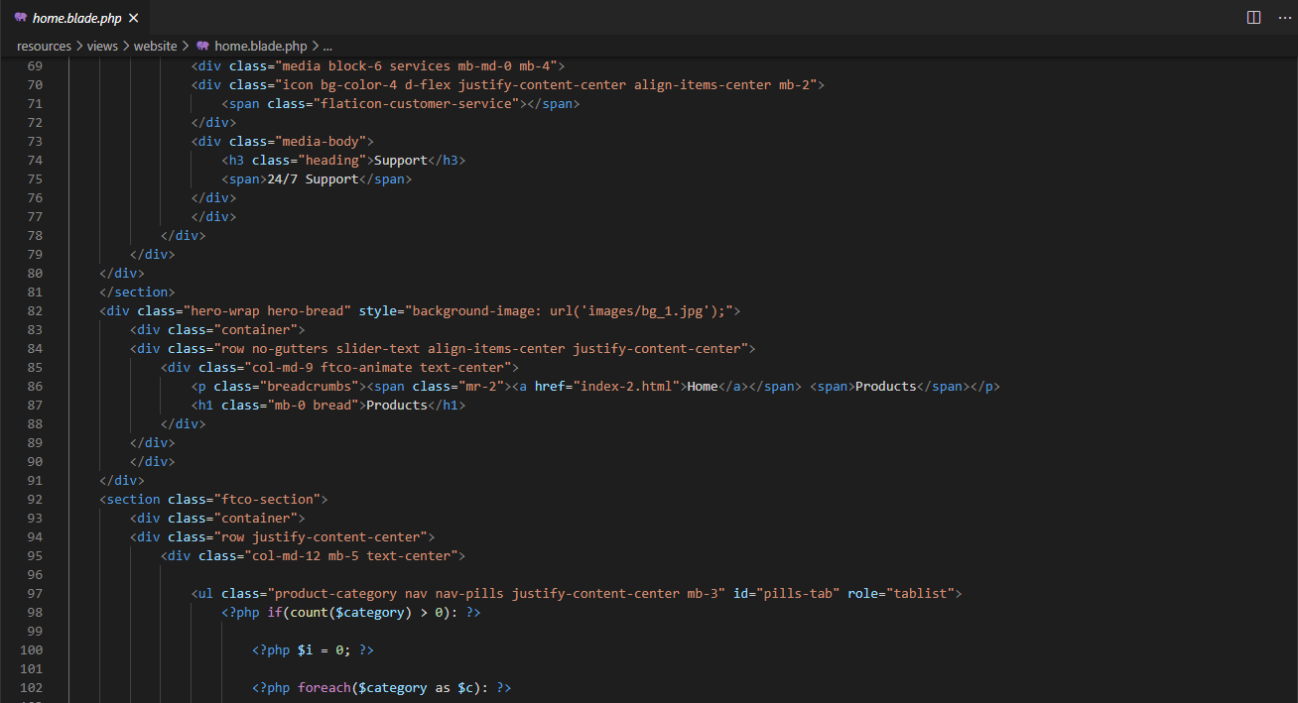

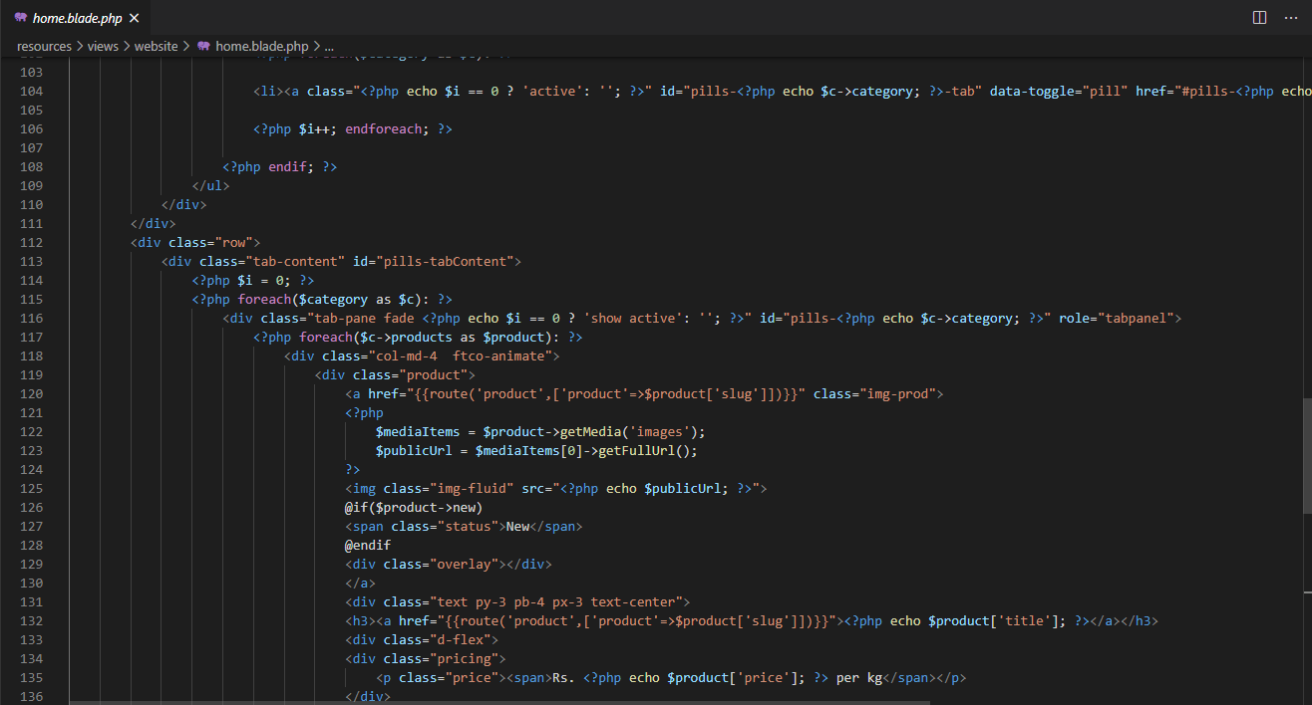

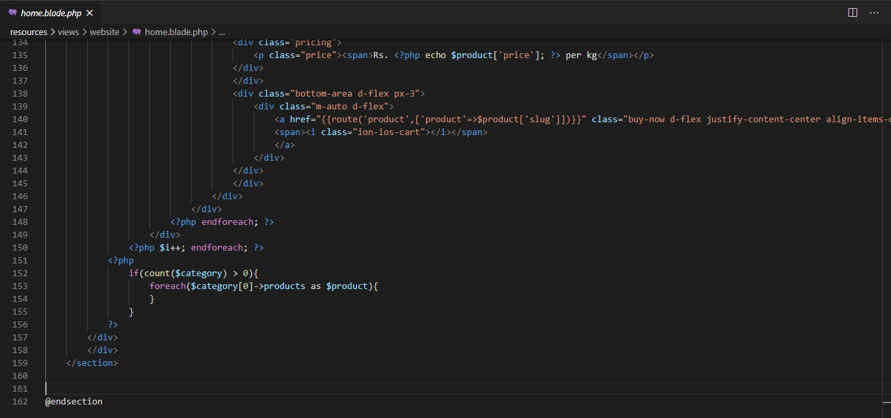

Figure 44: Home.php

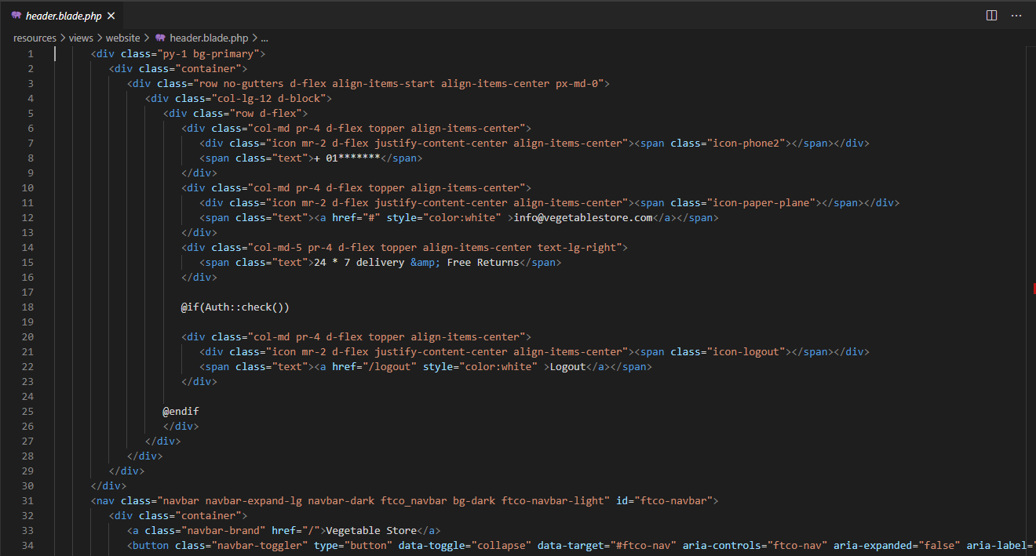

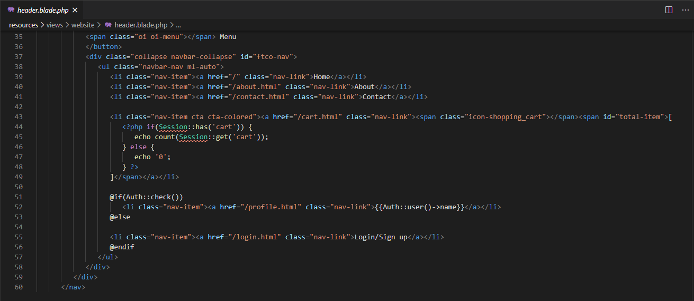

Figure 45: Header.php

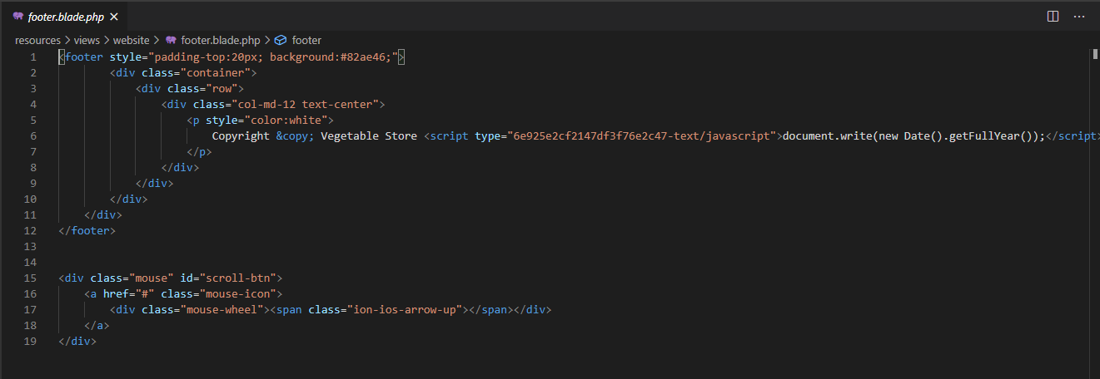

Figure 46: Footer.php

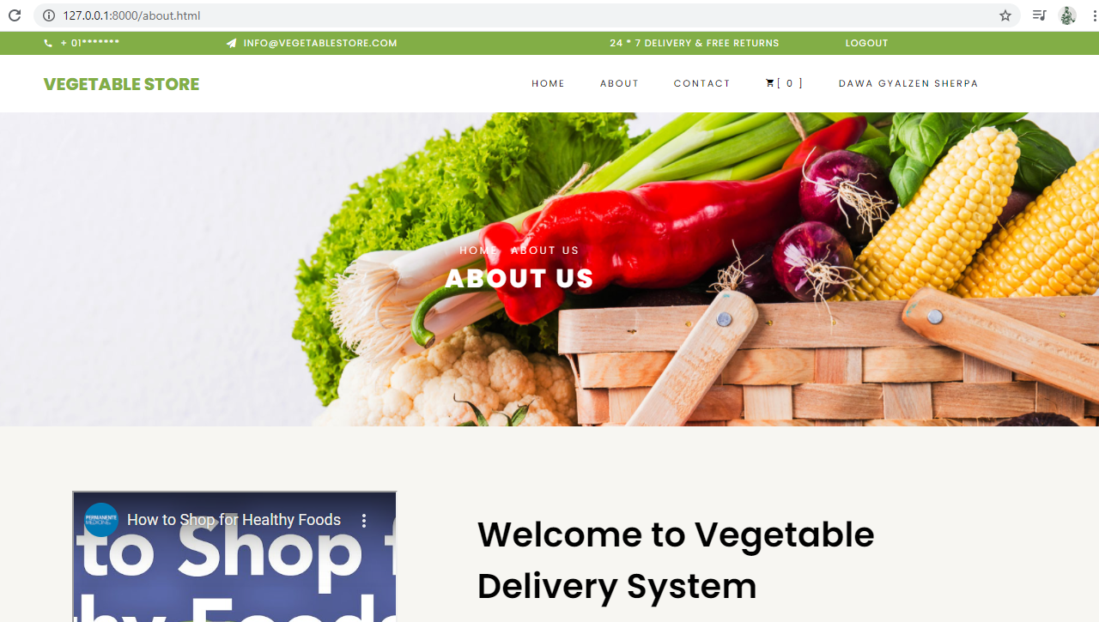

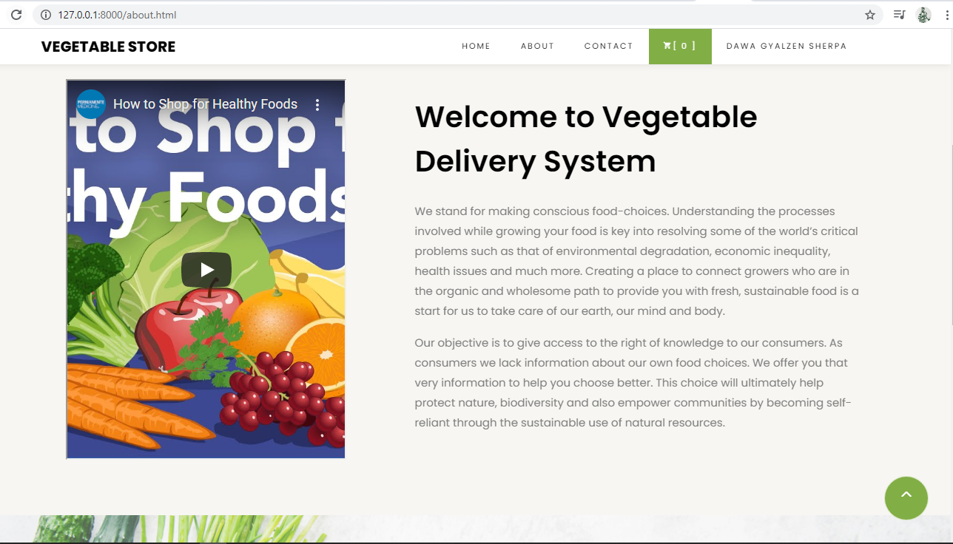

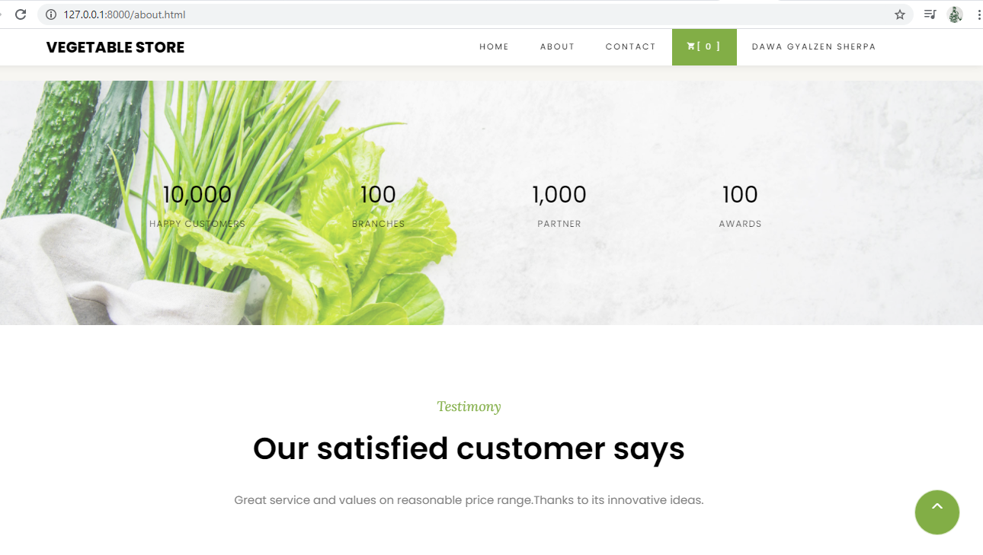

Figure 47: About Page

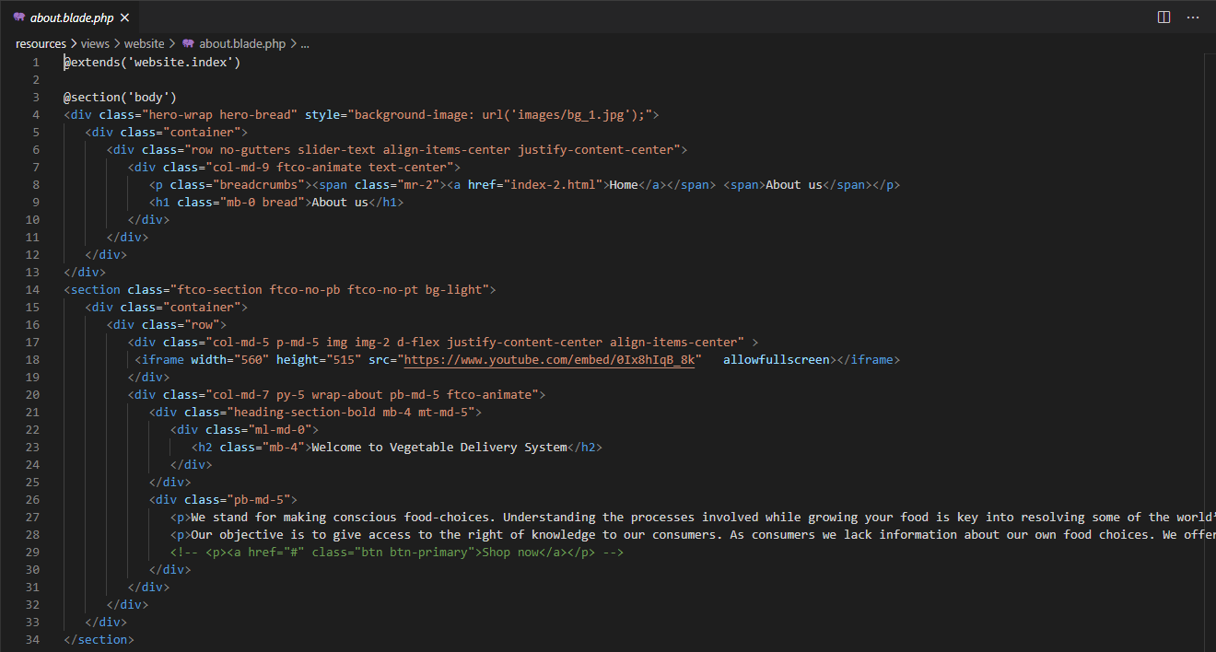

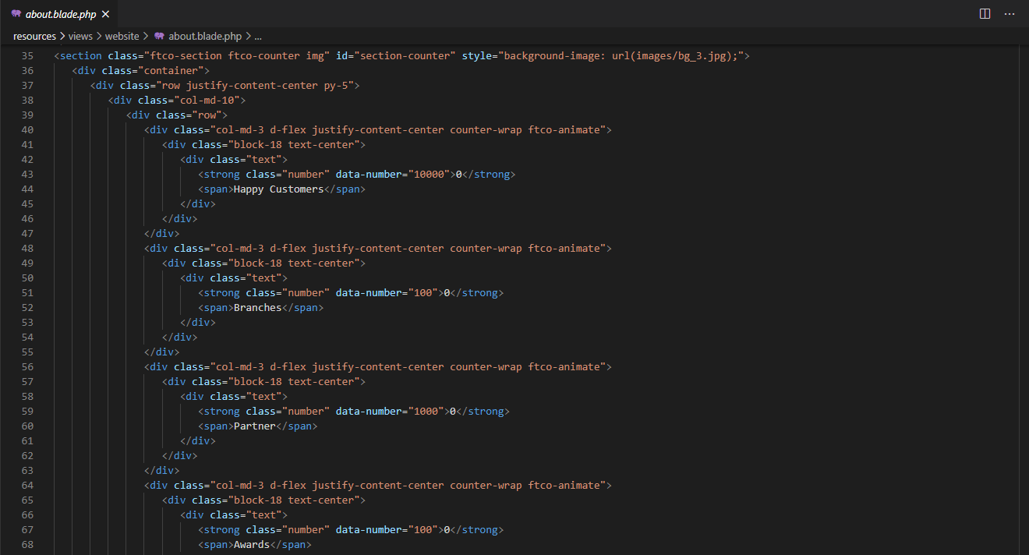

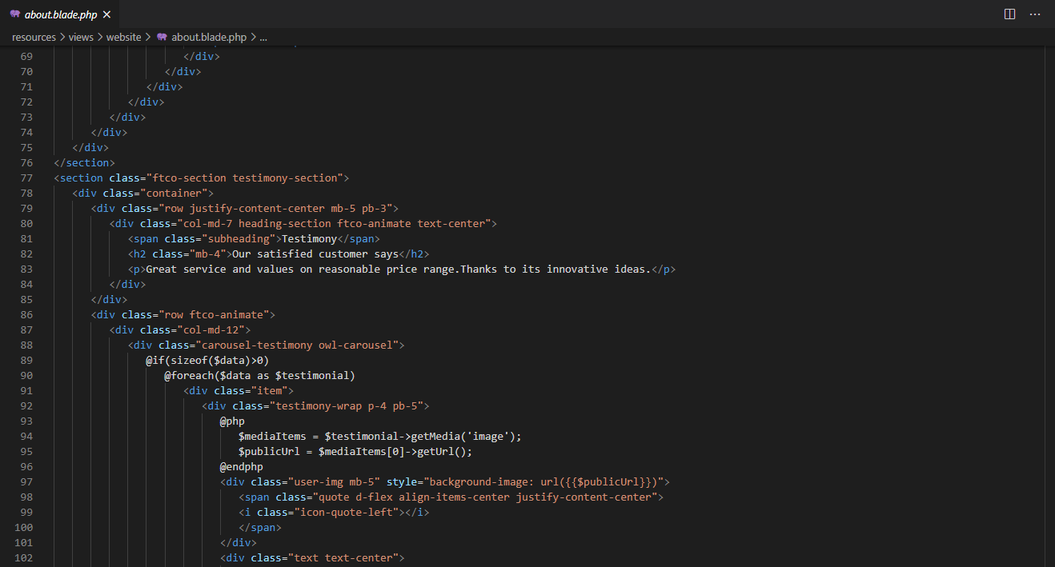

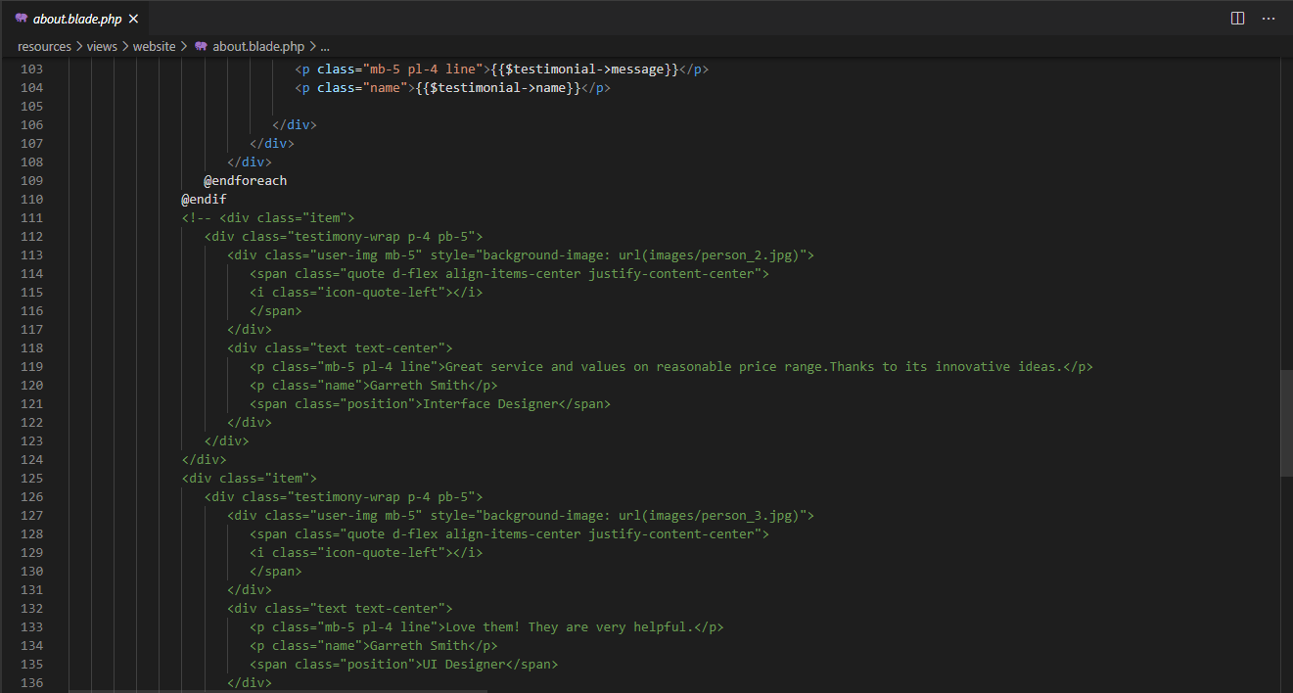

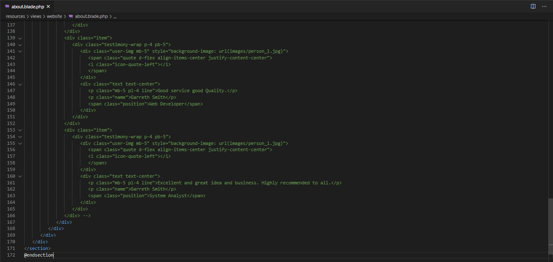

Figure 48: About.php

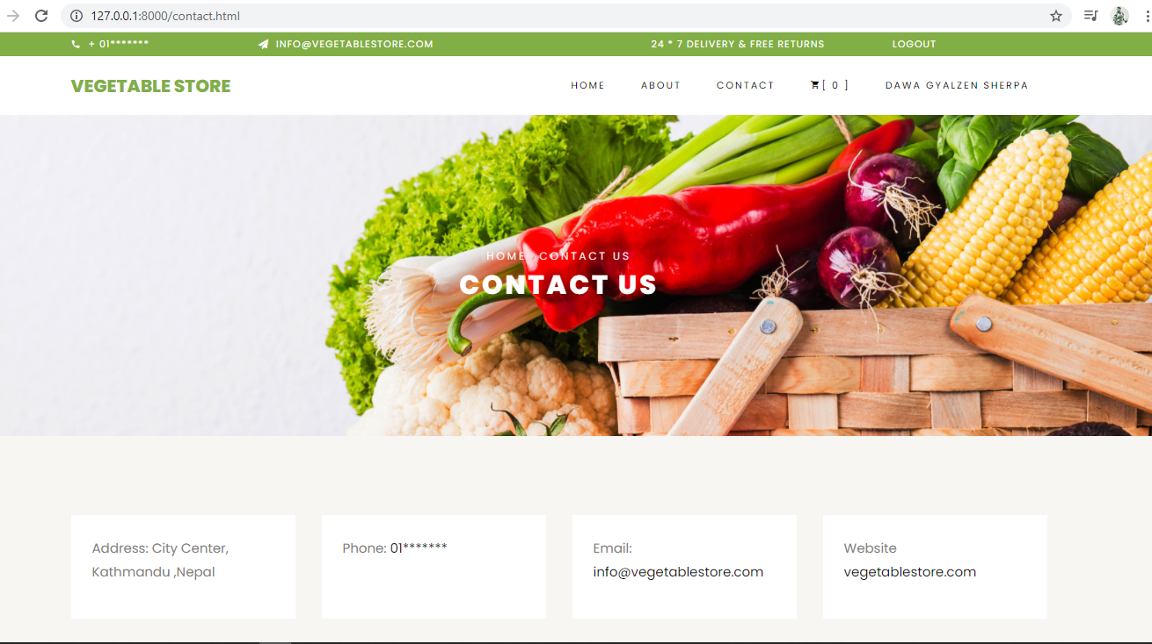

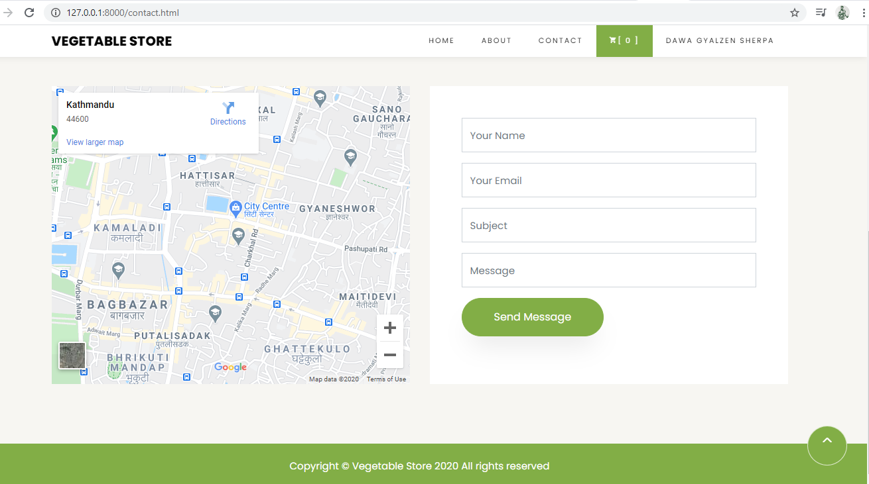

Figure 49: Contact Page

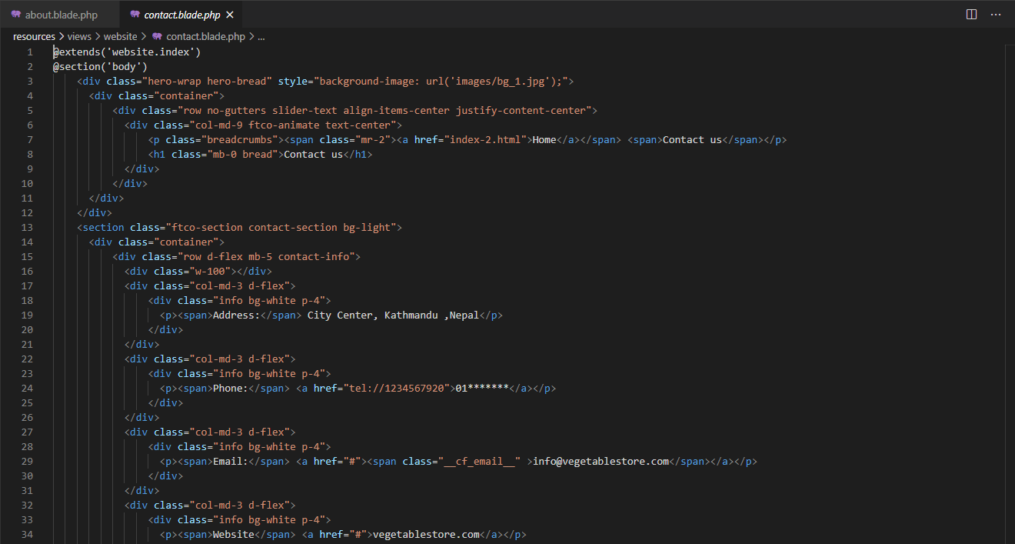

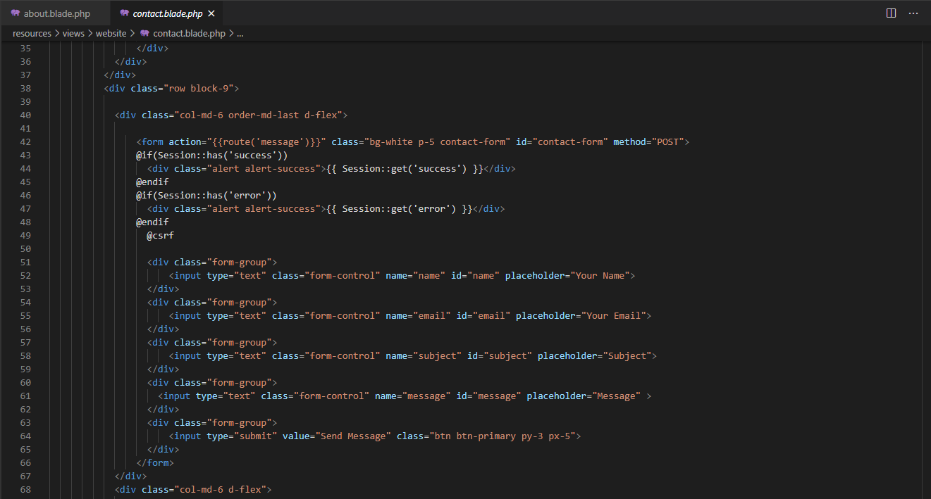

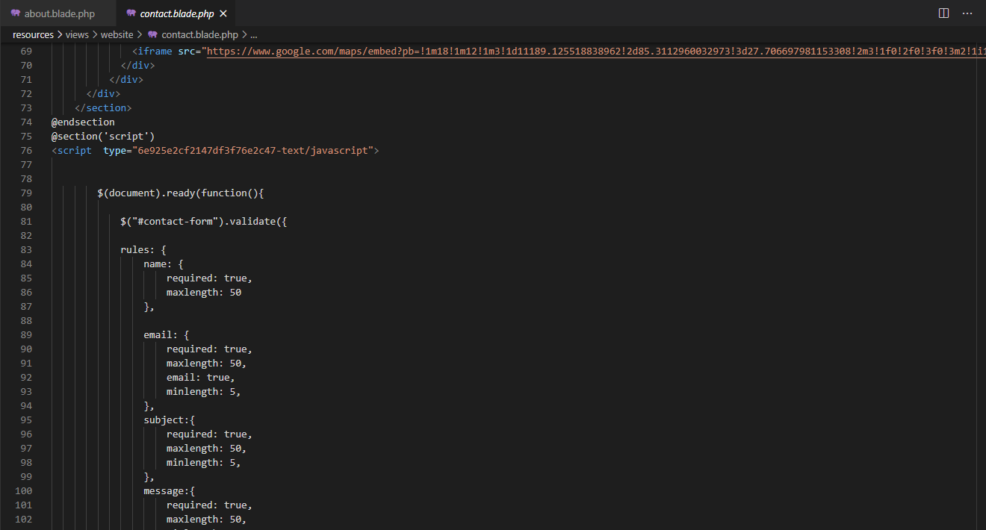

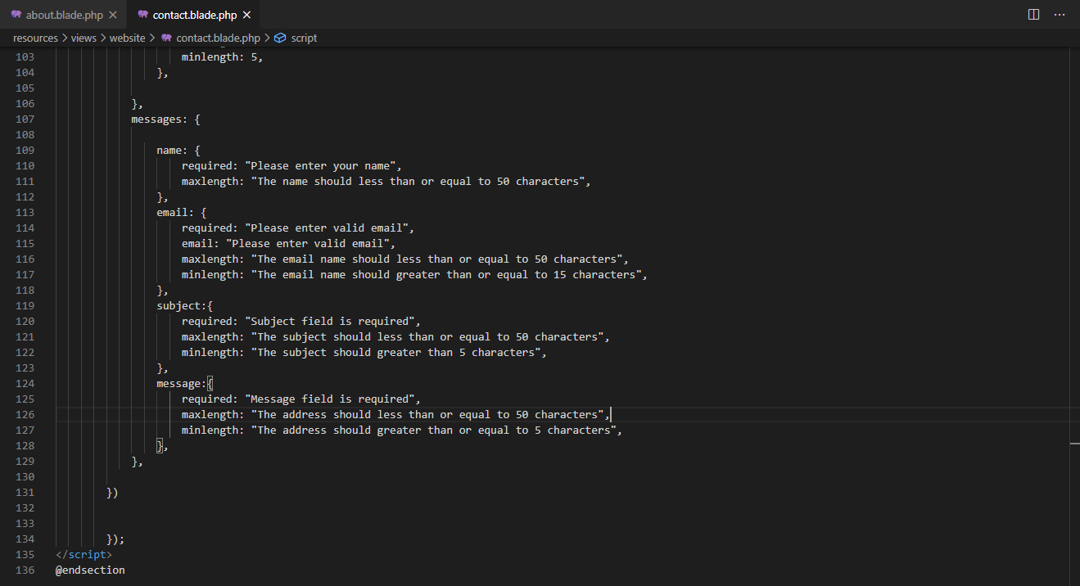

Figure 50: Contact.php

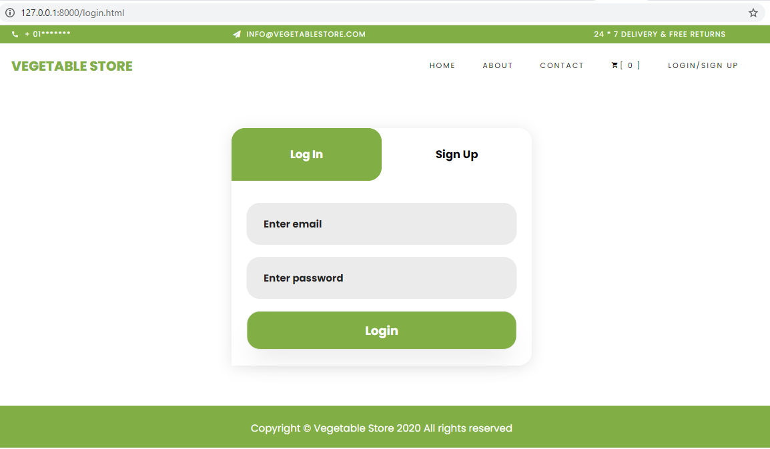

Figure 51: Login Form

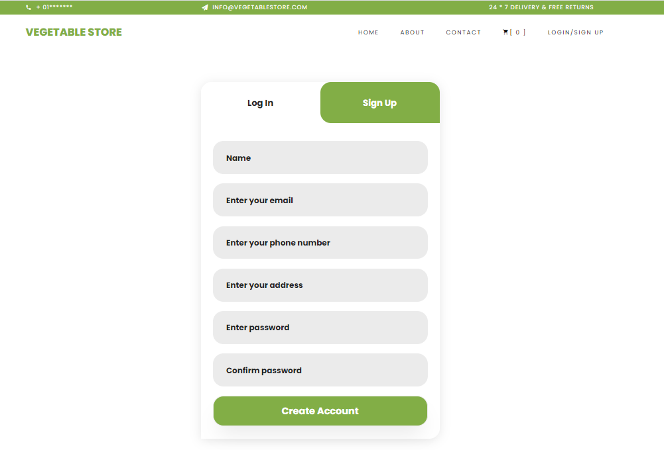

Figure 52: SignUp Form

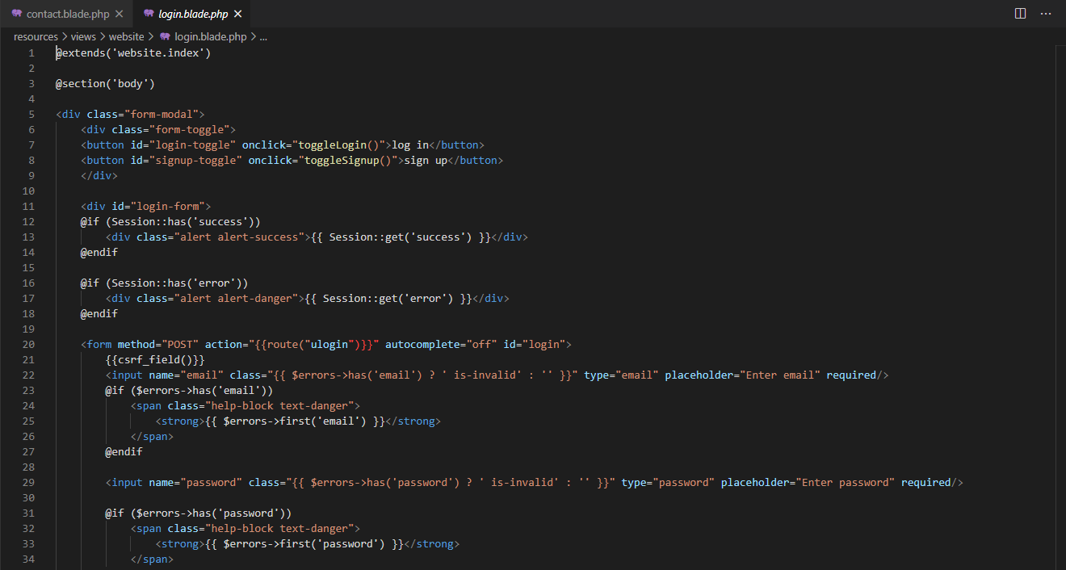

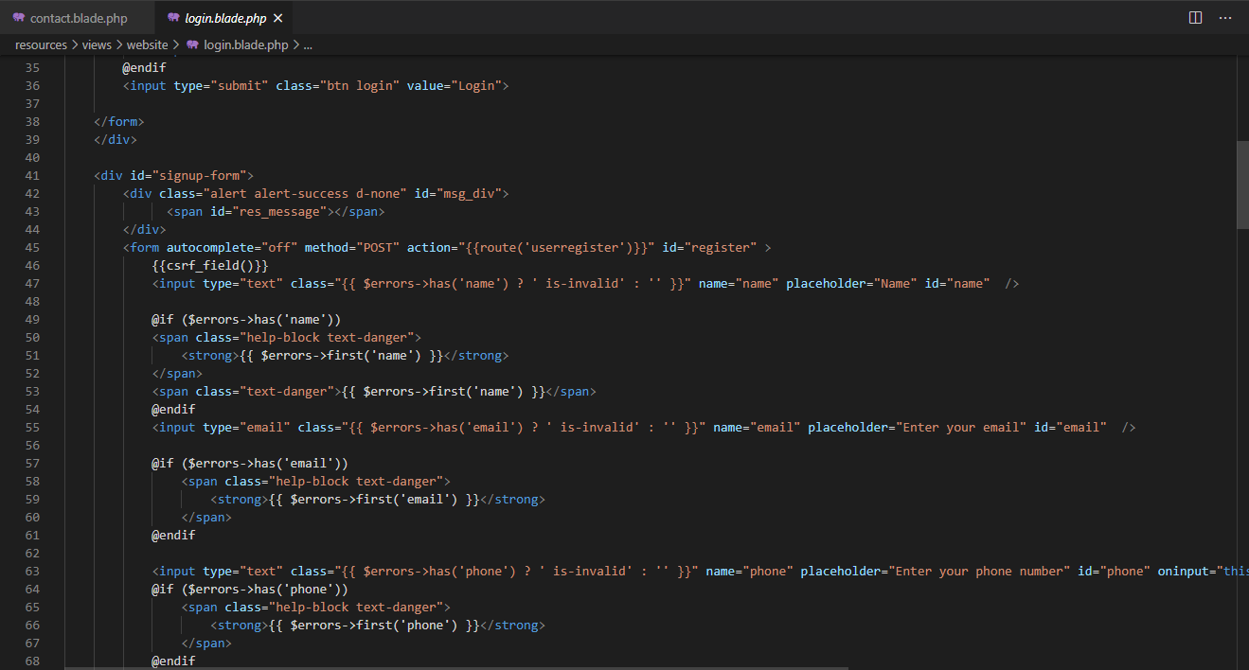

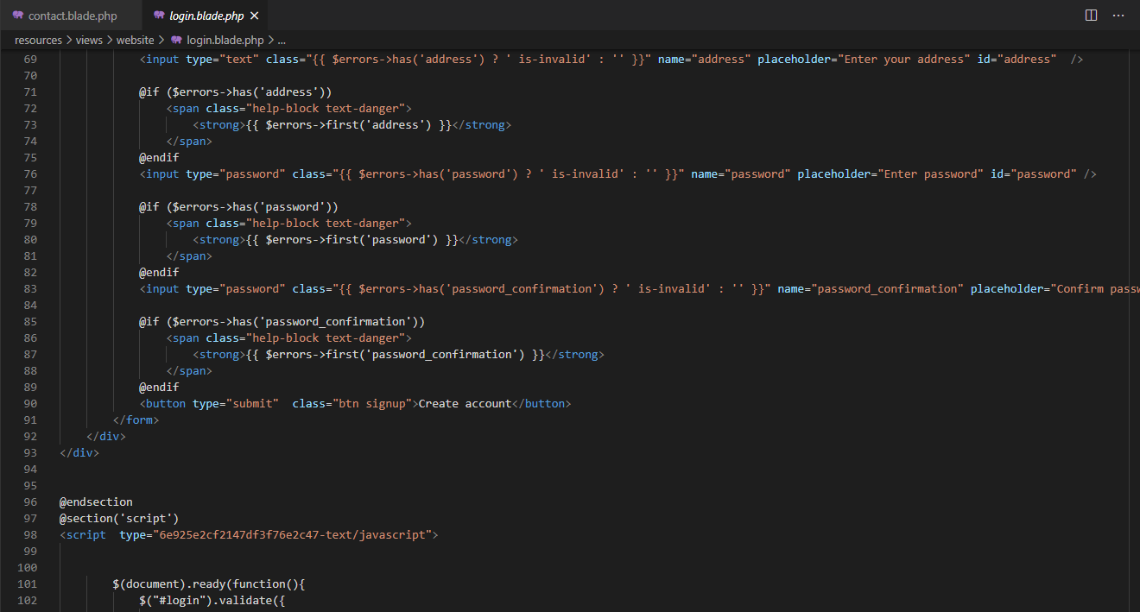

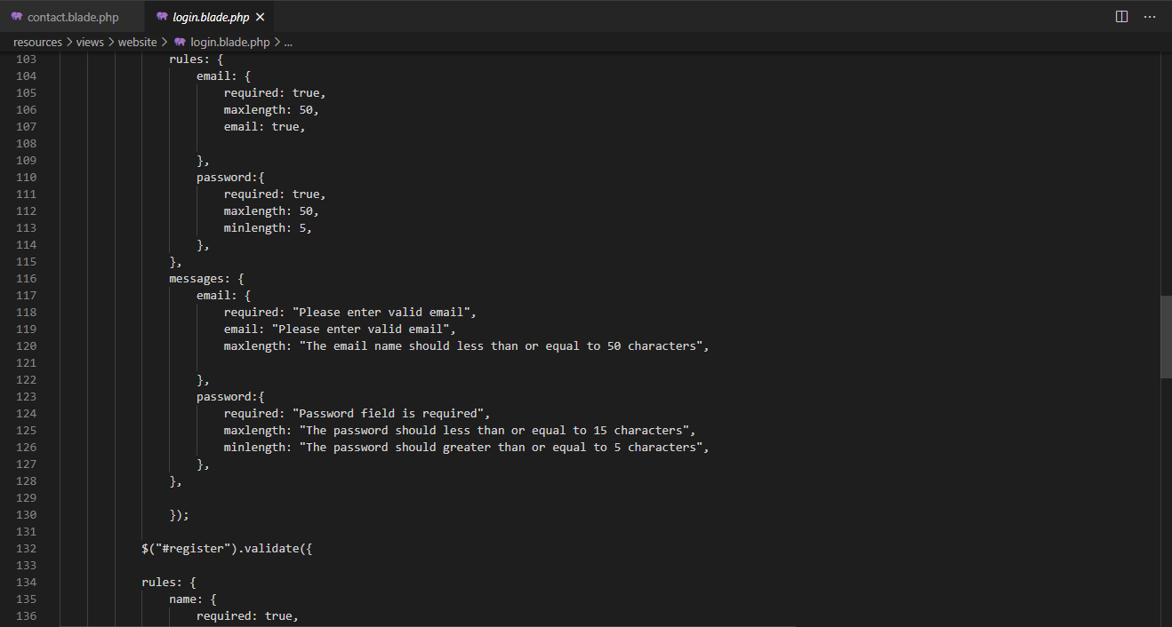

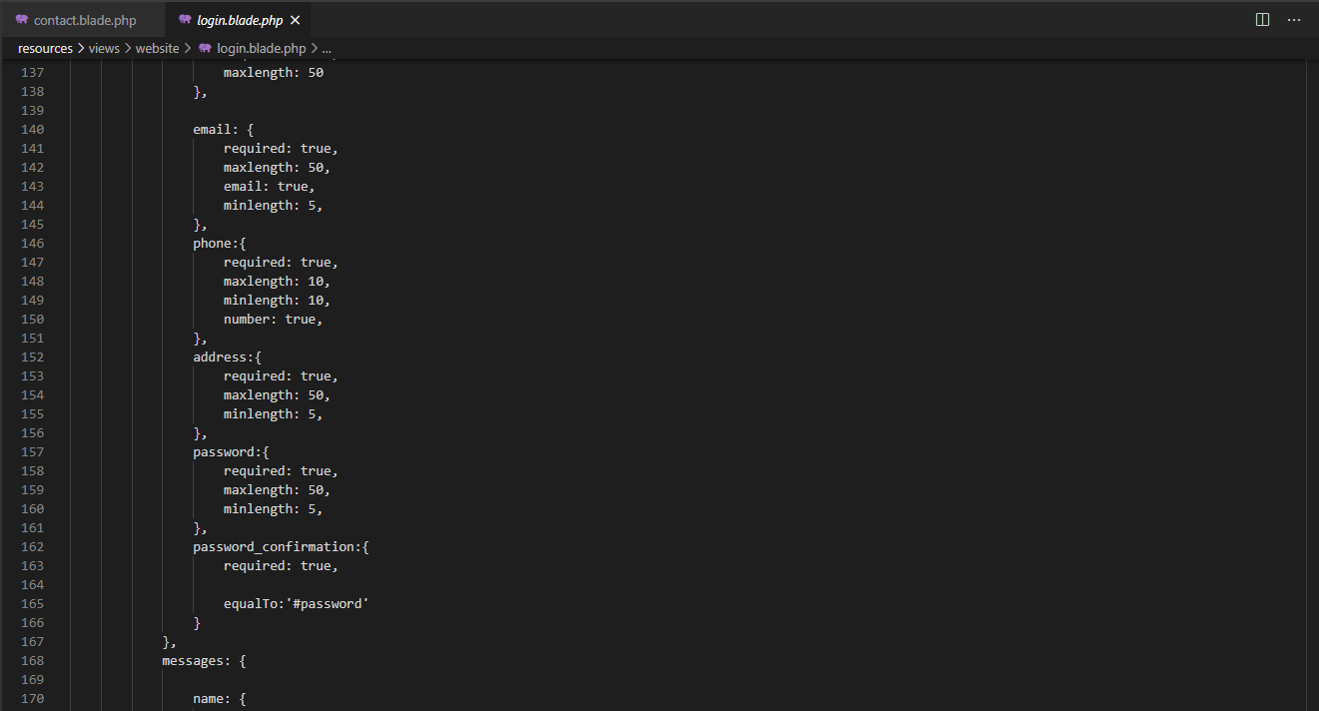

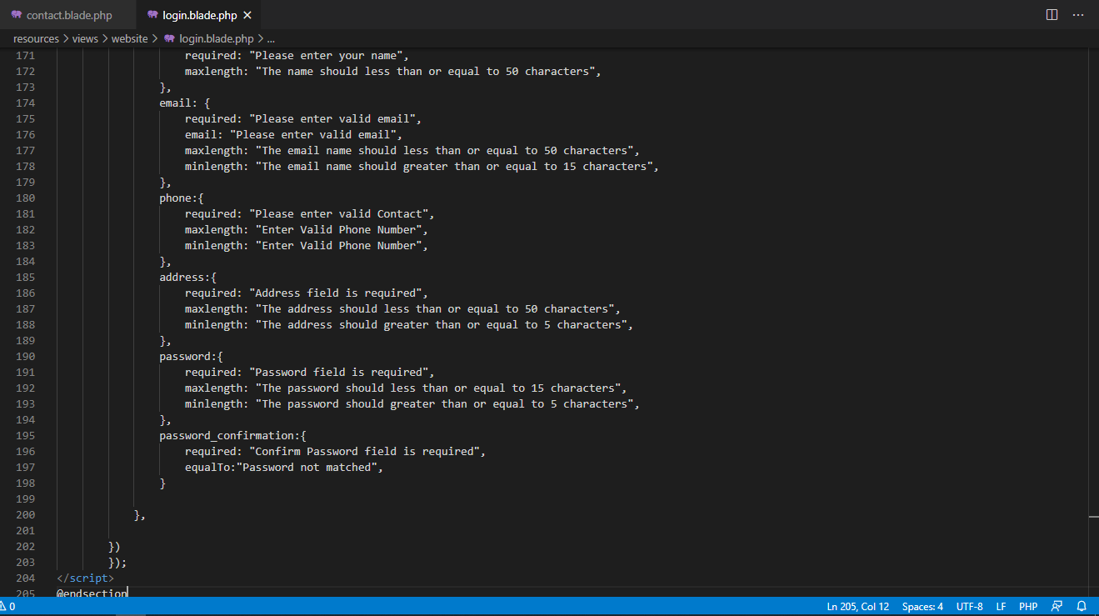

Figure 53: Login and Signup.php

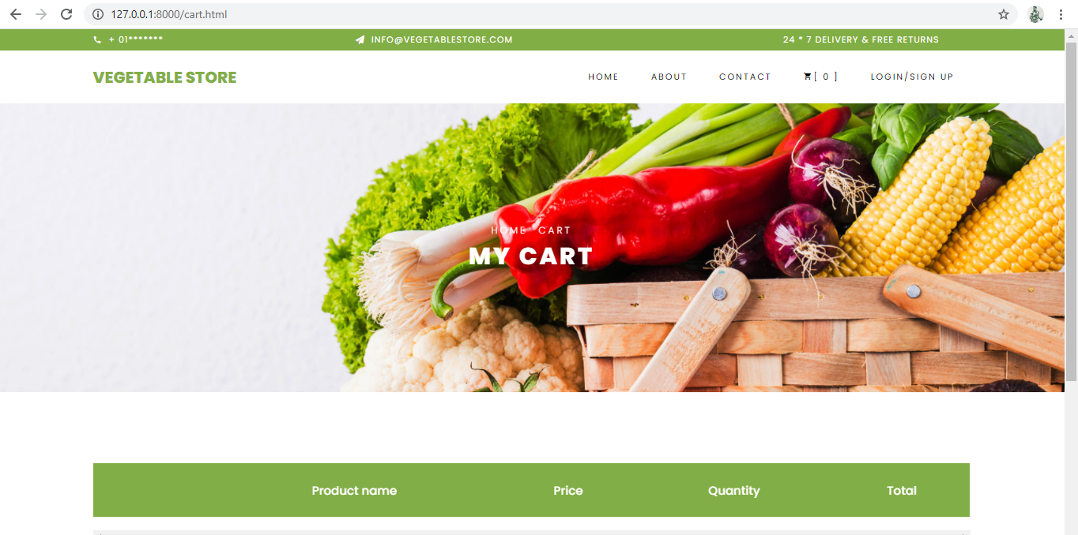



Figure 54: Add to Cart Page

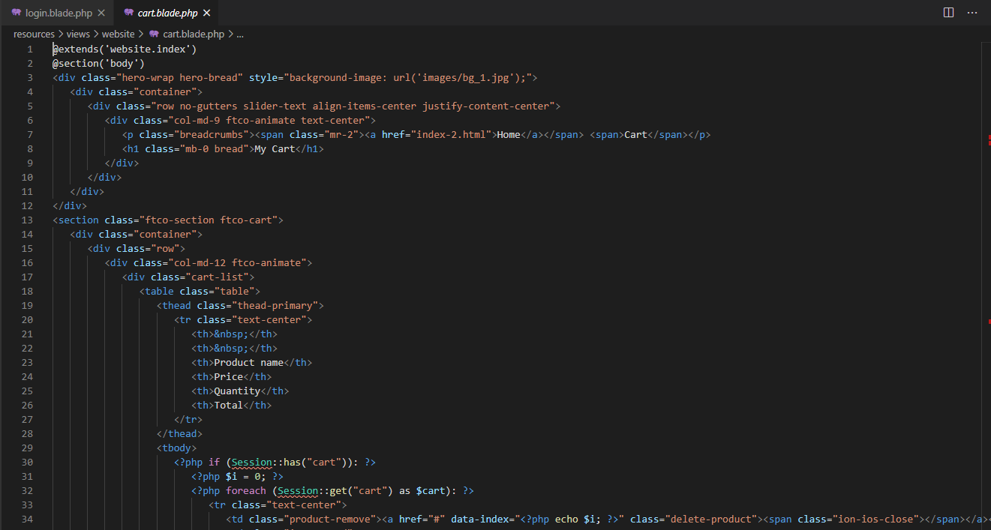

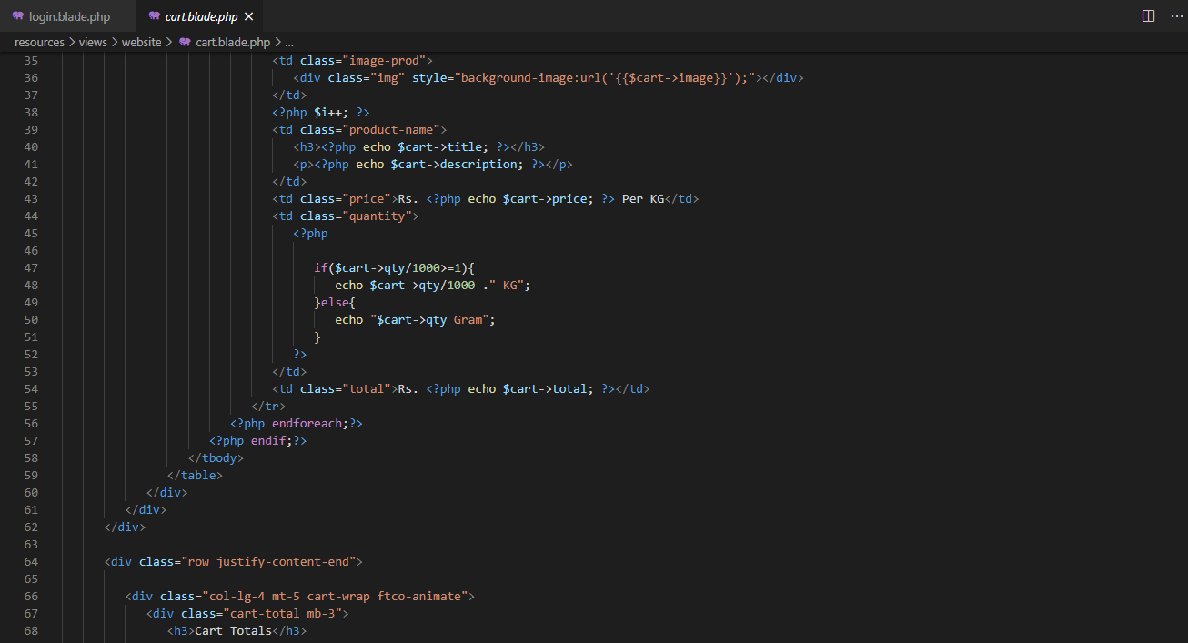

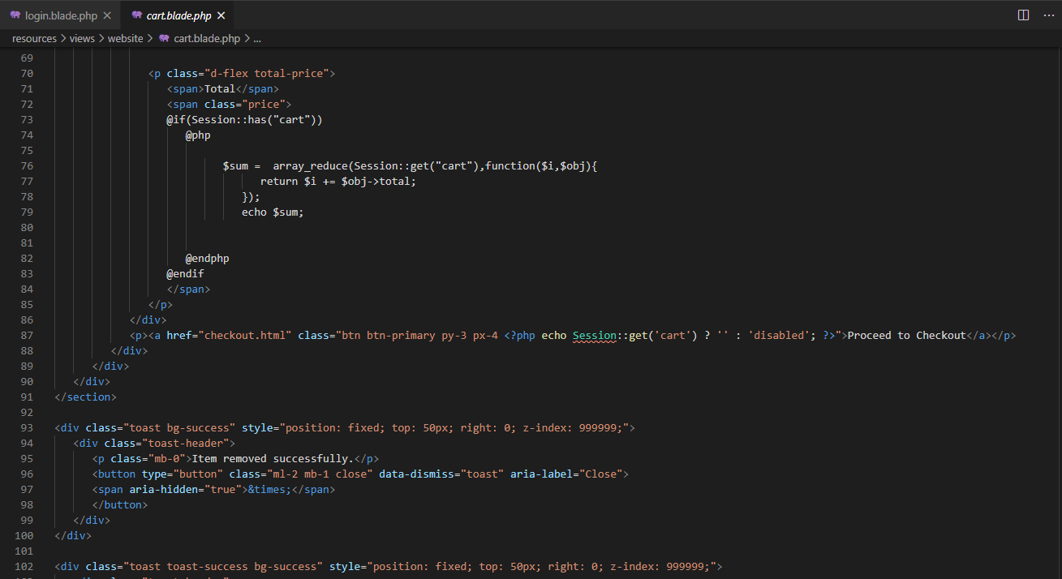

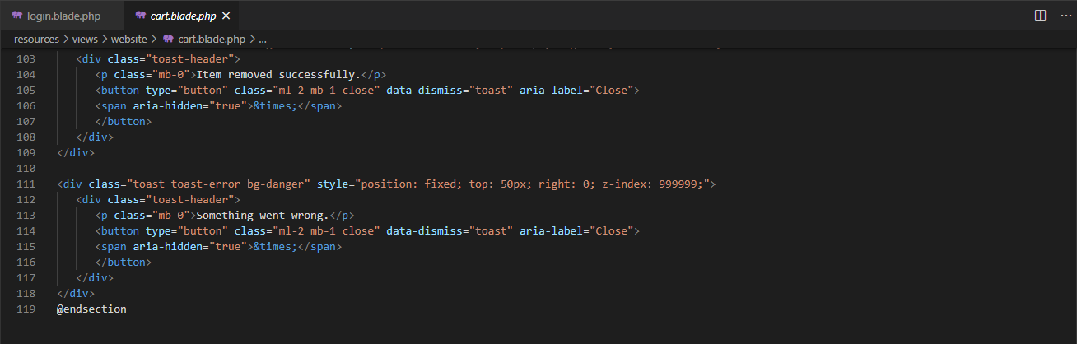

Figure 55: Cart.php

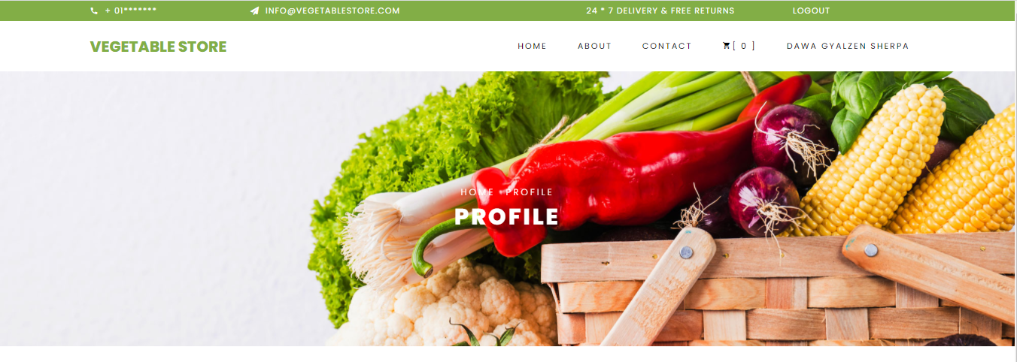

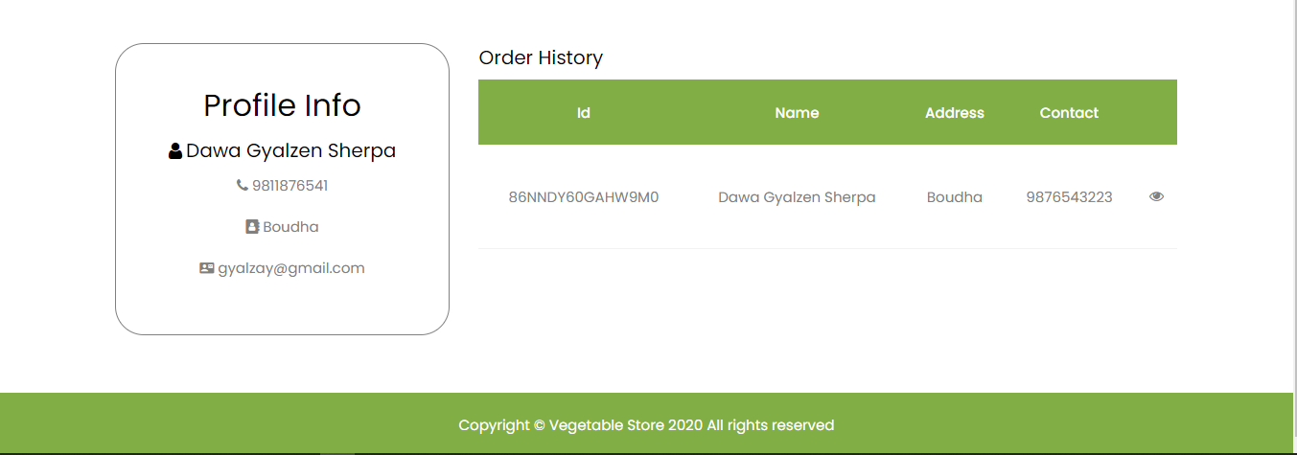

Figure 56: Profile Page

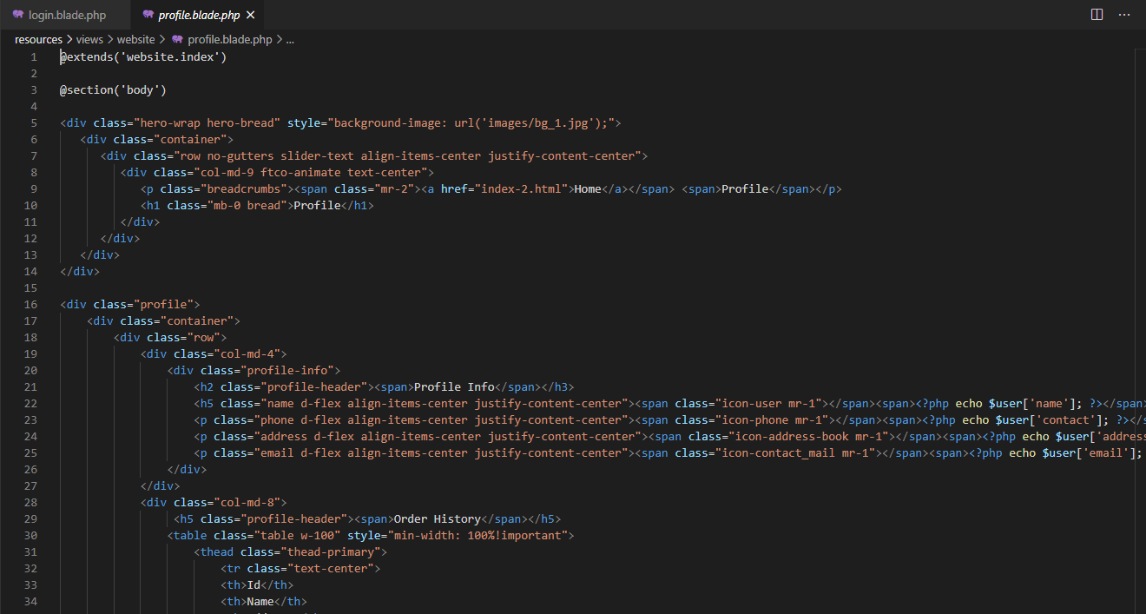

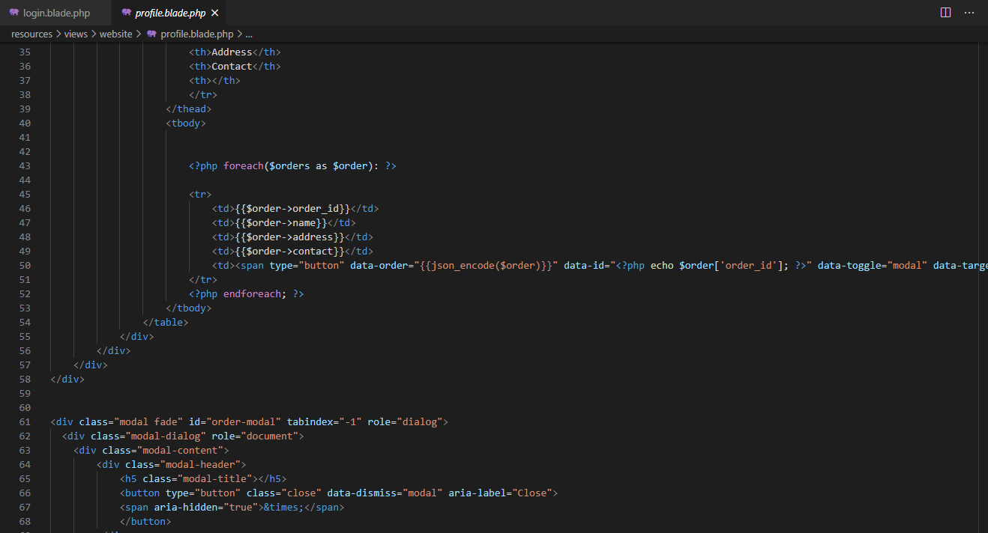

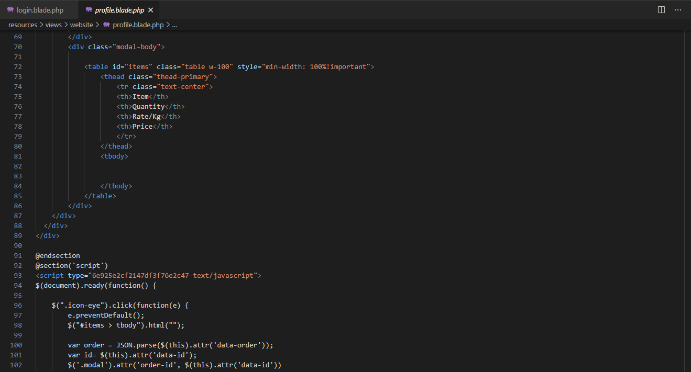

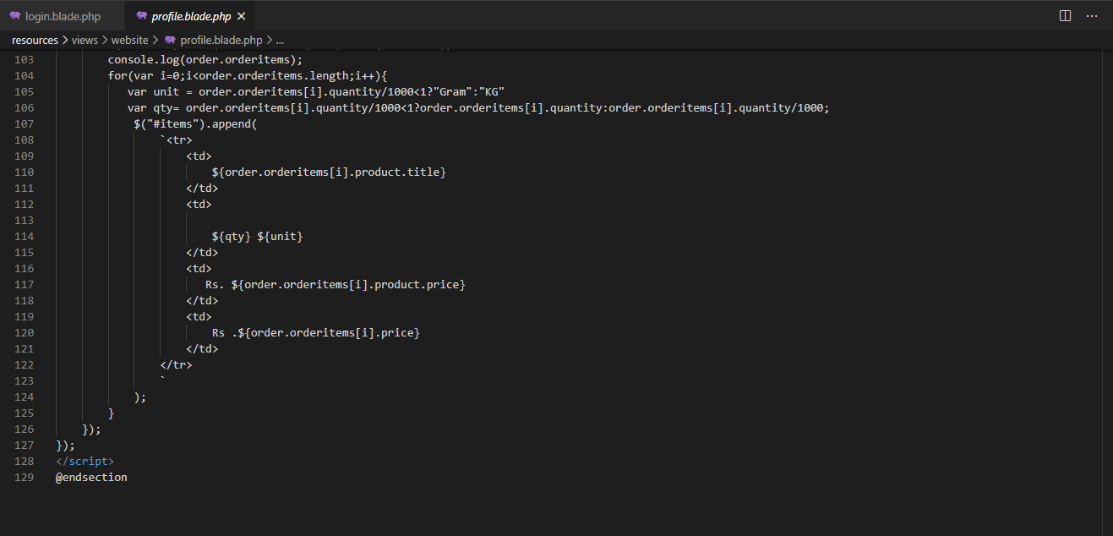

Figure 57: Profile.php

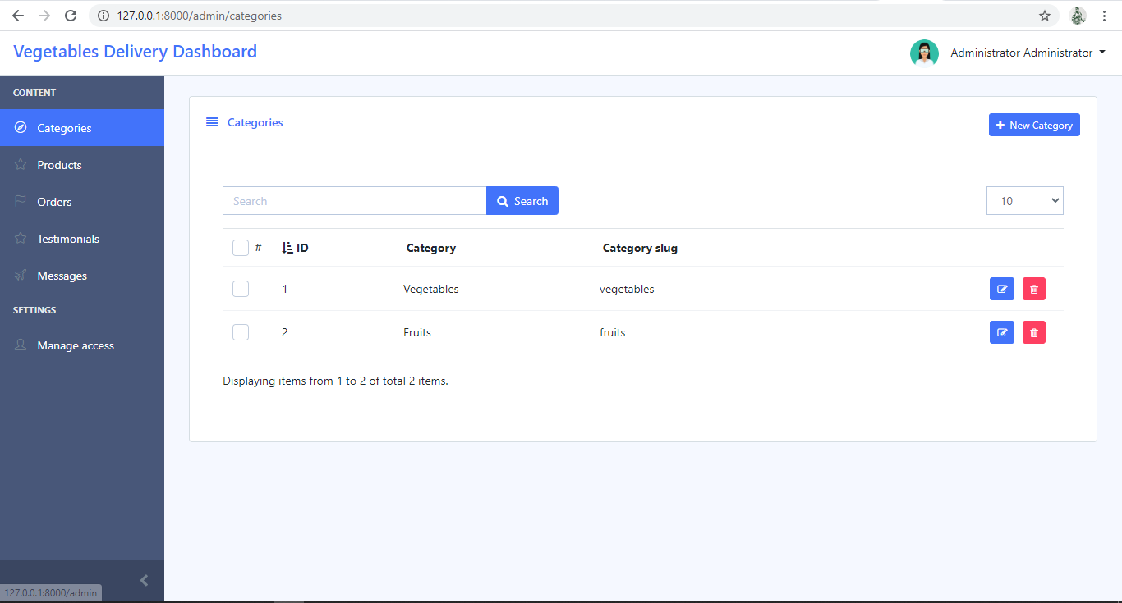

Figure 58: Category Page

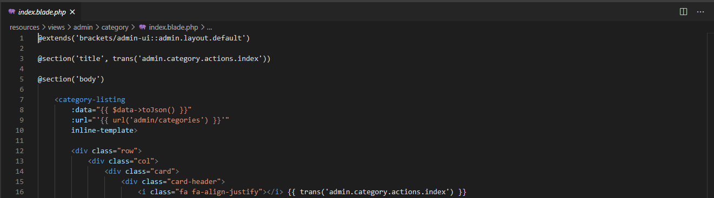

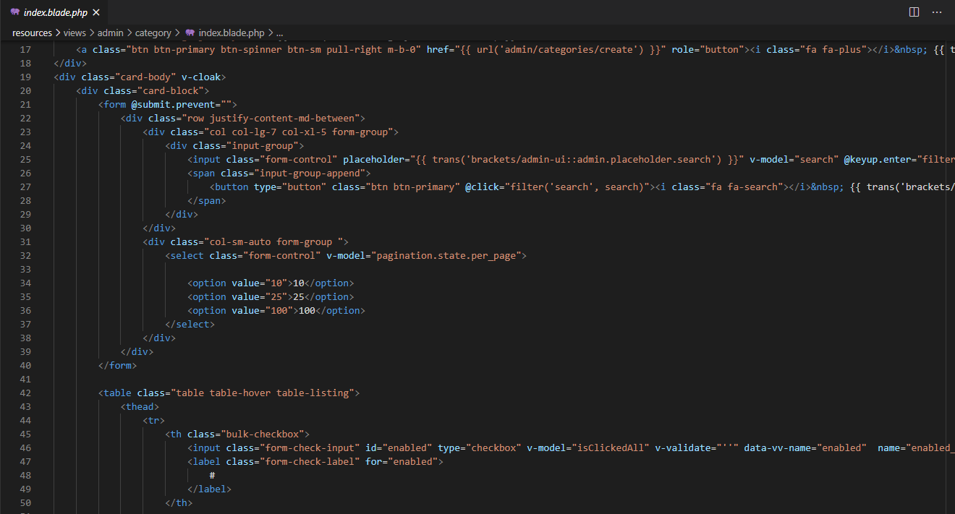

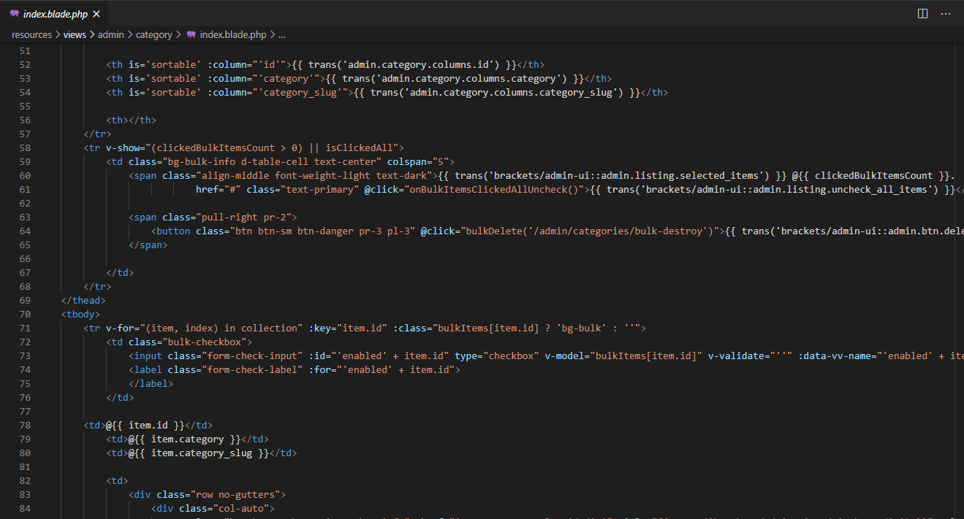

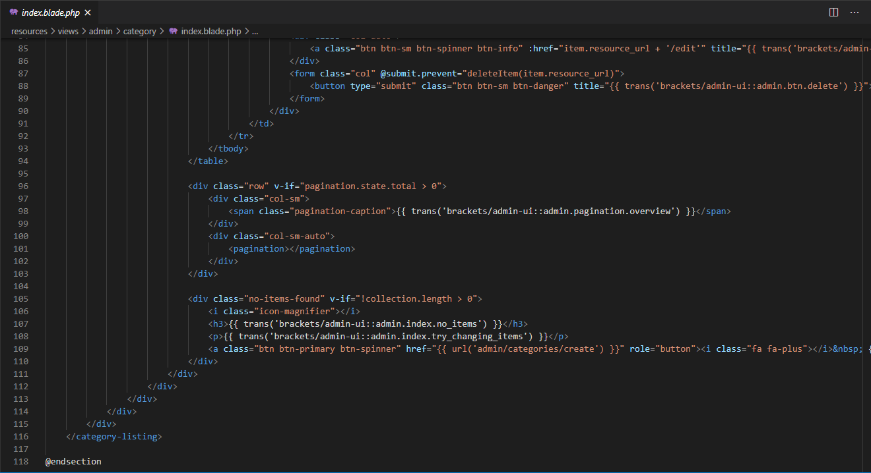

Figure 59: Add Category.php

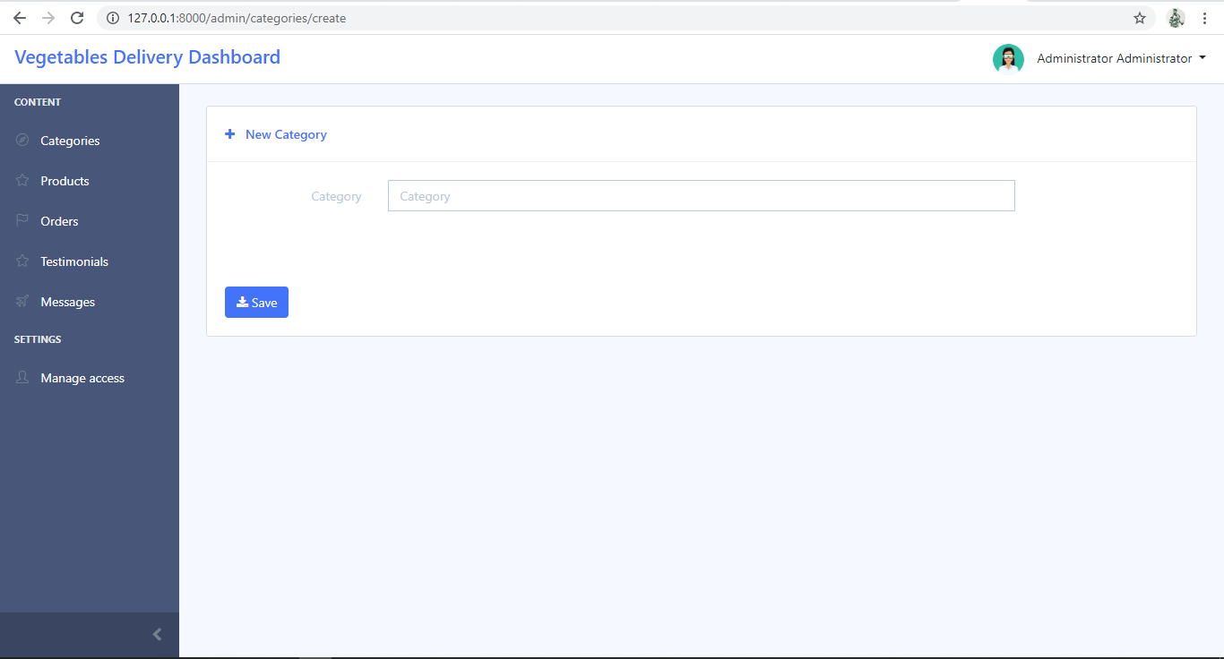

Figure 60: New Category Form Page

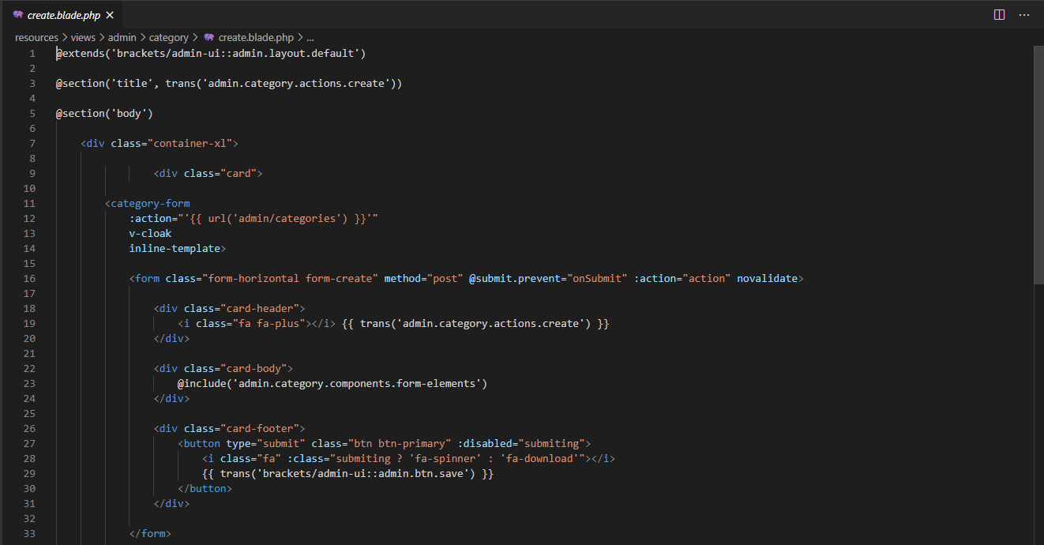

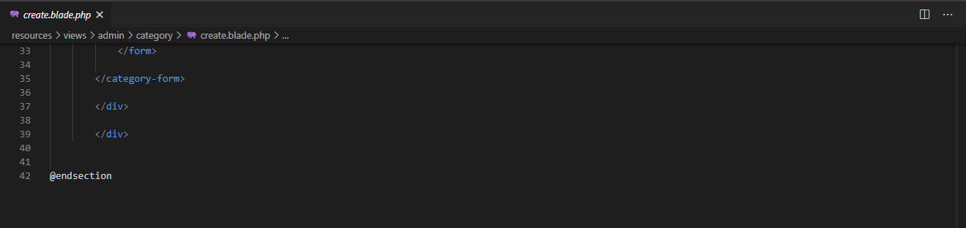

Figure 61: Add New Category.php

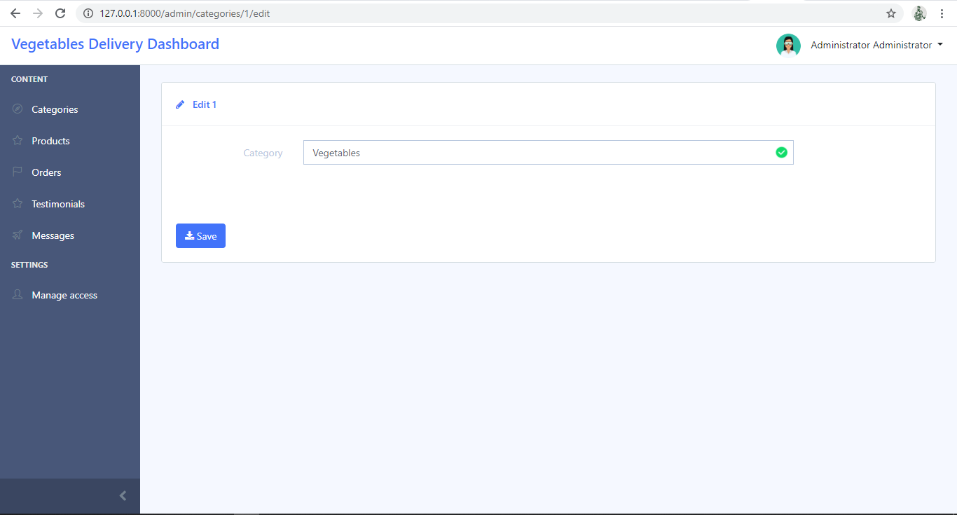

Figure 62: Edit Category

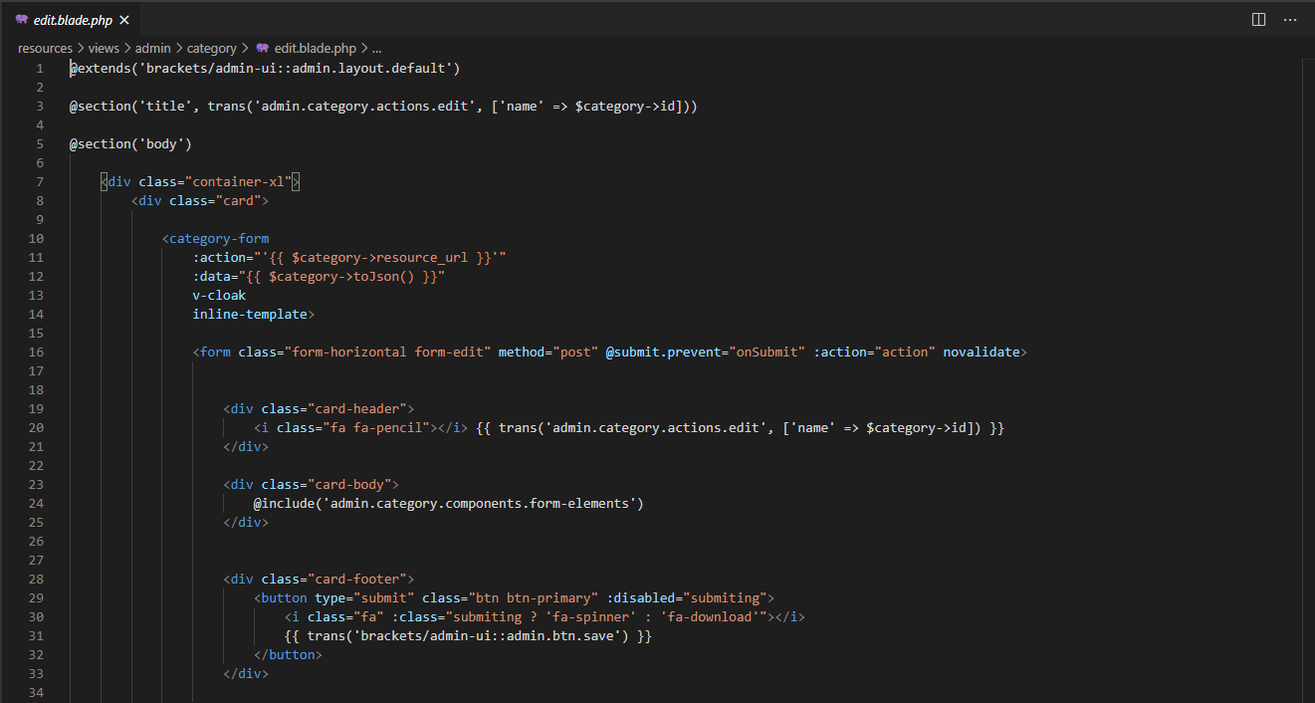

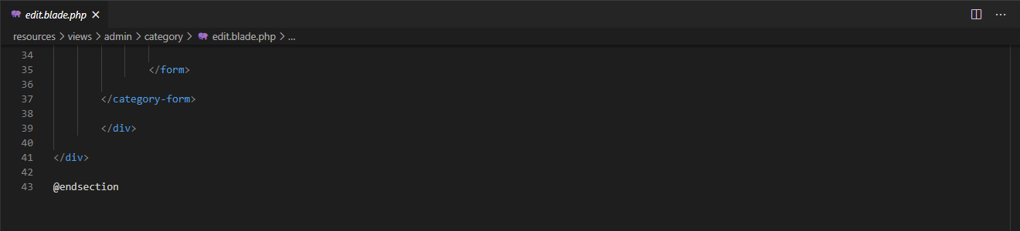

Figure 63: Edit Category.php

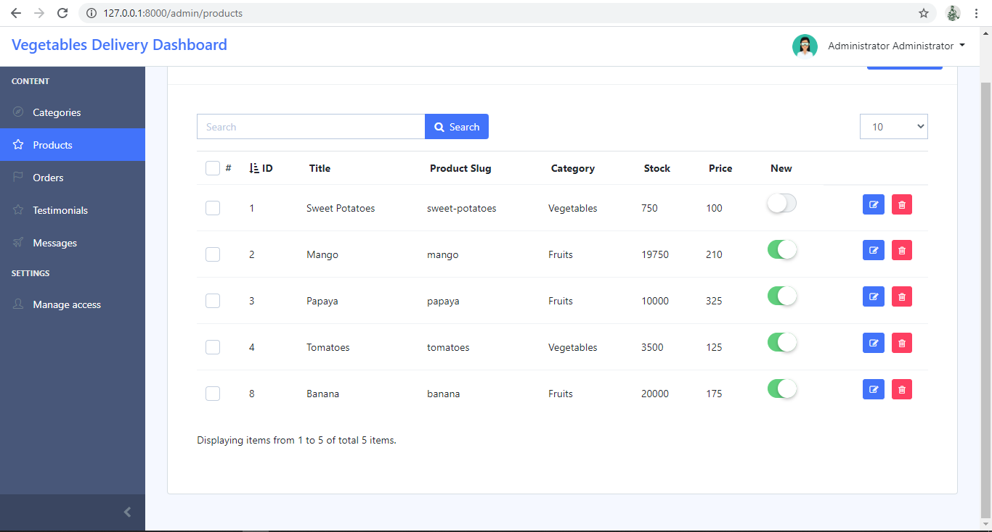

Figure 64: Product Page

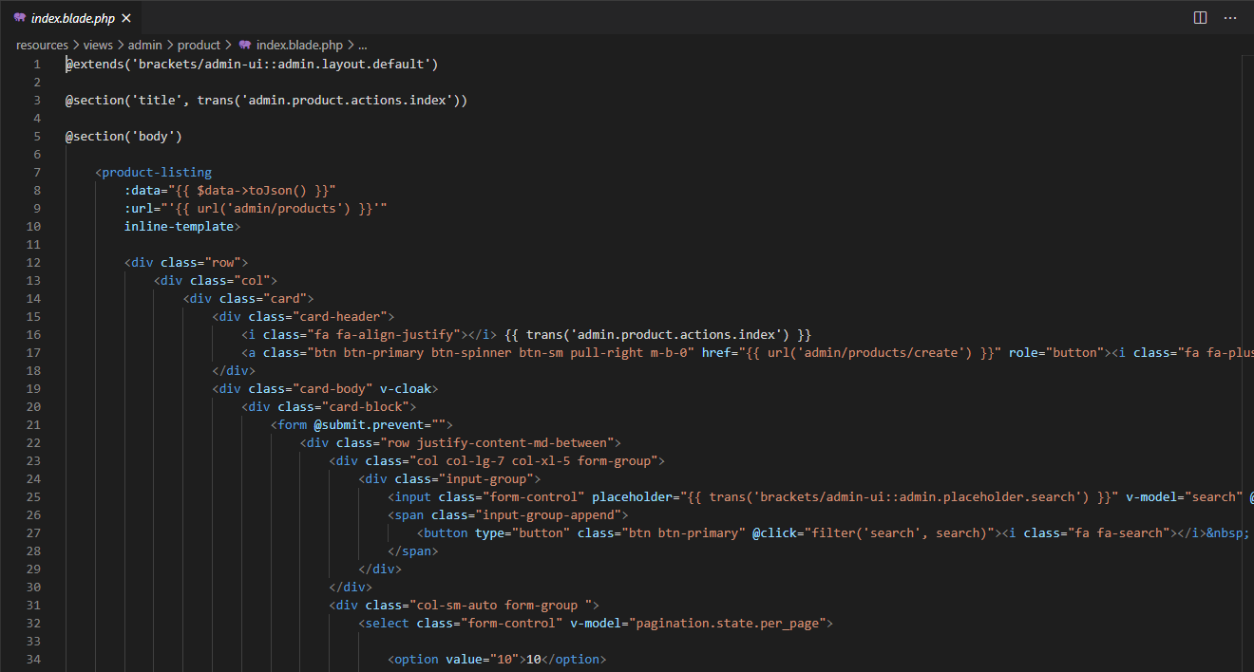

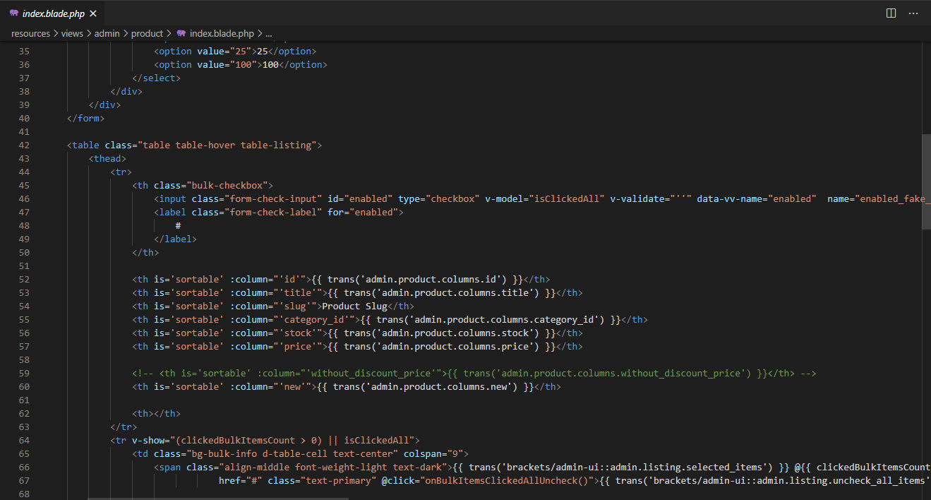

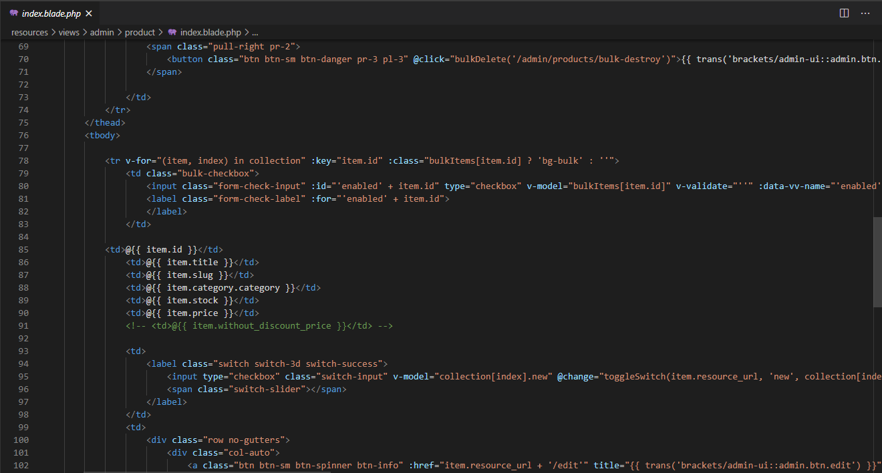

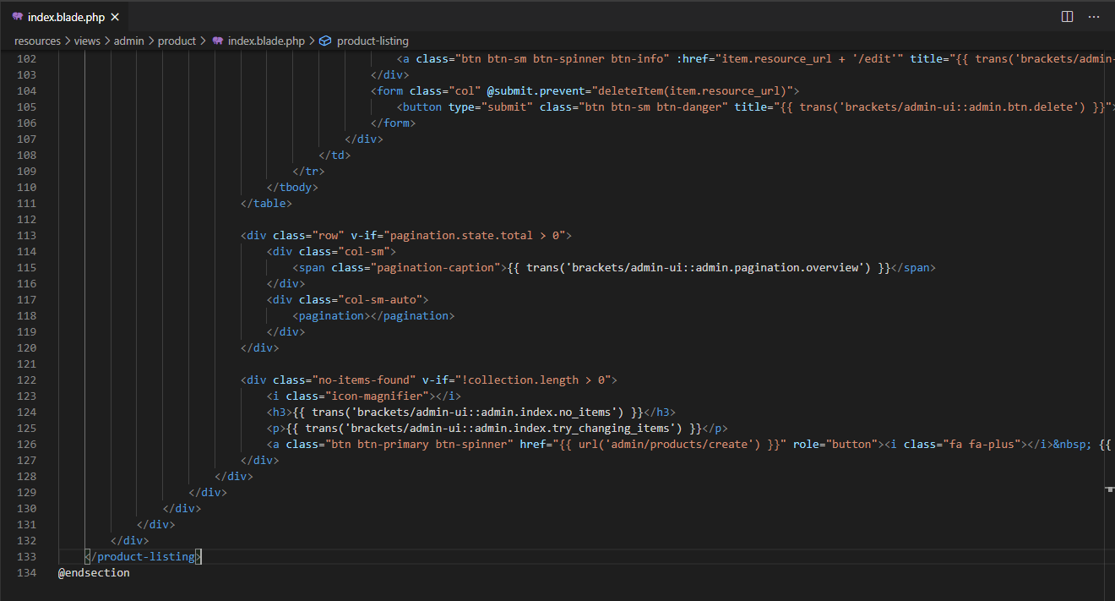

Figure 65: Product.php

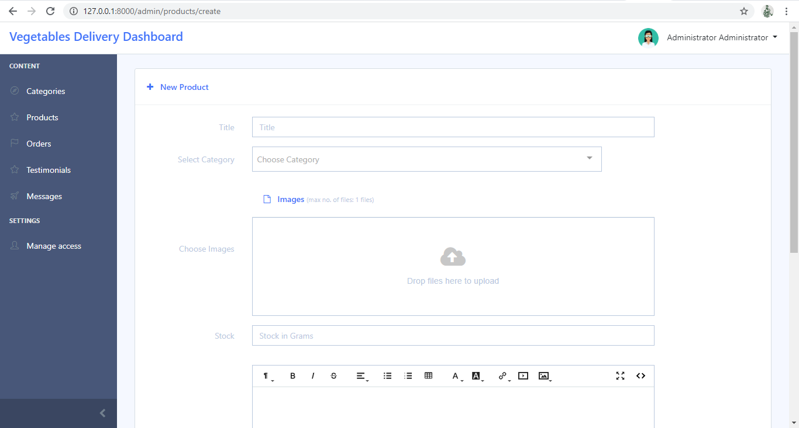

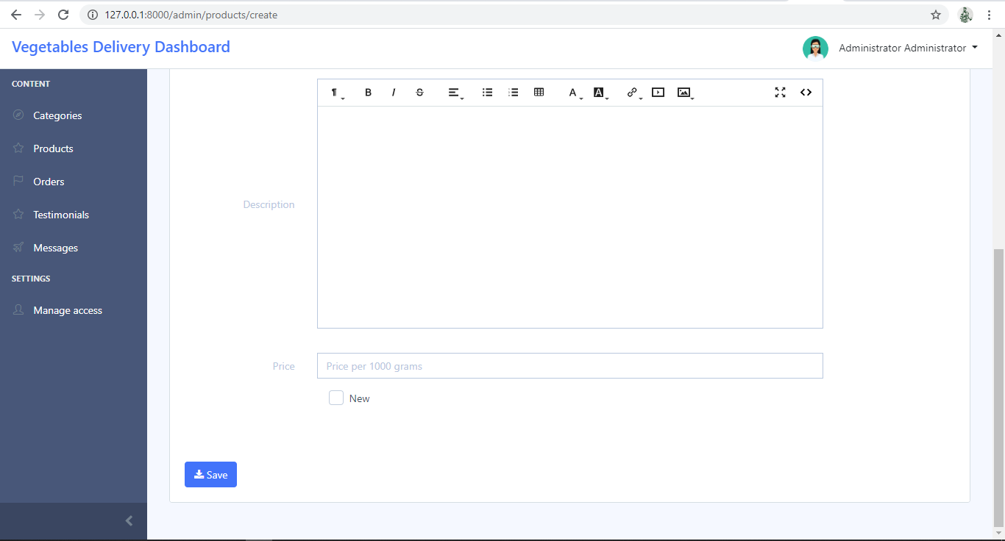

Figure 66: New Product Form

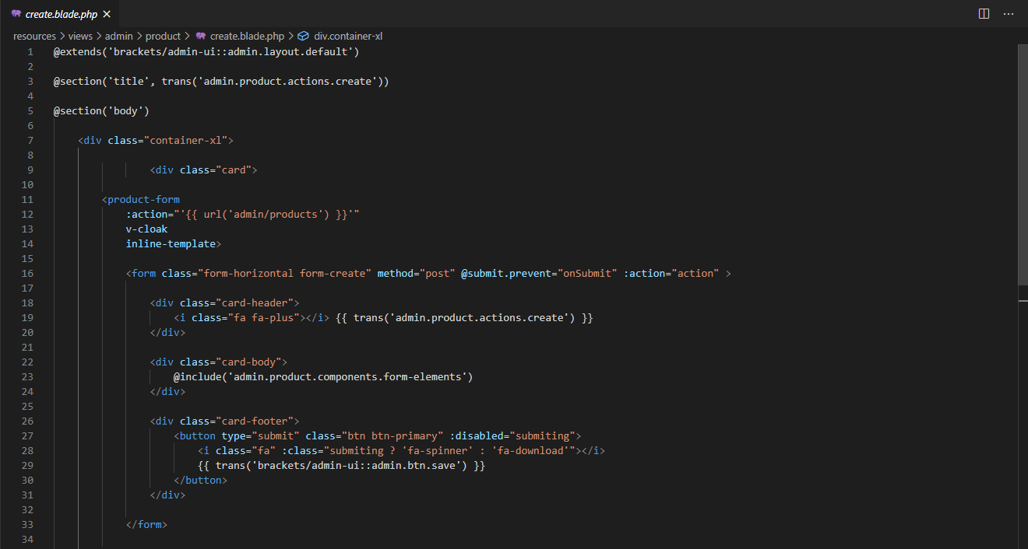

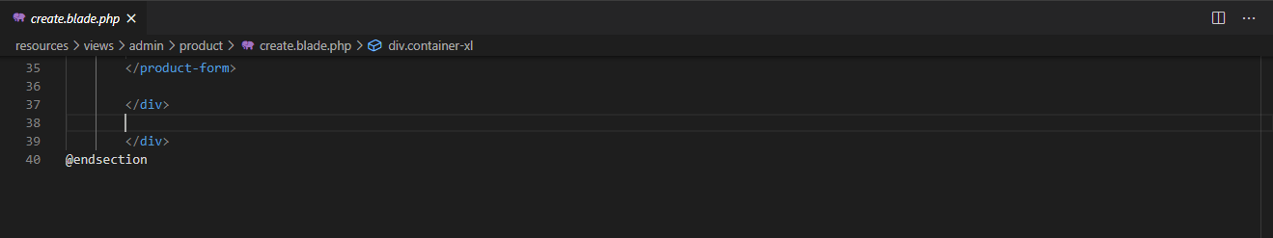

Figure 67: New Product.php

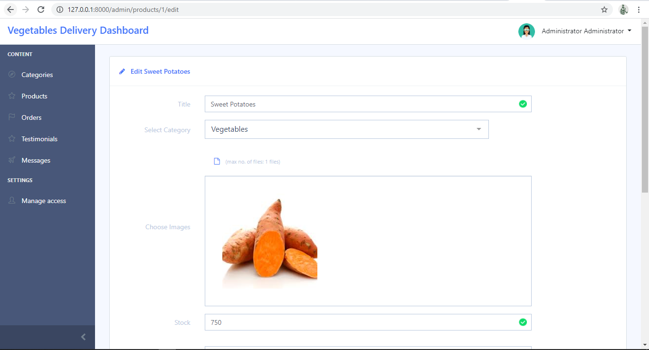

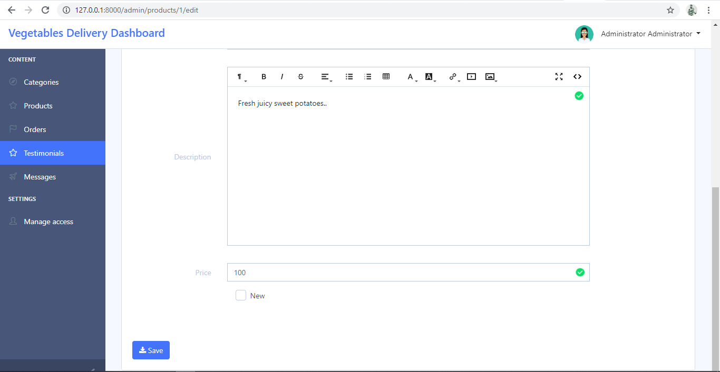

Figure 68: Edit Product Form

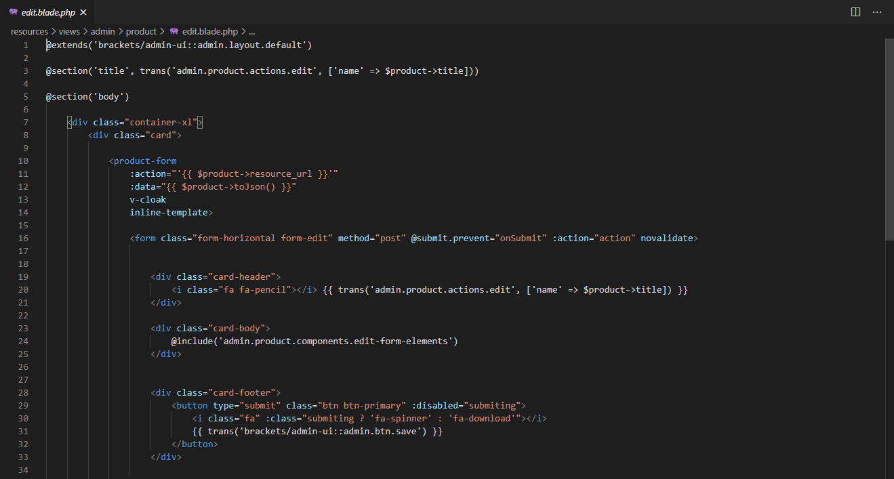

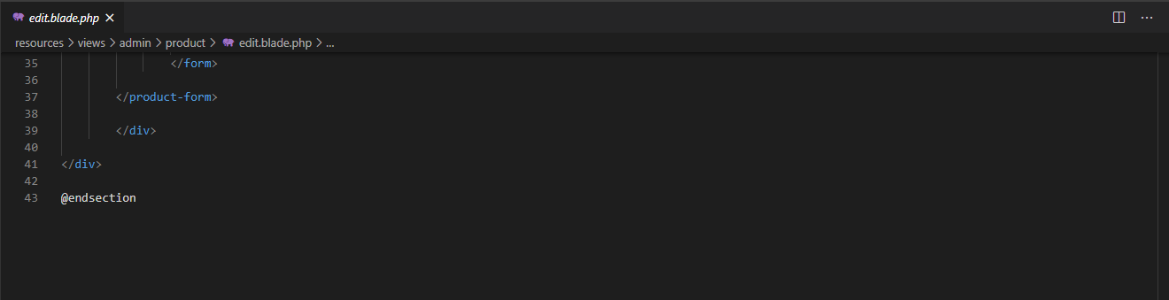

Figure 69: Edit Product.php

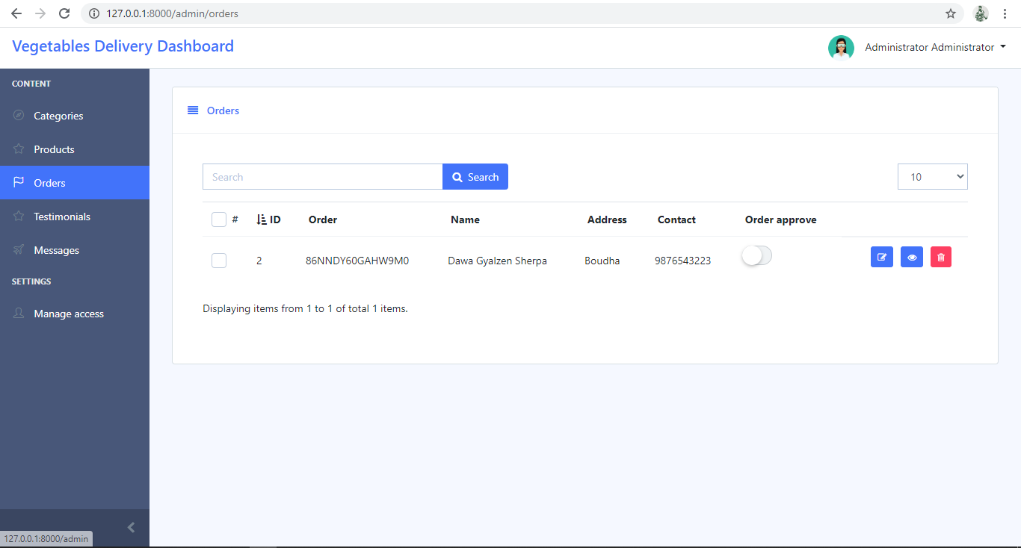

Figure 70: Orders Page

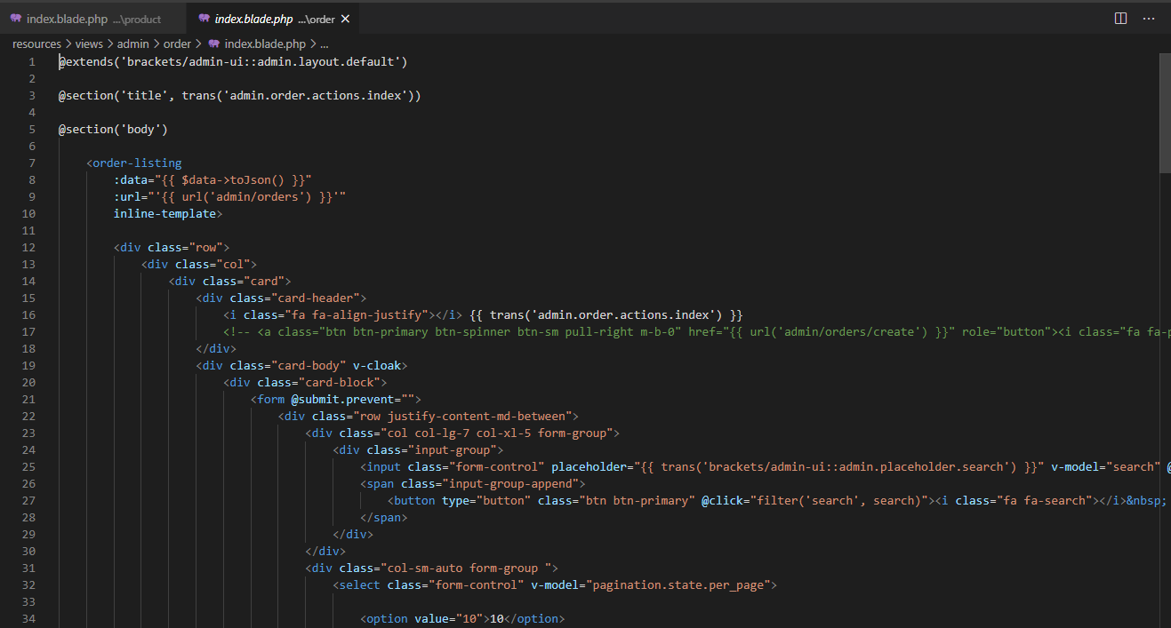

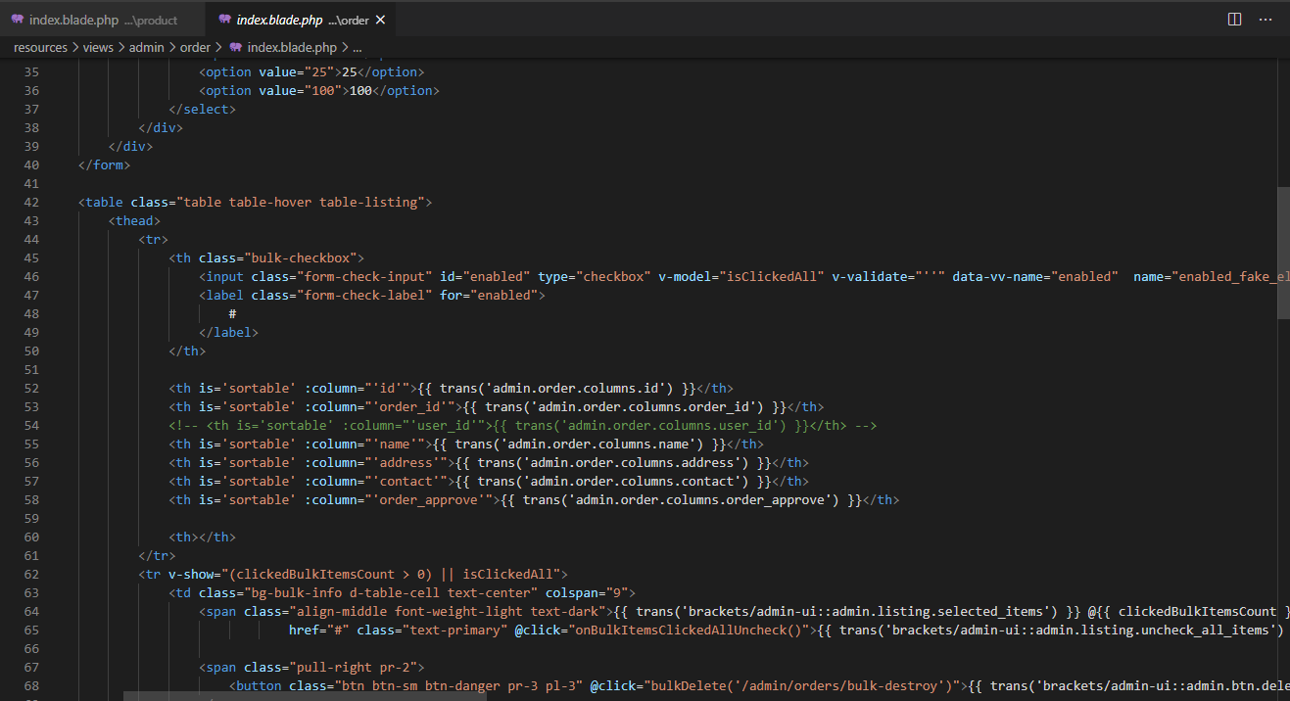

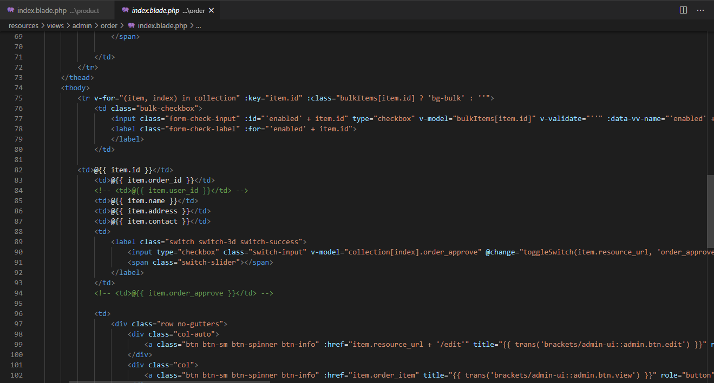

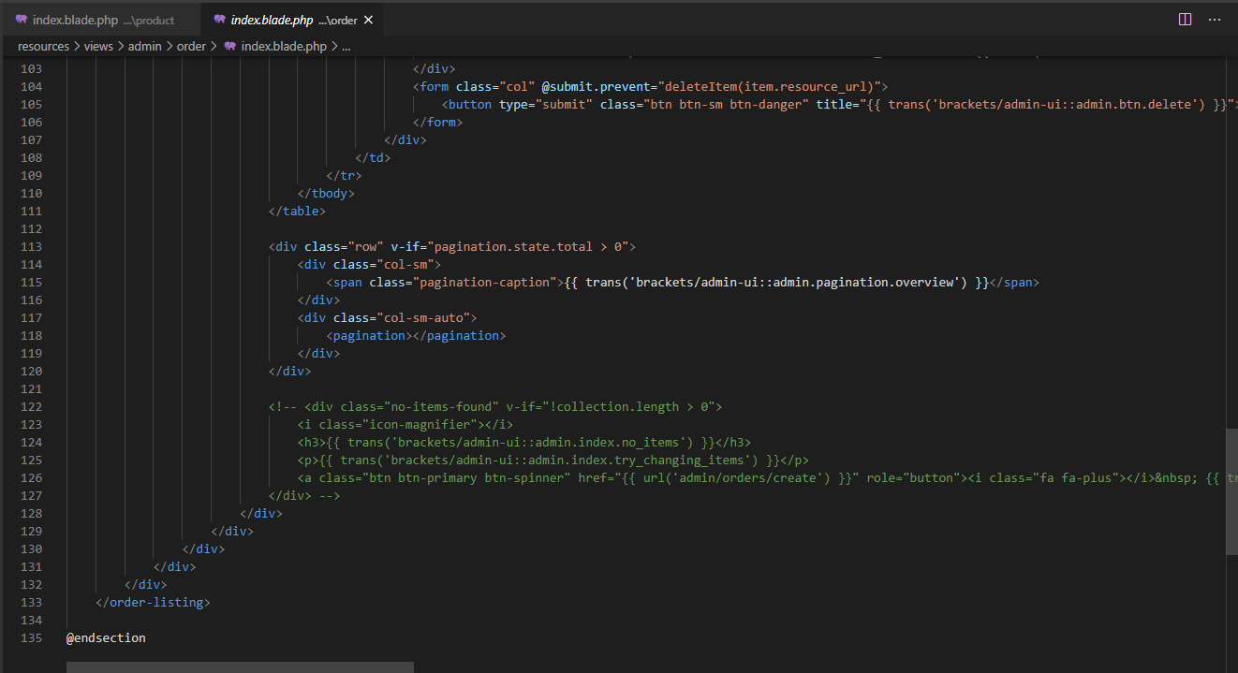

Figure 71: Orders.php

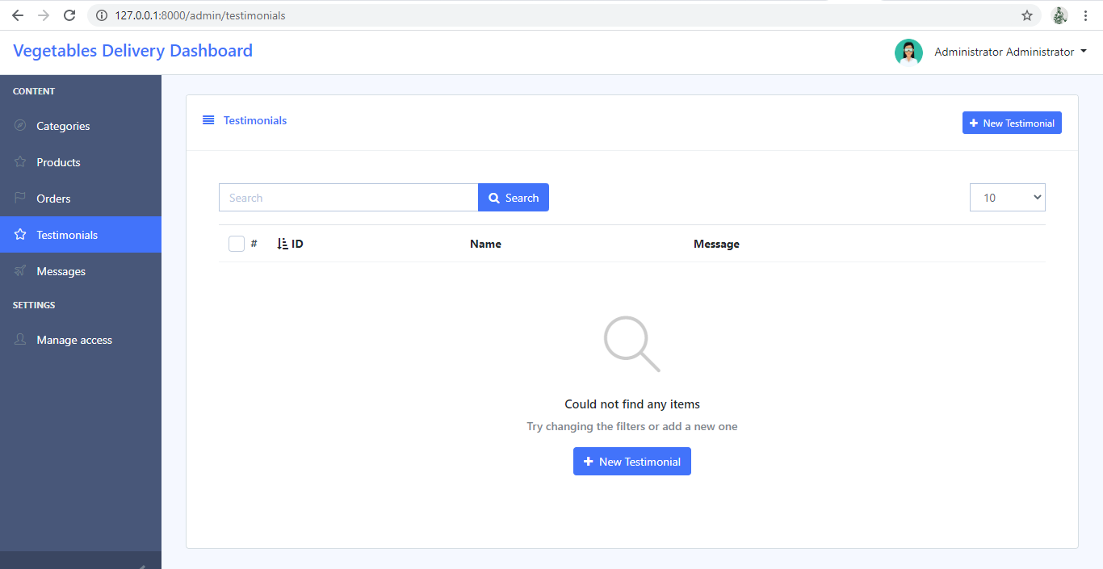

Figure 72: Testimonials Page

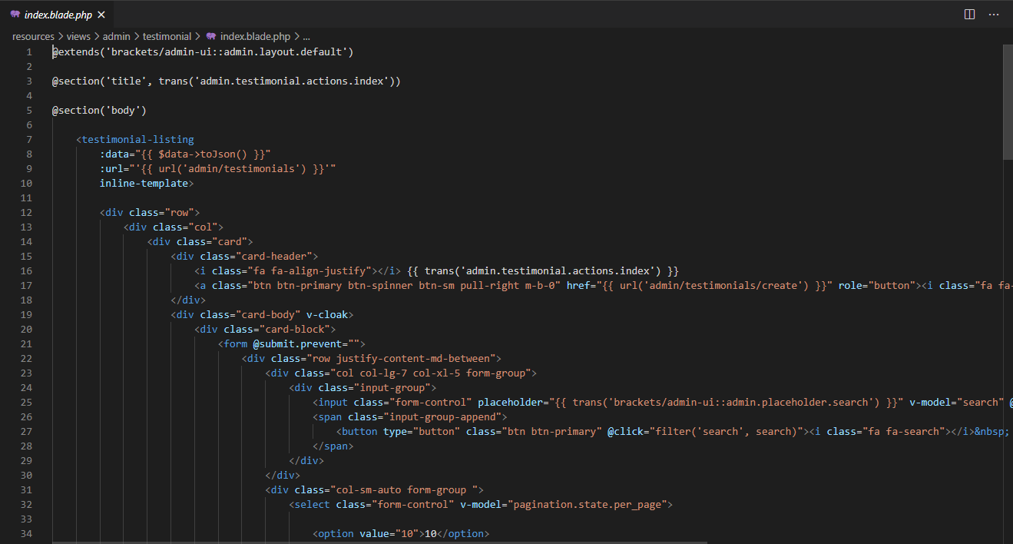

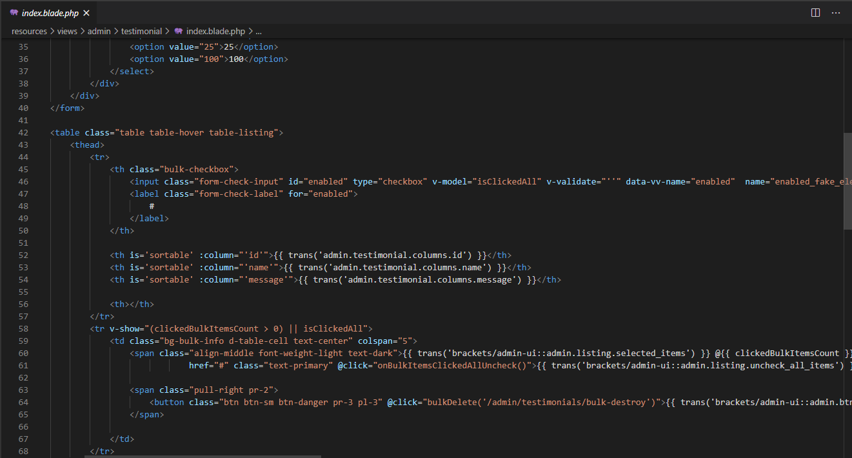

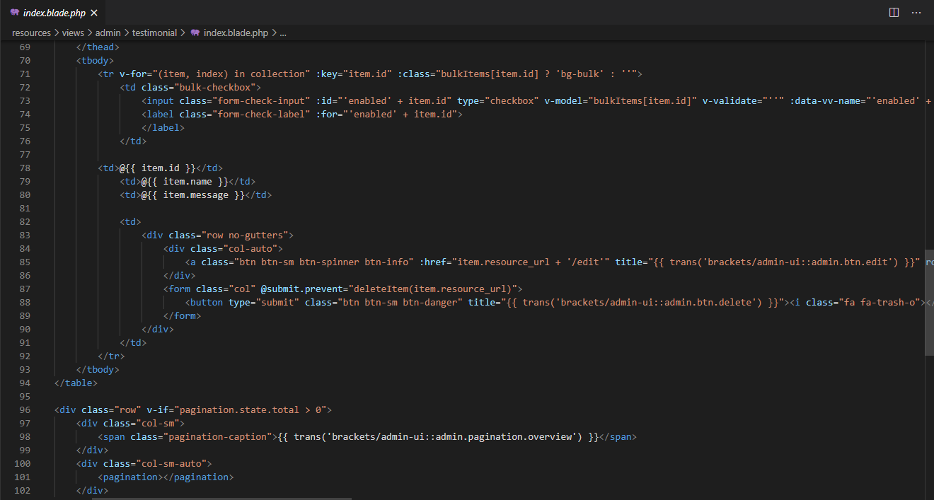

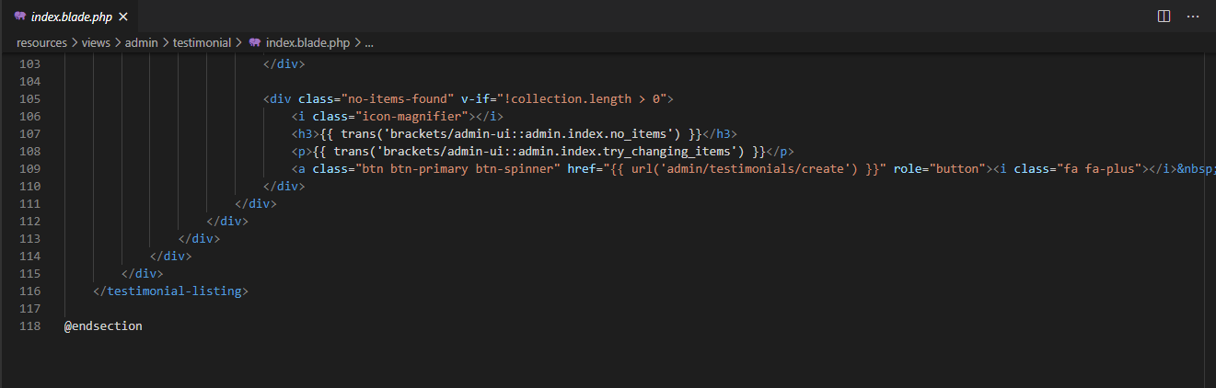

Figure 73: Testimonials.php

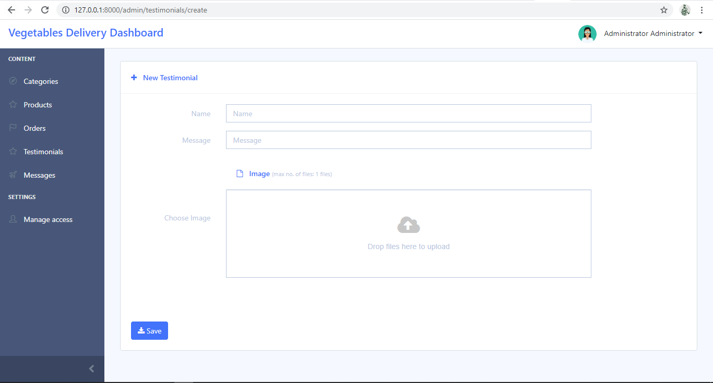

Figure 74: Add Testimonial Form

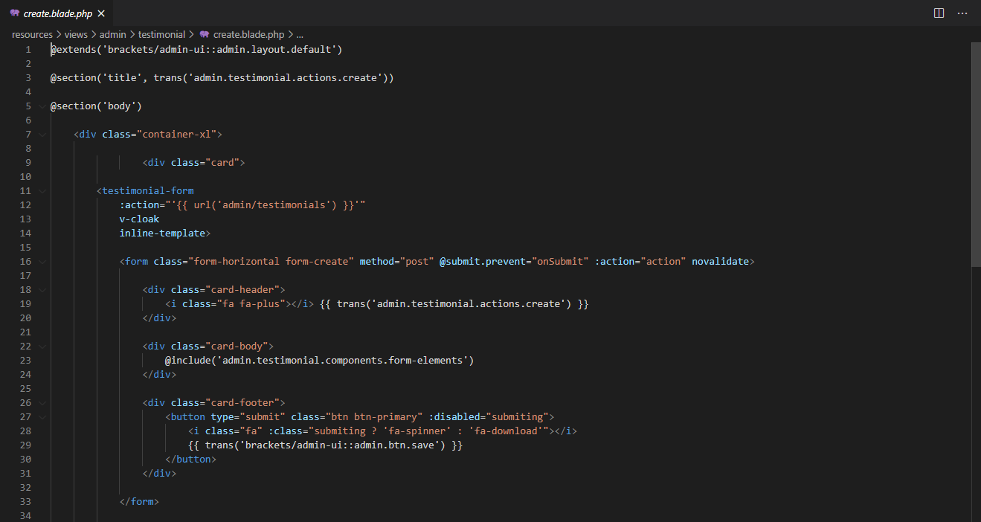

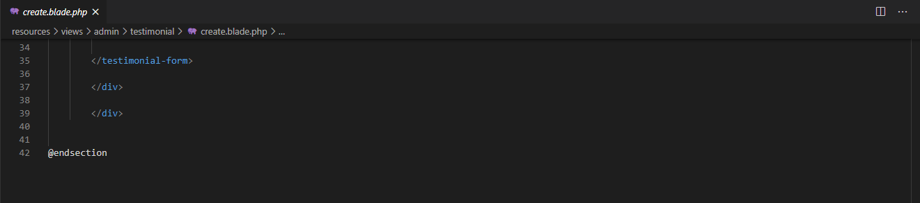

Figure 75: Add Testimonial.php

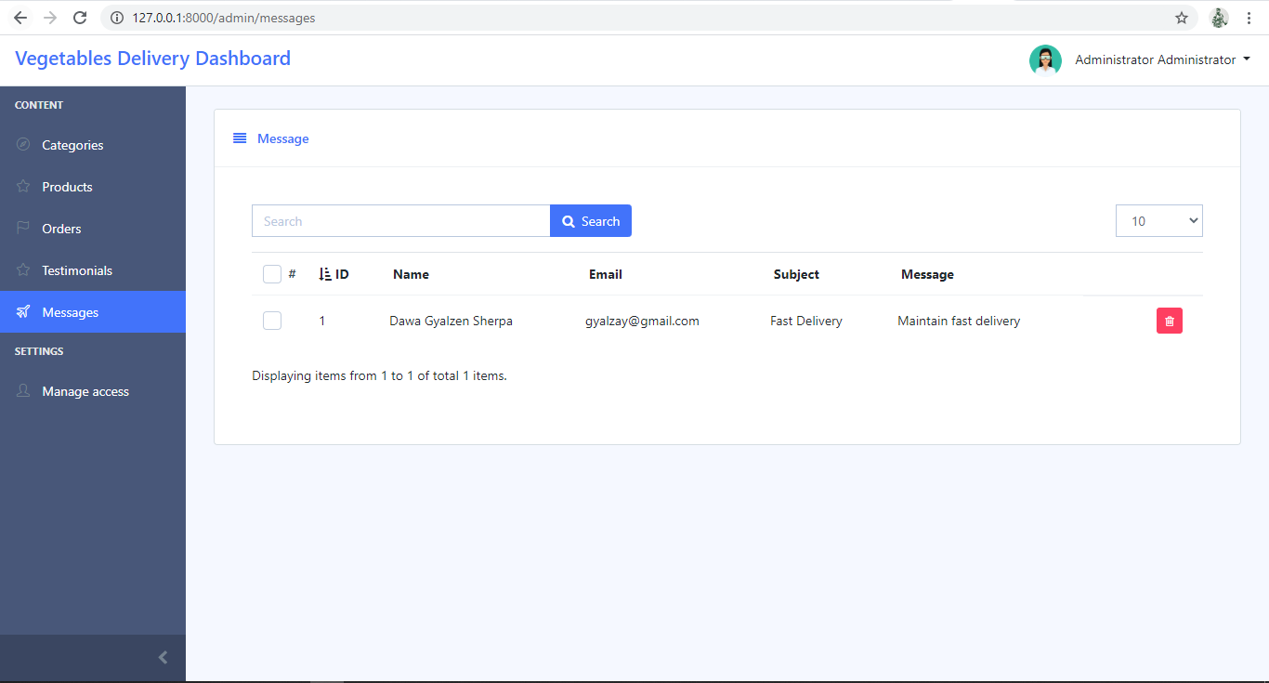

Figure 76: Messages Page

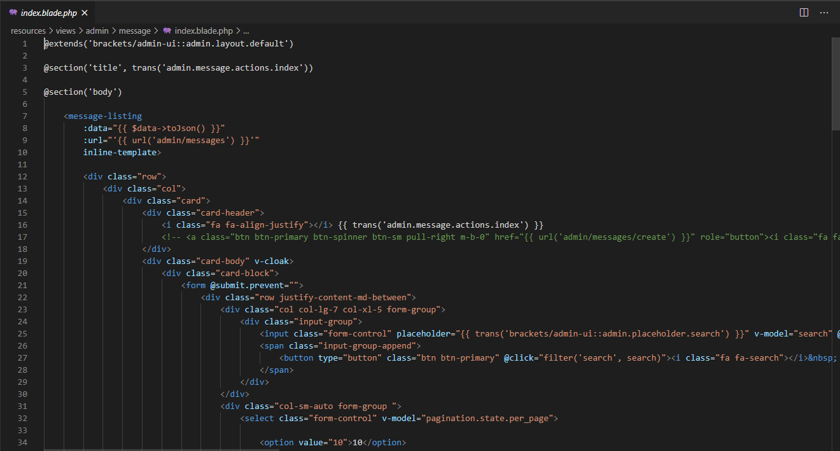

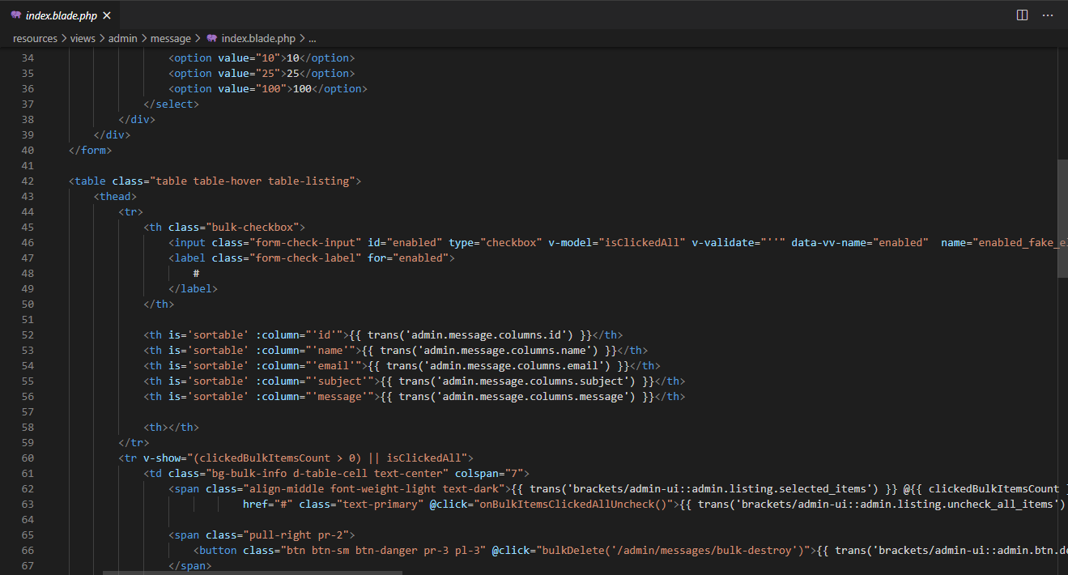

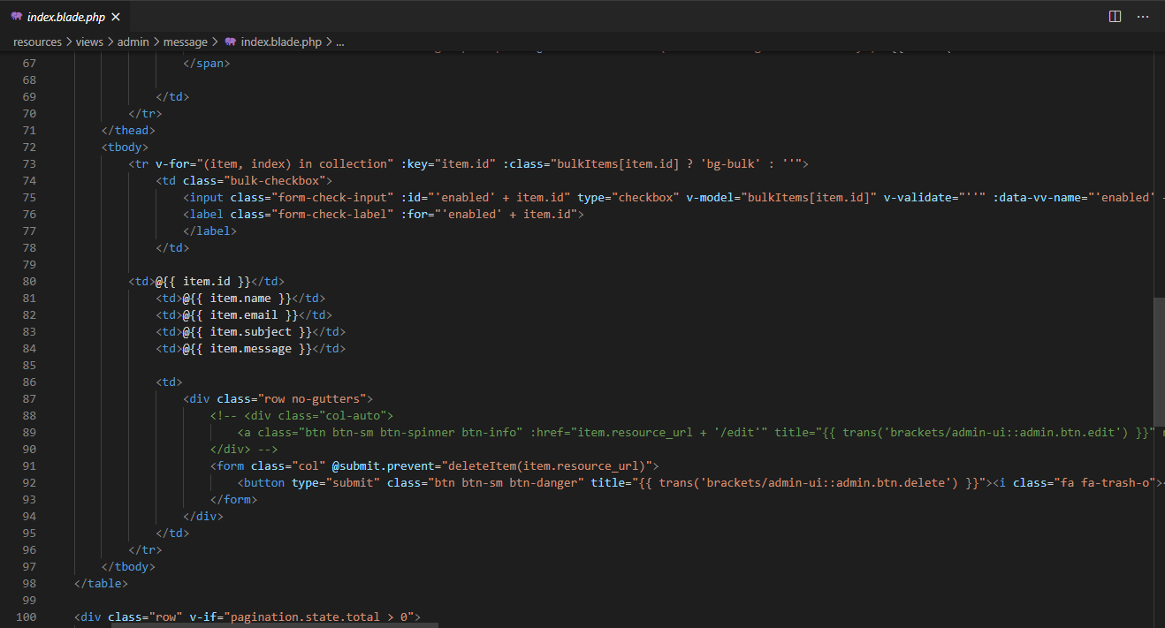

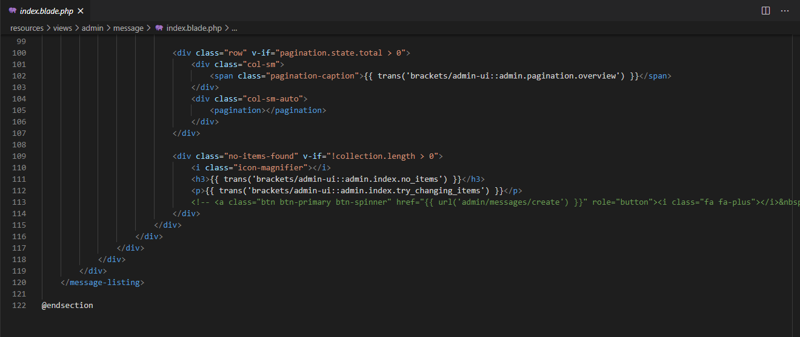

Figure 77: Messages.php

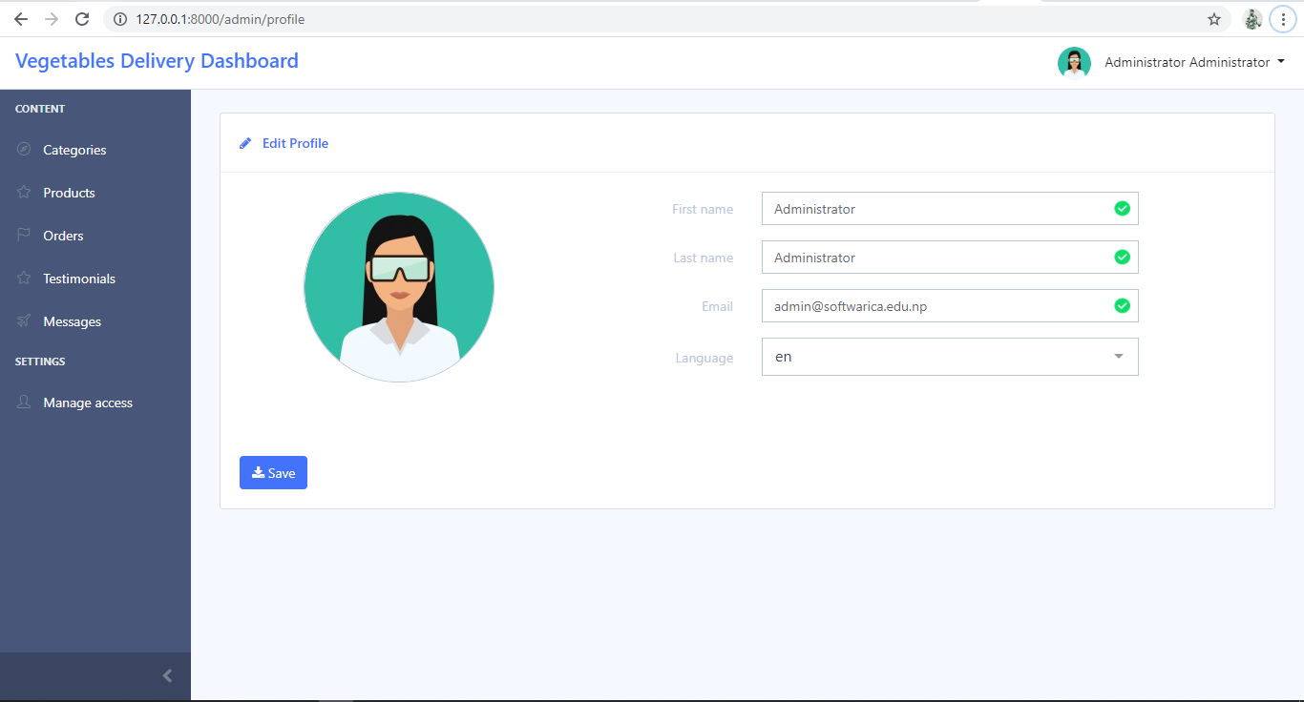

Figure 78: Admin Profile Edit Form

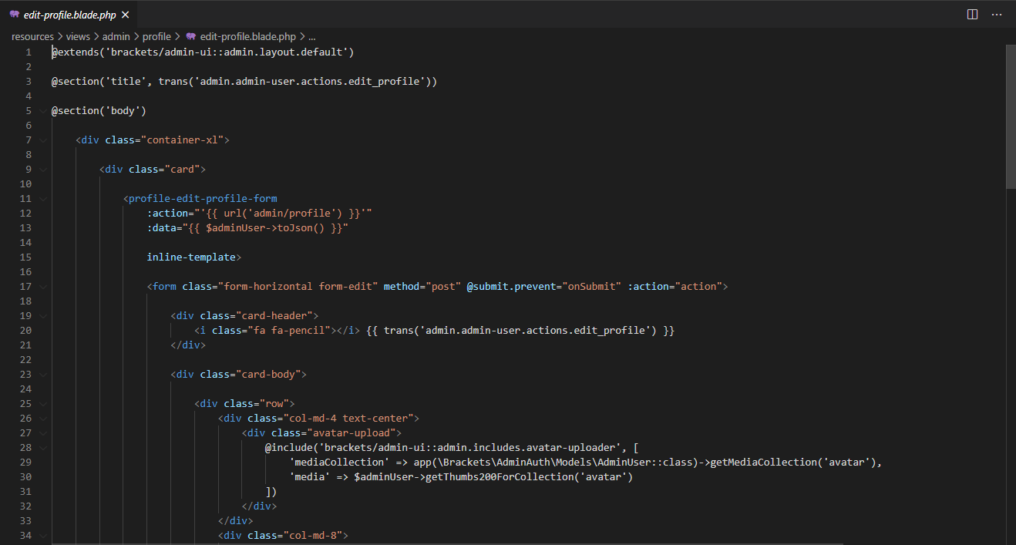

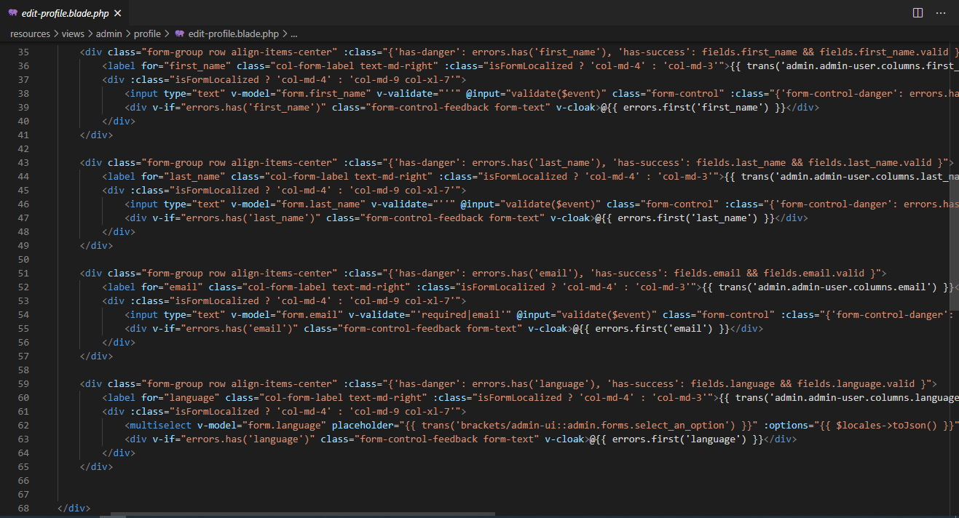

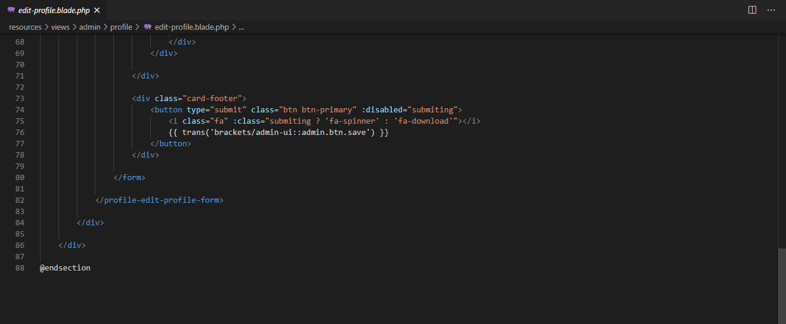

Figure 79: Edit Profile.php

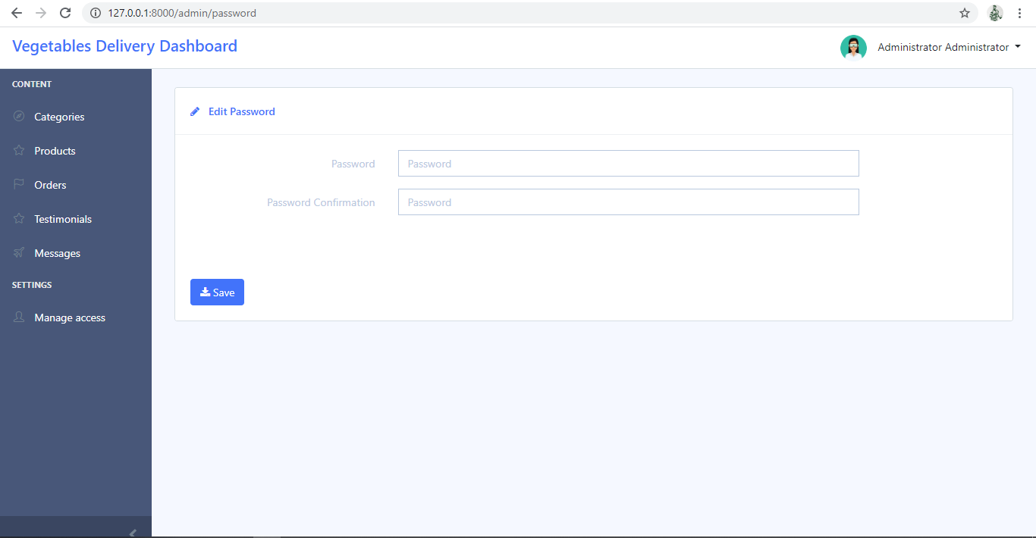

Figure 80: Admin Password Edit Form

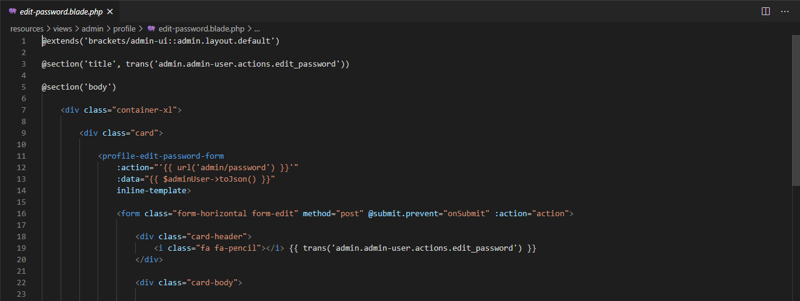

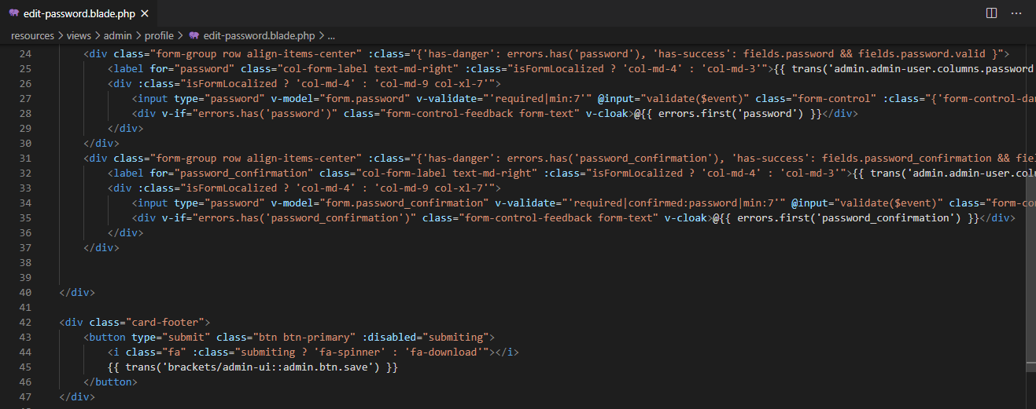

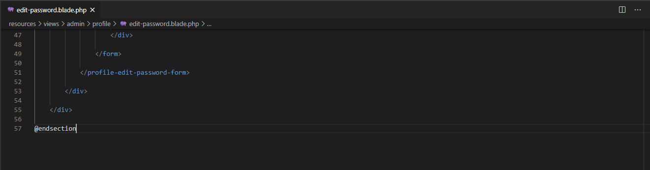

Figure 81: Edit Password.php

# References

*Analysis*. (2020, 10 10). Retrieved from businessdictionary.com: http://www.businessdictionary.com/definition/analysis.html

*BEHAVIORAL MODELING*. (2020, 10 03). Retrieved from OReilly: https://www.oreilly.com/library/view/systems-analysis-and/9781118037423/11_chapter006.html

*Black Box Testing*. (2020, 10 10). Retrieved from guru99: https://www.guru99.com/black-box-testing.html

*Data Modelling*. (2020, 10 05). Retrieved from guru99: https://www.guru99.com/data-modelling-conceptual-logical.html

*feasibility study*. (2020, 10 02). Retrieved from Investopedia: https://www.investopedia.com/terms/f/feasibility-study.asp

*Feasibility Study*. (2020, 10 04). Retrieved from Simplilearn: https://www.simplilearn.com/feasibility-study-article

*Feasibility Study*. (2020, 10 09). Retrieved from simplilearn: https://www.simplilearn.com/feasibility-study-article

*Functional Requirements*. (2020, 09 23). Retrieved from ofnisystems.com: http://www.ofnisystems.com/services/validation/functional-requirements/

*Interviewing in Information Gathering*. (2020, 10 06). Retrieved from System Analysis: https://www.w3computing.com/systemsanalysis/interviewing/

*MoSCoW Prioritization*. (2020, 10 04). Retrieved from ProductPlan: https://www.productplan.com/glossary/moscow-prioritization/

*Sequence Diagram*. (2020, 9 28). Retrieved from Visual Paradigm: https://www.visual-paradigm.com/guide/uml-unified-modeling-language/what-is-sequence-diagram/

*Software testing*. (2020, 09 29). Retrieved from Software testing material: https://www.softwaretestingmaterial.com/software-testing/

*STRUCTURAL MODELING*. (2020, 09 30). Retrieved from O Reilly: https://www.oreilly.com/library/view/systems-analysis-and/9781118037423/10_chapter005.html

*System Analysis*. (2020, 09 28). Retrieved from Using Questionnaires in Information Gathering: https://www.w3computing.com/systemsanalysis/using-questionnaires-information-gathering/

*System Architecture*. (2020, 09 27). Retrieved from Johner Institute: https://www.johner-institute.com/articles/product-development/system-architecture/

*System Requirements Specifications*. (2020, 09 30). Retrieved from inflectra: https://www.inflectra.com/ideas/topic/requirements-definition.aspx

*UML - Class Diagram*. (2020, 10 01). Retrieved from tutorialspoint: https://www.tutorialspoint.com/uml/uml_class_diagram.htm

*Unit Testing Tutorial*. (2020, 10 10). Retrieved from guru99: https://www.guru99.com/unit-testing-guide.html

*Use Case Diagram*. (2020, 07 31). Retrieved from Visual Paradigm: https://www.visual-paradigm.com/guide/uml-unified-modeling-language/what-is-use-case-diagram/